**TESTING**

QUIET, PLEASE

DO NOT DISTURB

**TESTING**

|  |  |
| --- | --- |
| Laptop Clip Art At Clker Com Vector Laptop | test clipart - Clip Art Library |

**DO NOT DISTURB**

Thank you.

**NO ENTRY**

**TESTING** 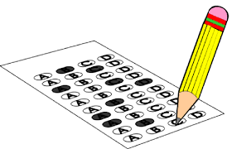

**DO NOT DISTURB**