# Name: _________________________________________________ Period ______

# 

# Star Life Cycle Web Activity

**Directions:** Click on each of the links. READ all of the information on each page AND read information within any links. Give detailed answers for each question.

1. Look at this Star Lifecycle diagram taken from <http://www.enchantedlearning.com/subjects/astronomy/stars/lifecycle/>

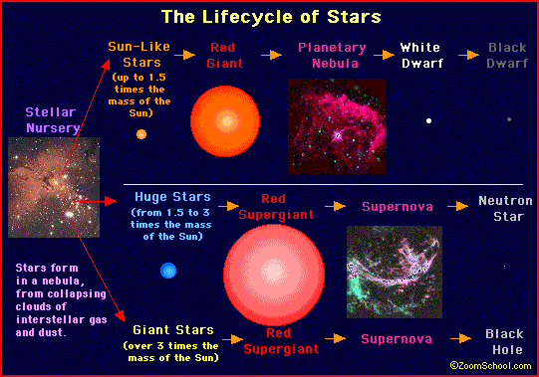

1. Based on the diagram, how do all stars start?
2. What is the main determining factors as to whether a star ends up as a black dwarf, neutron star or black hole?

**The Life Cycle of Stars**

1. Click on [Protostars](http://sunshine.chpc.utah.edu/Labs/StarLife/protostars.html) hyperlink.
2. Define nebula:
3. How does a protostar become an actual star?
4. What happens to protostars that do not become actual stars?
5. Explain what deuterium burning is AND why it matters to a protostar.
6. Click on [Main Sequence](http://sunshine.chpc.utah.edu/Labs/StarLife/mainsequence.html) of a Star.
7. Explain main sequence equilibrium.
8. How long will a star remain on the main sequence?
9. Click on [Old Stars](http://sunshine.chpc.utah.edu/Labs/StarLife/oldstars.html).
10. What makes a star “old”?
11. Which star has a longer life span, a larger one or a smaller on
12. Explain your answer to #10 in detail.
13. Click on [Stellar Remnants](http://sunshine.chpc.utah.edu/Labs/StarLife/remnants.html).
14. Explain the elements of planetary nebulae.
15. Describe the life span of white dwarfs.
16. Discuss several elements created by a supernova.
17. What is a pulsar?
18. How can we “see” a black hole?
19. Click on [Studying Stars](http://sunshine.chpc.utah.edu/Labs/StarLife/studying.html),
20. What is apparent magnitude?
21. What is absolute magnitude?
22. Explain what an H-R Diagram is AND scroll down to look at the H-R Diagram. Describe what it looks like.
23. Explain the relationship between star mass and life span.
24. Explain how stars make heavy elements.