5th Grade Links for Families and Students
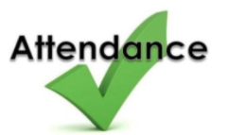 | Why is attendance important?  Click to find out!!  (native language attendance link)
 Missing Homework Policy | ALL students are responsible for missed assignments. Each day consists of a math lesson(s) and core class rotation(s). Whether due to lack of bus transportation, illness, appointments, or vacation, students will have to complete assigned work for a grade. The district make-up work policy is one day for every day missed plus one additional day. We are VERY busy in 5th grade and being late to class by five minutes makes a huge difference as we begin working immediately! Make-up work must be completed in a timely manner, or the grade entered will reflect missing; that equates to a zero. Missing work GREATLY impacts a student’s core class grade.
Why Read at home?    How to help my student CLICK | 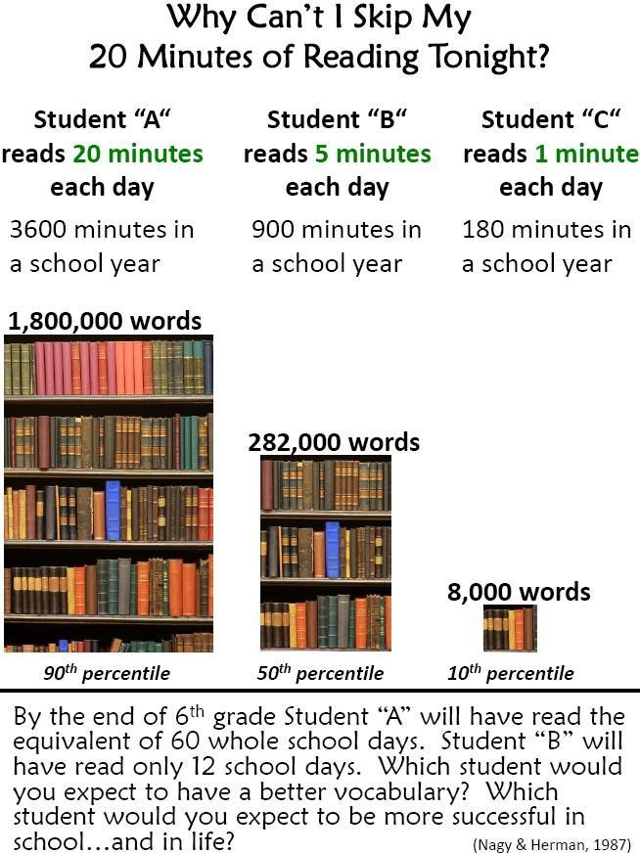
 | Accessing Microsoft Teams : https://teams.microsoft.com
 | 5th grade teacher emails:  Mrs. Thompson: shthompson@washoeschools.net  Mr. Wilson: jewilson@washoeschools.net  Mrs. Humphreys: shumphreys@washoeschools.net  Mrs. Trail: Lindsay.trail@washoeschools.net
 | 5th grade Welcome Pack Click!

*******Practicing Math Facts (x ÷ - +) and more! *******

 | - Quizziz through Clever
 | - Khan Academy  It is best to access this program through Clever  https://www.khanacademy.org/
 | - Every operation of practice https://www.softschools.com/math/games/
 | - Multiplication.com https://www.multiplication.com/games/all-games
 | - Envision Math Login
 | - External resource will require parent subscription: IXL.com  TEACHER FAVORITE!!

*******Language Arts Practice*******
- Access through CLEVER RAZ-Kids

AR Shortcut – Accelerated Reader

AR Book List – Find book levels and points here!

www.Storyonline.net

Typing.com can also be accessed through Clever

Other programs:
- Hour of Code

- SBAC Practice

