Chapter 2: Reasoning and Proof
Day | Date | Assignment (Due the next class meeting)
Monday  Tuesday | 8/26/24 (A)  8/27/24 (B) | Study for Chapter 1 test (2.1 Notes)
Wednesday  Thursday | 8/28/24 (A)  8/29/24 (B) | Ch 1 Test  2.1 p. 115 #16, 18-19, 21, 22, 26-28, 34, 36, 40-45, 51, 60, 63
Friday | 8/30/24 | 2.2 and 2.4 Worksheet (included in this packet)
Labor Day 9/2 – No School
Tuesday | 9/3/24 (B) | 2.2 and 2.4 Worksheet (included in this packet)
Wednesday  Thursday | 9/4/24 (A)  9/5/24 (B) | Algebraic Proofs Wk (included in this packet)  2.3 and Constructions Wk (included in this packet)
Friday  Monday | 9/6/24 (A)  9/9/24 (B) | 2.5 Worksheet (included in this packet)
Tuesday  Wednesday | 9/10/24 (A)  9/11/24 (B) | 2.6 Worksheet (included in this packet)
Thursday  Friday | 9/12/24 (A)  9/13/24 (B) | Chapter 2 Review Worksheet (will be given in class)
Monday  Tuesday | 9/16/24 (A)  9/17/24 (B) | Study for the Chapter 2 Part 1 Test!!
Wednesday  Thursday | 9/18/24 (A)  9/19/24 (B) | Chapter 2 Part 1 Test

- Each problem will be worth 1 point unless specified.
- Corrections are expected to be done to earn back points missed for each assignment.
- Worksheets and Textbook Solutions found here: https://www.washoeschools.net/Page/9309
- All assignments must be complete the day that they are due to receive full credit.
  - Every problem must be attempted with the picture drawn and work shown.
  - Proofs must be attempted to at least 2 steps, with diagram drawn and set-up shown.

Need extra help?
Try www.khanacademy.org, watch the videos on the YouTube channel, or see your teacher for help.

2.2 and 2.4 Worksheet
For #1 – 3, write each statement as a conditional statement, and identify the hypothesis and conclusion.

1) All straight angles have a measure of 180 degrees.
2) Adin gets $5 for his allowance if he completes all of his chores.
3) Every shark skeleton is made up of cartilage.

For #4 – 7, use the statement “If a two angles are complementary, then they are both acute” in order to identify each statement as the converse, inverse, contrapositive, or biconditional statement. Also, identify each statement as TRUE or FALSE.

4) If two angles are not both acute, then they are not complementary.
5) If two angles are both acute, then they are both complementary.
6) Two angles are complementary if and only if they are both acute.
7) If two angles are not complementary, then they are both not acute.

For #8 – 10, use the statement “If Gary did not fail any classes, then he is eligible to play sports” in order to identify each statement as the converse, inverse, contrapositive, or biconditional statement.

8) If Gary did fail a class, then he is not eligible to play sports.
9) If Gary is not eligible to play sports, then he did fail a class.
10) If Gary is eligible to play sports, then he did not fail any classes.

11) Is the following conditional statement true or false? If false, provide a counter-example.
“If a number is odd, then it is divisible by 3.”

For #12 – 15, use the statement “A right angle has a measure of 90 degrees” in order to identify each statement as the converse, inverse, contrapositive, or biconditional statement. Also, identify each statement as TRUE or FALSE.

12) If an angle has a measure of 90 degrees, then it is a right angle.
13) If an angle does not have a measure of 90 degrees, then it is not a right angle.
14) If an angle is not a right angle, then it is does not have a measure of 90 degrees.
15) An angle is a right angle if and only if it has a measure of 90 degrees.

16) Is the following biconditional statement true? Explain your reasoning. Two angles are complementary if and only if they are both acute angles.

For #17 – 19, write a two-column proof, supplying your own correct conclusion and reason. (Hint: These should only be 2-step proofs.)
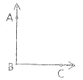
17) Given: 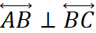
Conclusion: ? .

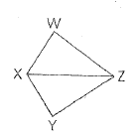
18) Given: 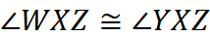
Conclusion:

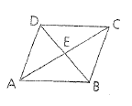
19) Given: E is the midpoint of 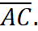
Conclusion:

20) , . 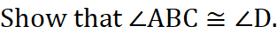 (Hint: Find x.) This is NOT a proof!
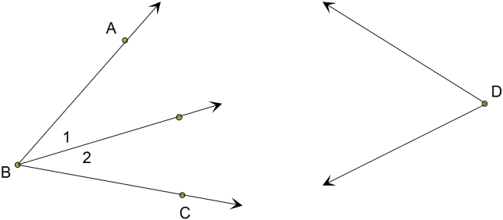

21) Given: 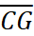 bisects 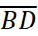.
X
Prove: 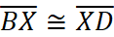

22) Given: 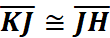

Prove: J is the midpoint of 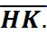

23) Write a paragraph proof: If 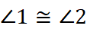, then they are both right angles.

24) Q is between P and R. PQ = x² + 3, QR = 4 + 2x, and PR = 15. Is Q the midpoint of 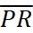? Justify your conclusions with work.

25) 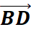 bisects ABC, and mABC = 25. Solve for x and y.

For #26 – 29, determine whether each statement is sometimes, always, or never true. Justify your conclusion with an explanation or diagrams.
26) There is only one plane that contains three noncollinear points A, B, and C.

27) If points M, N, and P lie in plane X, then they are collinear.

28) Points A, B, and C determine exactly one plane.

29) Three coplanar lines have two points of intersection.

30) Solve: 3x² – 5x + 1 = 0.

A) 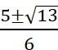
B) 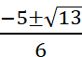
C) 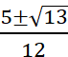
D) 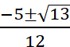

Answers:

1) Conditional: If an angles is a straight angle, then it has a measure of 180 degrees. Hypothesis: An angle is a straight angle. Conclusion: It has a measure of 180 degrees.
2) Conditional: If Adin completes all of his chores, then he gets $5 for his allowance. Hypothesis: Adin completes all of his chores. Conclusion: He gets $5 for his allowance.
3) Conditional: If an animal is a shark, then its skeleton is made of cartilage. Hypothesis: An animal is a shark. Conclusion: Its skeleton is made up of cartilage.
4) contrapositive, T 5) converse, F 6) biconditional, F 7) inverse, F 8) inverse
9) contrapositive 10) converse
11) False. Sample counter example: 7 is odd but is not divisible by 3.
12) converse, T 13) contrapositive, T 14) inverse, T 15) biconditional, T
16) No, because the converse is not a true statement. Both the converse and the conditional statement must be true.

2.3 and Constructions
For #1 – 3, draw a conclusion. What type of reasoning is used?
1) At Fumio’s school if you are late five times, then you will receive a detention. Fumio has been late to school five times.

2) If Natalie saves $2000, then she will go on vacation. If she goes on vacation, then Natalie will take time off of work.

3) Every Wednesday Lucy’s mom calls. Today is a Wednesday.

For #4 – 5, determine whether each conclusion is valid by the Law of Detachment, the Law of Syllogism, or if it is invalid. If it is invalid, then explain your reasoning.
4) Given: Right angles are congruent. and are right angles.
Conclusion:

5) Given: If Dante obtains a part-time job, then he can afford a car payment. Dante can afford a car payment. Conclusion: Dante obtained a part-time job.

For #6 – 7: Is the conclusion below valid or invalid? If it is invalid, then provide a counter-example.
6) Given: If a person is a Missouri resident, then he or she does not live by a beach. Michelle does not live by a beach. Conclusion: Michelle is a Missouri resident.

7) Given: All vegetarians do not eat meat. Theo is a vegetarian. Conclusion: Theo does not eat meat.

For #8 – 9: Use the Law of Syllogism or Law of Detachment to draw a valid conclusion from each set of statements, if possible. If no valid conclusion can be drawn, write no valid conclusion and explain your reasoning.
8) If two lines are perpendicular, then they intersect to form right angles. Lines r and s form right angles.

9) If the measure of an angle is between 90 and 180, then it is obtuse. If an angle is obtuse, then it is not acute.

For #10 – 11, find x.
3xº
2xº
xº
10) 11)
2xº

3xº

12) Construct the bisector of 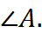 13) Construct the bisector of 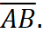
A

A
B

14) Copy 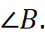 15) Copy 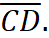
B
C
D

Selected Answers:
1) Conclusion: Fumio will receive a detention. Law of Detachment
2) Conclusion: If Natalie saves $2000, then she will take time off of work. Law of Syllogism
3) Conclusion: Lucy’s mom will call today. Inductive reasoning 4) Valid; Law of Detachment
5) Invalid; Dante could afford the car payment because he was given money as a gift or because he paid off other bills.
6) Invalid; Michelle could live in another state that does not have any beaches, such as Kansas.
7) Valid
8) no valid conclusion; the lines might not intersect at all but could be parallel or on different planes.
9) If the measure of an angle is between 90 and 180, then it is not acute.
10) 18 11) 30

2.5 Worksheet
O
1) 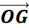 and 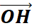 divide straight angle FOJ into three angles whose measures are in the ratio 4:3:2. Find mFOG.

2) Points A, B, and C are collinear. AC = 9, BC = 14, and AB = 5. Which point is between the other two points?

3) Given: 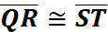
QS = 5x + 17, RT = 10 – 2x,
RS = 3.
Find QS and QT. (This is not a proof!)

4) Given: The ratio of 1 to 2 is 4 to 5, respectively.
Find the measure of 1. (This is not a proof!)

5) The measures of two complementary angles are in the ratio of 4:1. What is the measure of the smaller angle?

For #6-7, choose the answer that completes the proof
6) Given: , 

Prove: 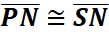
1) 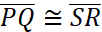, 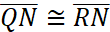 | 1) Given
2) 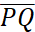 + 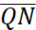 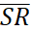 + | 2)
3) + + 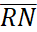 | 3) Substitution (1 into 2)
4) PQ + QN = PN and SR + RN = SN | 4)
5) 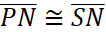 | 5) Substitution (6 into 5)
6.)
A.) 3) Segment Addition Postulate  5) Addition Property of Equality | C.) 3) If 2 segments have the same measure, then =  5) Addition Property of Equality
B.) 3) Addition Property of Equality  5) Angle Addition Postulate | D.) 3) Addition Property of Equality  5) Segment Addition Postulate

7)
Given:

Prove: $∠1≃∠3$

1) | 1) Given
2) 1 and 2 are a linear pair. | 2)
3) 1 is supplementary to 2 | 3) If two angles form a linear pair, then they are supplementary angles.
4) $∠1≃∠3$ | 4)
7)
A.) 2) Diagram  4) Transitive | C.) 2) Given  4) if =, then
B.) 2) Diagram  4) If two angles are supplements of the same angle, then they are congruent. | D.) 2) Given  4) Substitution (3 into 1)

8) Given segment with three points labeled as A, B, and C (although not in that particular order.) One of the points is the midpoint, and the other two points are the endpoints. Given that AC has length 8.4 inches, then find all possible lengths of BC. Draw diagrams or explain your reasoning.

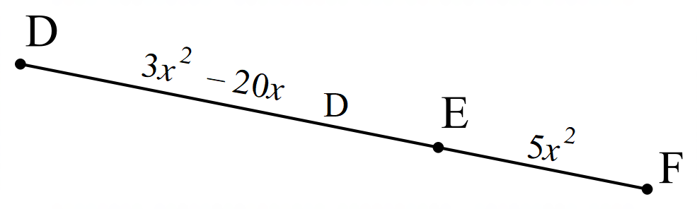
9) Find the value of x if the length of DF is 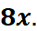

10) Given that points P, Q, and R are collinear with PQ = 11.4 and QR = 7.1. Find all possible values for the length of PR. Explain your reasoning.

11) Is the statement true or false? If false, provide a counter example. “If two angles are congruent, then they right angles.”

For #12 – 15, use the conditional statement: “If two angles form a linear pair, then they are supplementary.” For #12 – 14, match the requested statement.

12) Identify the contrapositive.

13) Identify the converse.

14) Identify the inverse.

A) If two angles are supplementary, then they form a linear pair.
B) If two angles are not supplementary, then they do not form a linear pair.
C) If two angles do not form a linear pair, then they are not supplementary.

15) Write a biconditional statement from the given conditional statement above (see directions above #12). Is the biconditional statement true or false? Explain your reasoning.

16) Given: 1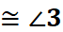
2
3
1

Prove: 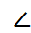2

Statements Reasons

Selected Answers:
1) 80 2) A 3) QS = 12 and QT = 21 4) 40º 5) 18 6, 7) see answer in class
8) 4.2, 8.4, or 16.8. Diagrams or explanation must be included. 9) 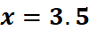
10) 4.3 or 18.5; If Q is between P and R, then PR is the sum of PQ and QR, which would be 18.5. If R is between P and Q, then PR = PR – QR, which is 4.3. If P is between Q and R, then PR = QR – PQ = -4.3, which is not possible.
11) False; counter-example: If two angles each measure 30 degrees, then they are congruent but are not right angles.
12) B 13) A 14) C
15) Two angles form a linear pair if and only if they are supplementary; False because the conditional and converse are not both true statements (the converse is false.)
16)
2
3
1

Given: 1

Prove: 2

1) 1 | 1) Given
2) 1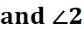 are vertical angles | 2) Diagram
3) 1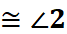 | 3) If vertical angles, then congruent
4) 2 | 4) Transitive

2.6 Worksheet
3
1
2
1) Given: 1 is supp to 3.
Prove: 1 is congruent to 2.

Use the following statements and reasons, and put them in the correct places to complete the proof.
<1 is supp to <3. <2 and <3 are a linear pair.
If two angles are supp to the same angle, then they are congruent.
<2 is supp to <3. Given
If two angles form a linear pair, then they are supplementary.
. Diagram

2) Given: 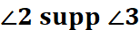
Prove: $∠1≃∠3$

3) Given: 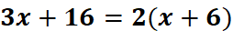.
Prove: x = - 4

4) Given: T comp W; X comp Z.
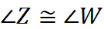
Prove: 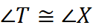

5) 1 is complementary to 2, and 1 is complementary to 3. If 2 = 49º, then find the measure of 3.

6) H is supplementary to G. F is supplementary to G. If F = 174º, then find the complement of H.

7) Find the value of TQS if 1 = (x²)º and 2 = (3x + 28)º.

8) Given: T is complementary to 1.
R is complementary to 2.
Prove: 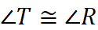

9) Given: 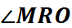 is complementary to 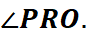
M
O
P
R
Prove: 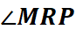 is a right angle.

1
2
3
10) Given: 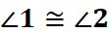
Prove: 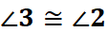

For #11 – 16, find the measure of each numbered angle in the diagram.
11) m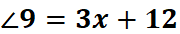 12) m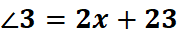 13) m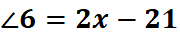
m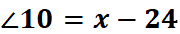 m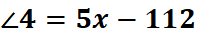 m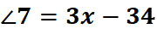
9
10
3
4
6
7
8

14) m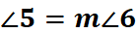 15) 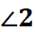 comp 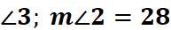 16) supp 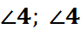 supp 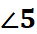
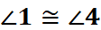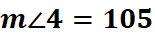
6
1 2
3

4
2 3 4 5
5

17) Given: 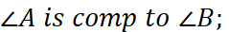 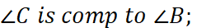 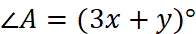; 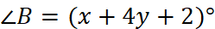; and
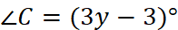. Find: 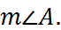

18) The measure of 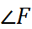 is 149° and 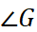 is supplementary to 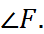 Find the measure of 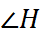if 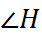 is complementary to the vertical angle of .

2.6 Answers:
1) Proof (answer will be given in class)
3) | 1.) Given
2.) | 2.) Distributive property of equality
3.) | 3.) Subtraction property of equality
4.) | 4.) Subtraction property of equality
2)  1) | 1) Given
2) | 2) diagram
3) | 3) If 2 angles form a l.p, then they are supp.
4) | 4) If 2 angles are supplementary to the same angle, then they are congruent

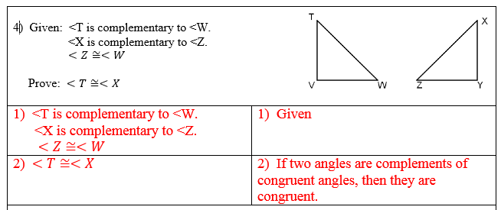

5) 49° 6) Not Possible 7) 131° or 164
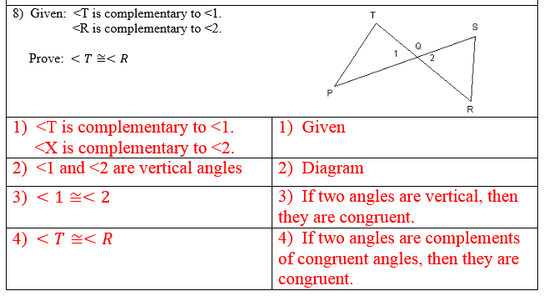
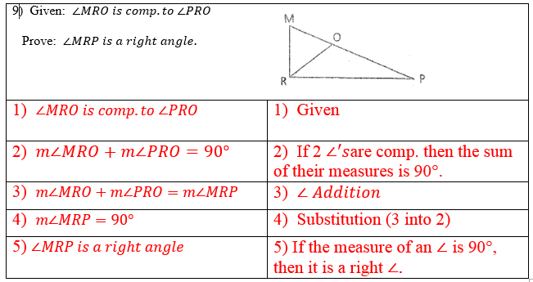
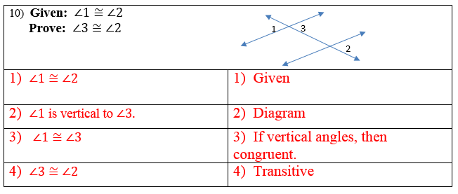
11)
12)
13)
14)
15)
16) 2 = 75;
17) 33
18) 59

3.1 Extra Problems
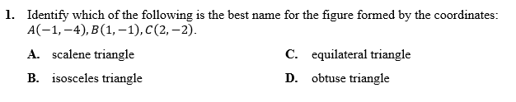
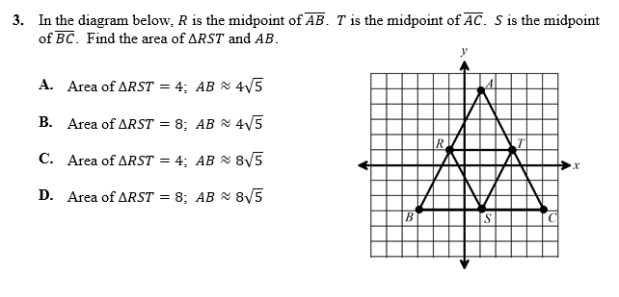
2) 2.

3) A, B and C are collinear with B between A and C. Find the length of BC if
4)
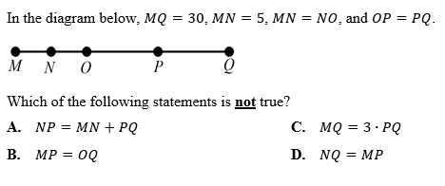
5) Given:
Find:

Answers:
1) B 2) B 3) 80 4) D 5) 66°

