Incline High School—Summer Reading Program 2024
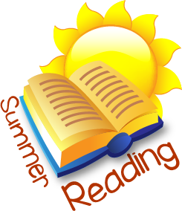
All IHS students will read two books over the summer break. Your English teacher will ask you to write about the books you read so be prepared for an assignment at the start of school. The lists below include the required reading for English AP classes, as well as suggested books or authors you might like. Keep in mind that this is summer reading, and you should choose books that you enjoy! Your choices do not have to come from the suggested list below but should be grade-level appropriate. We expect all newly enrolled students to complete this reading assignment as well, and they should see their English teacher about it on their first day.

Students in AP English Language and AP English Literature have specific books that you MUST read before school starts:

12th Grade—Advanced Placement Literature and Composition read in this order:
The Things They Carried O’Brien, Tim

1984 Orwell, George
Things Fall Apart Achebe, Chinua

11th Grade Advanced Placement Language and Composition
The Crucible Miller, Arthur
One Flew over The Cuckoo’s Nest Kesey, Ken
The Road McCarthy, Cormac

Suggestions for all other students, including incoming 9th graders:
Fiction: Young Adult Recommendation (also try other books by these popular authors)

All American Boys Reynolds, Jason and Kiely Brendan
Allegedly Jackson, Tiffany D.
Backfield Boys or The Prodigy Feinstein, John
Children of Blood and Bone Adeyemi, Tomi
Darius the Great Is Not Okay Khorram, Adib
Demon Copperhead Kingsolver, Barbara
Dig King, A.S.
Everything Sad is Untrue Nayeri, Daniel
Forgive Me, Leonard Peacock Quick, Matthew
Furia Mendez, Yamile Saied
Firekeeper’s Daughter Boulley, Angeline
It Ends with Us Hoover, Colleen
It Sounded Better in My Head Kenwood, Nina
Mexican Whiteboy De La Pena, Matt
My Life as an Ice Cream Sandwich Zoboi, Ibi
Neanderthal Opens the Door to the Universe Norton, Preston
Opposite of Always Reynolds, Justin A.
Patron Saints of Nothing Ribay, Randy
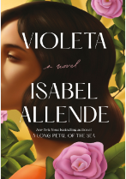
Promise Boys Brooks, Nick
Refugee Gratz, Alan
Scythe Shusterman, Neal
The Girl Who Fell from the Sky Durrow, Heidi
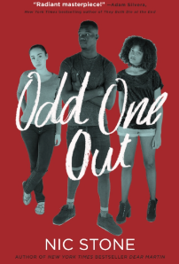
The Girls I’ve Been Sharpe, Tess
The Good Girl Kubica, Mary
The Kids Are Gonna Ask Anthony, Gretchen
The Nickel Boys Whitehead, Colson
There There Orange, Tommy
The Rest of Us Just Live Here Ness, Patrick
The Revolution of Evelyn Serrano Manzano, Sonia
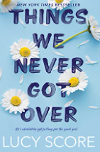
The Serpent King Zentner, Jeff
The Starless Sea Morgenstern, Erin

Fiction Series (book 1)
Chaos Walking Ness, Patrick
Grisha Trilogy Bardugo, Leigh
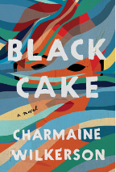
Legend Series or others Lu, Marie
Red Queen Aveyard, Victoria
Storm Breaker Horowitz, Anothny
The Bone Season or The Song Rising Shannon, Samantha
The Testing Charbonneau, Joelle
Three Dark Crowns Blake, Kendare
The Wrath and the Dawn Ahdieh, Renee
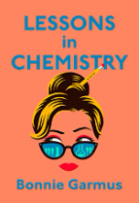
Non-Fiction
Fly Boys: A True Story of Courage Bradley, James
Fly Girls: How Five Daring Women Defied… O’Brien, Keith
Solito Zamora, Javier
Street Life Rios, Victor
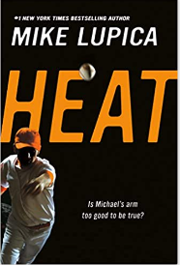
The Baseball Whisperer Tackett, Michael
The Devil’s Highway: A True Story Urrea, Luis Alberto
The Girl Who Escaped Isis: This Is My Story Khalaf, Farida
The 57 Bus Slater, Dashka
The 29th Day: Surviving a Grizzly Attack Messenger, Alex
Wolf Boys Slater, Dan
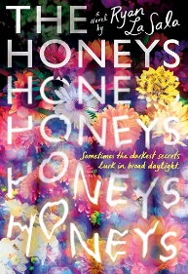
Literature
A Tree Grows in Brooklyn Smith, Betty
Catcher in the Rye Salinger, J. D.
How the Garcia Girls Lost Their Accent Alvarez, Julia
Jane Eyre Bronte, Charlotte
Portrait of Dorian Grey Wilde, Oscar
Slaughterhouse Five Vonnegut, Kurt
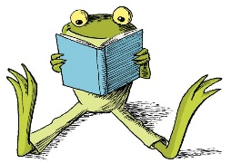
Wuthering Heights Bronte, Emily

Visit www.collegeboard.com for their list of suggested books for college-bound students.

