**Math 126** **Ch 3 Review Worksheet** Name: ___________________________

**Calculator allowed only on problems marked with an asterisk *.**

**For #1 – 4: Convert the equation to its equivalent exponential or logarithmic form:**

1. 2.

3. 4.

**For #5 – 12: Evaluate each expression without the use of a calculator.**

5. 6. 7.

8. 9. 10.

11. 12.

**For #13 – 19: Expand or condense the following expressions:**

13. 14. 15.

16. 17.

18. 19.

**For #20 – 29: Solve the following equations. No calculator unless marked with an asterisk *(#29… round to 3 decimal places.)**

20. 21.

22. 23.

24. 25.

26. 27.

28. *29.

**For #30 – 33: Graph each function. Include the asymptote and the anchor point. Also, describe the domain and range in interval notation.**

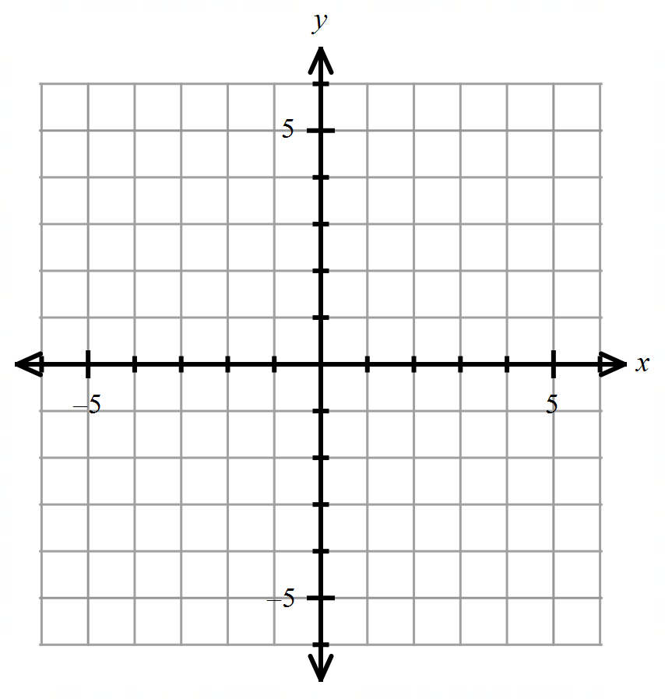

30) 31)



32) 33)

*34) The brewing pot temperature of coffee is 180º F, and the surrounding room temperature is 76º F. After 5 minutes, the temperature of the coffee is 168º F. Use Newton’s Law of Cooling: .

a) Write an equation to represent this situation.

b) How long will it take for the coffee to reach a serving temperature of 155º F? Round your answer to one decimal place.

**For #35 – 36: Use the compound interest formulas A = Pto solve:**

35) Find the total value of an investment of $900 at 12% compounded quarterly for 6 years.

36) Find the accumulated (total) value of an investment of $4000 at 7.3% compounded continuously for 5 years.

37. The half-life of silicon-32 is 710 years. If 50 grams is present now, how much will be present in 200 years? (Round your answer to three decimal places.)

38. The logistic growth function = models the number of people who have become ill with a particular infection t weeks after its initial outbreak in a particular community.

a) How many people were ill after 9 weeks? Round your answer to the nearest whole number, if needed.

b) What is the max number of people that could get this infection? (In other works, what is the limiting value?

39) The population of a particular country was 30 million in 1984; in 1989 it was 37 million. The exponential growth function models the population of this country years after 1984. Use the fact that 5 years after 1984 the population increased by 7 million to find to three decimal places.

40) Carbon-14 has a half-life of 5600 years. A fossilized leaf contains 18% of its normal amount of carbon 14. How old is the fossil (to the nearest year)? Use an exponential decay model to solve this problem.

**Answers:**

1) 2) 3) 4) 5) 1 6)

7) 0 8) 13 9) 18 10) 11) 3 12) 123

13) 14) 15) 16)

17) 18) 19) 20) 1 21) 22) or

23) 24) 25) 26) 36 27) 6 28) 2 29)

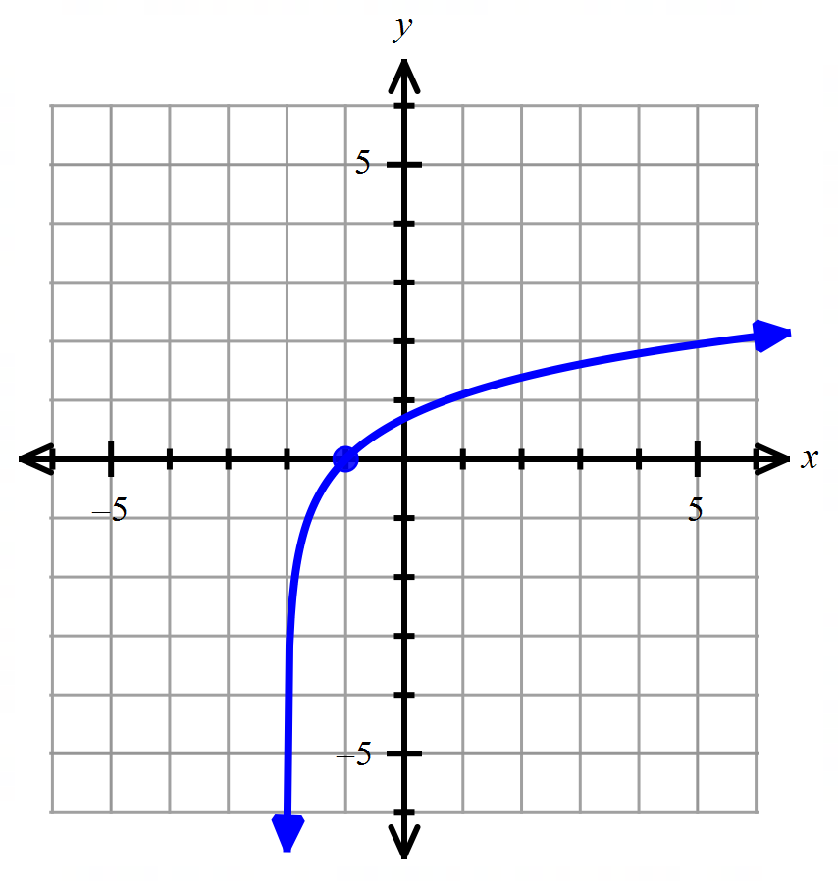30) 31) 32) 33)

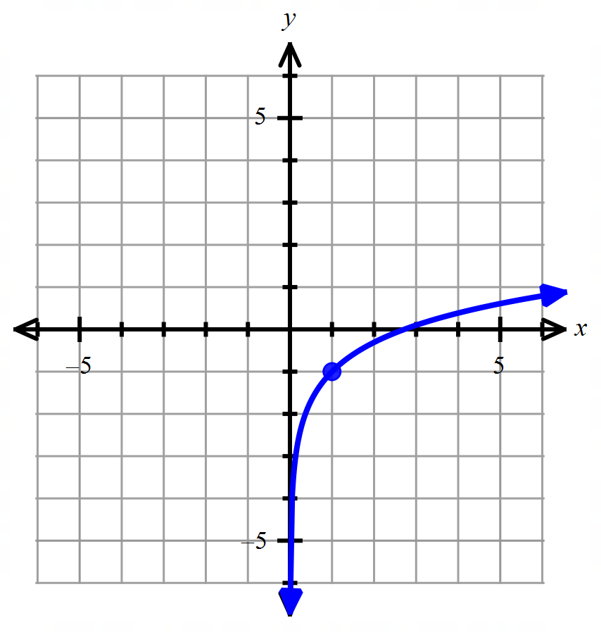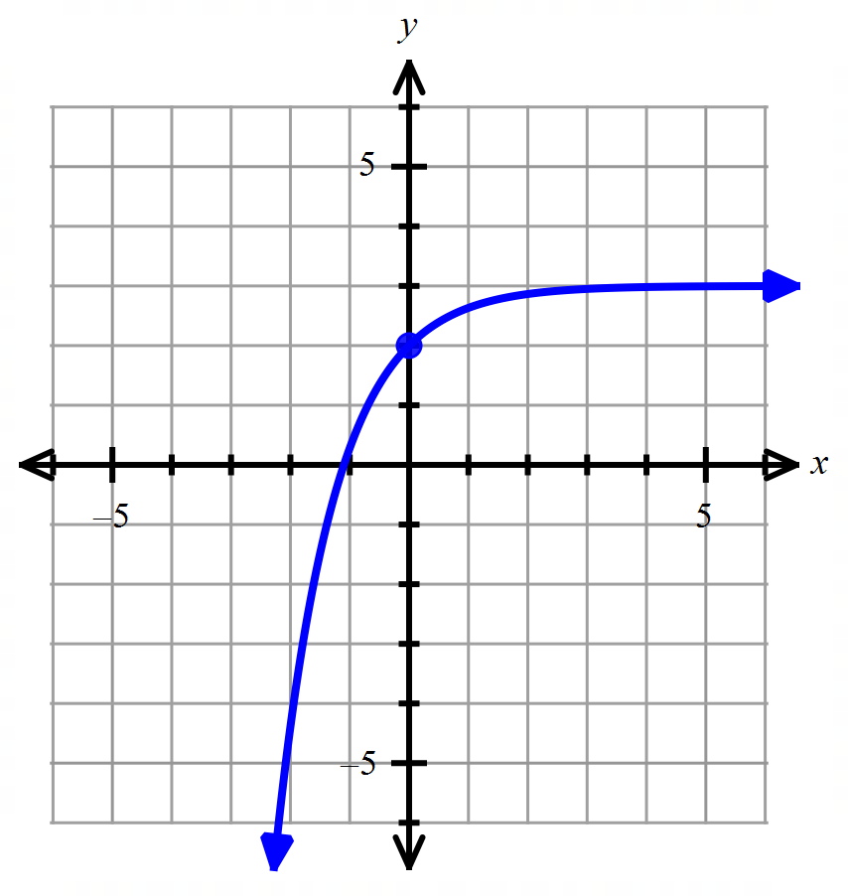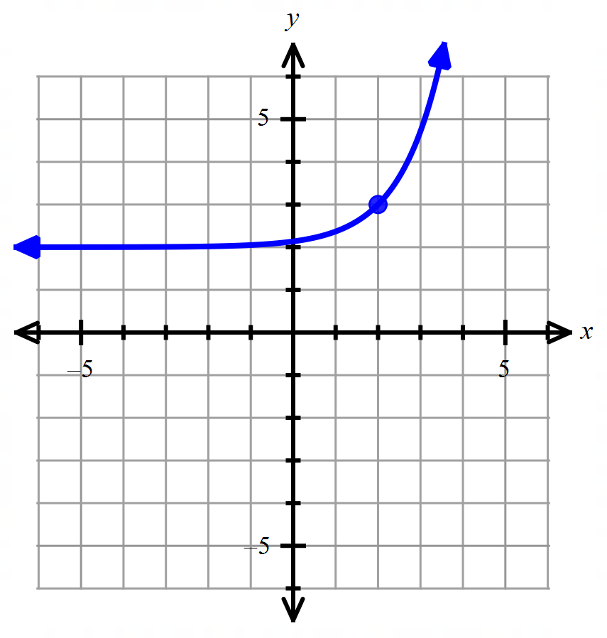

34a) 34b) 11.2 minutes 35) $1829.51 36) $5762.06

37) 41.131 grams 38a) 84,502 people 38b) 87,000 people 39) 0.042 40) 13,854 years