4.1 Extra Problems ANSWERS
1) 127º
2) D
3) B

4.2 Extra Problems ANSWERS
1) 118º
2) Scalene $AB=2\sqrt{5}, BC=5, AC= \sqrt{53}$
3) A
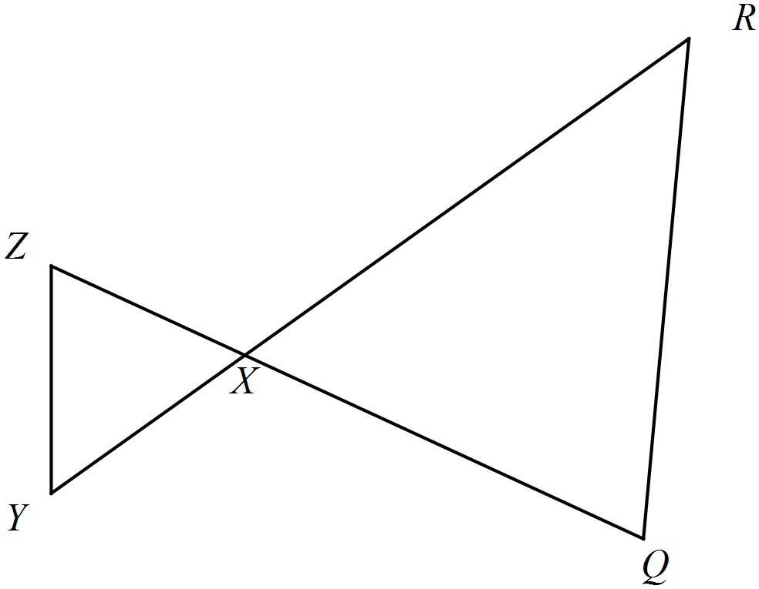
4) Given: $∆XYZ≅∆XRQ$
Prove: X is the midpoint of $\overline{YR}$

1. $∆XYZ≅∆XRQ$ | 1. Given
2. $\overline{XY} ≅ \overline{XR}$ | 2. CPCTC
3. X is the midpoint of $\overline{YR}$ | 3. If a point divides a segment into 2 $≅segments, then it is a midpoint$

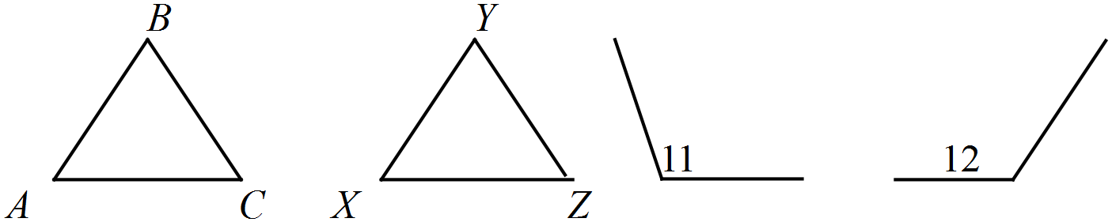
5)
Given: $∆ABC≅∆XYZ$,
$∠11$supp. $∠B$, $∠12$supp. $∠Y$

Prove: $∠11≅∠12$
1. $∆ABC≅∆XYZ$,  $∠11$supp. $∠B$, $∠12$supp. $∠Y$ | 1. Given
2. $∠B ≅ ∠Y$ | 2. CPCTC
3. $∠11≅∠12$ | 3. If 2 $∠^{'}$s are supp. to $≅ ∠^{'}s ,$  then they are $≅$to eachother

4.3 Extra Problems ANSWERS
1)  Given: $\overline{CB} ≅ \overline{ED}, \overline{CA} ≅ \overline{CE}, and$  $$\overline{AC} bisects \overline{BD}$$  Prove: $∆ABC≅∆ADE$ |  | D  B  A  E  C
1) $\overline{CB} ≅ \overline{ED}, \overline{CA} ≅ \overline{CE},$  $$and \overline{AC} bisects \overline{BD}$$ |  |  | 1) Given
2) $\overline{AB} ≅ \overline{AD}$ |  |  | 2) If a point is a bisector, then it creates 2 congruent segments.
3) $∆ABC≅∆ADE$ |  |  | 3) SSS (1, 1, 2)
2) Given: $\overline{QR}≅ \overline{SR}, \overline{ST}≅ \overline{QT}$  Prove: $∆QRT≅∆SRT$ | Q  R  T  S
1) $\overline{QR}≅ \overline{SR}, \overline{ST}≅ \overline{QT}$ | 1) Given
2) $\overline{TR}≅ \overline{TR}$ | 2) Reflexive
3) $∆QRT≅∆SRT$ | 3) SSS (1, 1, 2)
3)  Given: R is the midpoint of $\overline{QS} and \overline{PT}.$  Prove: $PQ≅TS$ | P  S  R  Q  T
1) R is the midpt of $\overline{QS} and \overline{PT}.$ | 1) Given
2) $\overline{PR}≅ \overline{RT}, \overline{QR}≅ \overline{RS}$ | 2) If a segment is a midpoint, then it creates 2 congruent segments.
3) $∠$PRQ and $∠$SRT are vertical | 3) Diagram (optional step)
4) $∠PRQ≅ ∠SRT$ | 4) If two angles are vertical angles, then they are congruent.
5) $∆PRQ≅∆TRS$ | 5) SAS (2, 4, 2)
6) $PQ≅TS$ | 6) CPCTC
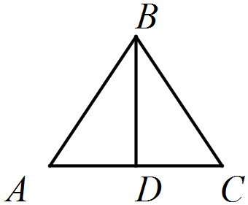
4)
Given: $\overline{BD}⊥ \overline{AC}, \overline{BD} bisects \overline{AC}$
Prove: $∆ABD≅∆CBD$

1) $\overline{BD}⊥ \overline{AC}, \overline{BD} bisects \overline{AC}$ | 1) Given
2) $∠$ADB and $∠$CDB are rt <’s | 2) If 2 seg are $⊥$, then they create rt $∠$’s.
3) $∠ADB≅∠CDB$ | 3) If 2 $∠$s are rt $∠$s, then they are congruent.
4) $\overline{AD}≅ \overline{DC}$ | 4) If a segment bisects a segment, then it creates two congruent segments.
5) $\overline{BD}≅ \overline{BD}$ | 5) Reflexive Property
6) $∆ABD≅∆CBD$ | 6) SAS (4, 3, 5)
5)  Given: $\overline{YX}≅ \overline{WZ}, \overline{YX} || \overline{ZW}$  Prove: $∆YXZ≅∆WZX$ | W  X  Y  Z
1) $\overline{YX}≅ \overline{WZ}, \overline{YX} ∥\overline{ZW}$ | 1) Given
2) $\overline{ZX}≅ \overline{ZX}$ | 2) Reflexive Property
3) $∠YXZ≅ <WZX$ | 3) If parallel lines, then alt int $∠$s are congruent.
4) $∆YXZ≅∆WZX$ | 4) SAS (1, 3, 2)
4.6 Extra Problems ANSWERS

1) 84º
2) Given: $∠W ≅ ∠Y$, $\overline{WV}≅ \overline{ZY}$  Prove: $∆XWV≅∆XYZ$  W |  |  |  |  | V  Z  Y  X
1) $∠W ≅ ∠Y$, $\overline{WV}≅ \overline{ZY}$ |  |  | 1) Given
2) $\overline{WX}≅ \overline{XY}$ |  |  | 2) If , then
3) $∆XWV≅∆XYZ$ |  |  | 3) SAS (1, 1, 2)
3) 30º
4) x = 25º, and y = 75º
5) Given: $\overline{FG}≅ \overline{FH}$  Prove: $∠G≅ ∠JHK$  G |  |  | J  K  F  H
1) $\overline{FG}≅ \overline{FH}$ |  |  | 1) Given
2) $∠G≅ ∠FHG$ |  |  | 2) If , then
3) $∠JHK≅ ∠FHG$ |  |  | 3) If 2 $∠$s are vertical, then they are congruent.
4) $∠G≅ ∠JHK$ |  |  | 4) Transitive
6) 57
7) $x=25, y=10$

8) Given: $∠XVZ ≅ ∠XZV$, $\overline{WV}≅ \overline{ZY}$  Prove: $∠W≅∠Y$  W |  |  | V  Z  Y  X
1) $∠XVZ ≅ ∠XZV$, $\overline{WV}≅ \overline{ZY}$ |  |  | 1) Given
2) $\overline{XV}≅ \overline{XZ}$ |  |  | 2) If , then
3) <XVW is supp to $∠$XVZ  <XZY is supp to $∠$XZV |  |  | 3) If 2 $∠$s form a linear pair, then they are supp.
4) $∠XVW ≅ ∠XZY$ |  |  | 4) If two angles are supplements of congruent angles, then they are congruent.
5) $∆XWV≅∆XYZ$ |  |  | 5) SAS (1, 4, 2)
6) $∠W≅∠Y$ |  |  | 6) $CPCTC$
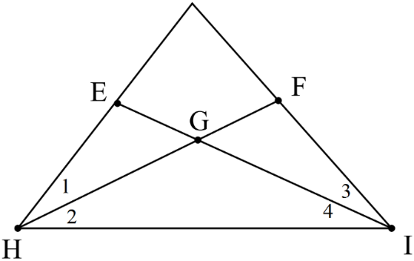
9) Given: $∠1 ≅ ∠3$, $∠2 ≅ ∠4$

Prove: $\overline{EH}≅ \overline{FI}$

1) ∠1≅∠3,∠2≅∠4 |  | - Given
2) HG ≅ GI |  | - If , then
3) $∠$EGH ≅ $∠$FGI |  | - If two angles are vertical, then they are congruent.
$$4) ∆HGE≅∆IGF$$ |  | - ASA(1, 2, 3)
$$5) \overline{EH}≅\overline{FI}$$ |  | - CPCTC

