
Friday, May 17, 2024, Edition.
Created for your enjoyment by selected members of the Success Skills and Yearbook classes.

New Starbucks Summer Menu
by Emy Jacob
Starbucks recently released their new summer menu, and everyone is loving it. It features three new drinks, two of which are refreshers, one is a new cold brew, and we also got two new bakery items. The new refreshers are the summer berry refresher with boba and the summer berry lemonade refresher with boba. There are blue drinks with pink boba they are supposed to taste like blue raspberry! We also get a white chocolate macadamia nut cold brew with foam! Yummy new drinks, I am thrilled we haven’t gotten a refresher since pineapple paradise, and I thought it was awful. The bakery item is a pineapple cloud cake, which I hope is redeeming to the awful refresher. Finally, we have an orange cake pop which isn’t a shocker, but I’m still excited. That’s the new menu, go try some overpriced drinks!
What Sports Should Be Added to Our School?
by Blake Christensen

Mrs. Gentner- Motor cross.
Cinco- Fortnite tournaments.
Larson- boys volleyball + Underwater Hockey.
Destin- Baseball.
Mr. Gentry- Golf.
DJ- Infantry.
Madiline- Swimming.
Levi- Boys volleyball.
John- Soccer.
Mr. Coomler- Football.
Bode- Airsoft.
Mr. Edwards- Rowing, Swimming, Baseball, Underwater hockey, Skiing, and ping pong.

Summertime Jobs
by Sarah C.
Summertime is just around the corner IMS students, for some of you during the summer, you may be able to start your very first job (8th graders)! Here are some places you should keep in mind…
Inclined Burger- Go in person or on their very own website to fill out an application.
Susie Scoops- Go in person or on their very own website to fill out an application.
Incline beach snack shop- I do not know YET where you can.

apply for this, but I’m sure as we get closer to the season, we will find out.
Lifeguard- Talk to Mrs. Hrindo if you are interested, she will find you the best places!
Mofo’s- Go in person or on their very own website to fill out an application.
Jiffy’s- Go in person or on their very own website to fill out an application.
Burnt Cedar Beach- Go in person or on their very own website to fill out an application.
Summer 2024 Watersports Attendant- Go in person or on their very own website to fill out an application.
If you are just looking for a one-time thing, try going around your neighborhood if they need babysitting, car washing, whatever you think they or even you might be interested in.
Kendrick Lamar vs. Drake Beef
by Sarah C.
Some of you may be wondering how this whole scandal started, well, I’m going to give you a quick rundown. Drake talks about how he, Kendrick Lamar, and J.cole are the “big 3” in the music industry, but Kendrick disagreed, so therefore he made a song saying that he is not a part of the “big 3” and that its just “big me.” So, realistically a crucial factor in this whole situation is Kendricks’s ego (no hate on kdot). Not much longer after Kendricks's song “Like that” dropped, J.cole released a diss on Kendrick saying how he fell off. Only a little after he released his diss “7-minute drill” he takes it down, removes it from the album, and therefore apologizes to Kendrick. Drake then spins back with his single “Push-ups”, and he discreetly throws out hate to many artists including kdot. The whole song is throwing a bunch of shade towards Kendrick. Once again, Drake makes yet another song where he uses AI voices of Tupac and Snoop Dogg. The song was named “Taylor Made.” Kendrick returns with a comeback where he releases his single “Euphoria” that is over 6 minutes long. The song was released weeks after all the hate from Drake. The track was mid, but nothing like his next. He then went ahead to drop another distrack, the song was labeled “6:16 in LA.” Drake then drops “Family Matters” which is where the tables turn and everyone starts taking Kendricks’s side due to Drake making heavy accusations, which overall he went too far. Kdot instantly replied within 30 minutes with his own song labeled “Meet the Grahams” and kdot goes crazy. He made claims such as Drake is hiding a second child who is a girl, and that apparently Drake is “ashamed” of her. MANY accusations were made about Drake just overall being a weirdo, and that he is a different person behind closed doors. The whole song was just a jumble of insane lore on Drake that could end his career. Lastly, hours after that, Kendrick drops “Not Like Us” where he just continued to absolutely DEMOLISH Drake and his career. Drake then responds with a song that I do not know the name of, where he says a whole lotta NOTHING. For the whole song he just yipper yaps. Therefore, Drake is officially COOKED. Kendrick on top!
Jewelry Inspo
by Emy Jacob
This is a jewelry guide to buy really nice pieces that last forever. Real jewelry isn’t affordable neither are the pieces I chose to cover. This is more of an unrealistic shopping experience. The first thing I would buy if I were absolutely loaded would be the Vivian Westwood pearl pendant necklace that’s classy and fun and such a “it” girl item, it’s so “skibidi”! Moving on to bracelets, I would layer the Van Cleef five motif bracelet in silver with a Cartier Love bracelet in silver. So cute and perfect for everyday the bracelet combo but plot twist it costs 10 racks! For extras, I would add an elevated Pandora heart ring and a Tiffany heart tag anklet. To add Ice Spice, I would layer a Swarovski simple round cut diamond necklace. That’s what I would buy if I had money!
Summer Countdown
(As of May 17th)
We only have 18 days left!! Which is 4 weeks!! Can you believe it?
*Do you want it to be summer? I know I do!
One Question Interviews About Summer
by Justine Daniel
(Featuring 2nd period PE)
Q: Do you have any summer traditions?
Yaretzi: I go to LA every summer.
Q: What is your favorite drink on a summer day?
Nico: Arizona Tea (Watermelon flavor)
Q: Which beach do you go to?
Atticus: Incline
Q: What is your favorite summer fruit?
Deigo: Watermelon
Q: What is your favorite summer food?
Kenia: Strawberries
Q: What is your favorite summer dessert?
Caleb (7th): Ice Cream
Q: Do you like swimming in Lake Tahoe, or a pool better?
RB: Pool
Q: What is your favorite Barbecue Food?
Mr. Snearly: Ribs from Famous Dave’s
Q: What is your favorite beach game/activity to do at the beach?
Evan: Basketball Game
Q: What is the average time you wake up in summer?
Zoe R.: 11 am
Guess Who?
by Katie Nelson
6th
· He has blonde hair, his best friend is Ryker, he injured himself recently on stairs.
· She has a sister in 8th grade, she plays volleyball and softball, and her best friend is Jolie.
7th
· He has blonde hair, his best friend is Tucker and Nick, he plays flag football.
· She has short hair, she skis and plays club soccer, and has two dogs.
8th
· He has black hair, three siblings, plays soccer, and has a yearbook.
· She has brown hair, two brothers, she plays softball, volleyball, and runs track, and is short.
Track Updates
by Jayden Jenkins
Incline’s track team had a meet on May 9th, here are the results. 100 meters, 7th grade boys Nicholas Pannone got 3rd place with a time of 14.23 and Trevor Thorne got 5th place with a time of 14.44. 100 meters, 8th grade boys Jaxon Abbate got 1st place with a time of 13.15. 200 meters 7th grade boys Francisco Jones got 30.02 and Teague Searle got 5th place with a time of 30.90. 200 meters 8th grade boys, Jaxon Abbate got 1st place with a time of 27.14, Reeve Denton got 2nd place with a time of 29.12 and Damyan Avila got 4th place with a time of 30.37. 400 meters, 7th grade boys Salomon McMahan got 3rd place 1:08.79 and Nicholas Pannone got 5th place with a time of 1:11.02. 400 meters, 8th grade boys Leo Dukes got 2nd place with a time of 1:10.64, Miguel Avila got 3rd place with a time of 1:11.84 and Damyan Avila got 4th place with a time of 1:12.69. 800 meters, 7th grade boys Leo Duran got 2nd place with a time of 2:45.19. 3200 meters, Atticus Edwards got 4th place with a time of 15:32. 3200 meters, 8th grade boys Miguel Avila got 2nd place with a time of 13:21 and Xavier LaForge got 4th place with a time of 13:30. 80m Hurdles-33” 8th grade Xavier LaForge got 1st place with a time of 13.96, and Jayden Haro got 4th place with a time of 17.62. 200m Hurdles-30” 7th grade boys Francisco Jones got 3rd place with a time of 34.97 and Teague Searle got 4th place with a time of 35.49. 200m Hurdles-30” Xavier LaForge got 4th place with a time of 32.96. 4x100 relay, 7th grade boys’ team one Trevor Thorne, Nicholas Pannone, Francisco Jones, and Leo Duran got 3rd place with a time of 57.98. 4x100 relay 8th grade boys’ team one Jayden Haro, Jaxon Abbate, Miguel Avila, and Damyan Avila got 2nd place with a time of 57.25 and team two Larsen Beenk, Xaiver LaForge, Reeve Denton, and Leo dukes got 3rd place with a time of 59.21. 4x400 relay, 7th grade boys Salomon McMahan, Leo Duran, Nicholas Pannone, and Trevor Thorne got 3rd place with a time 4:55.66. 4x400 relay 8th grade boys Larsen Beenk, Dayman Avila, Jaxon Abbate, and Leo Dukes got 2nd place with a time of 4:56.78. Discus-1kh 8th grade boys Rodrigo Tarazona got 4th place with a distance of 80-03; high jump 8th grade boys Reeve Denton got 2nd place with a height of 4-06 and Jaydeb Haro got 3rd place with a height of 4-04. Long jump 8th grade boys Xavier LaForge got 1st place with 14-02 and Reeve Denton got 4th place with a distance of 13-08. Triple jump 8th grade boys Xavier LaForge got 1st place with 23-06, Larsen Beenk got 2nd place with a distance of 30-00, Leo Dukes got 3rd place with a distance of 29-09, and Rodrigo Tarazona got 4th place with a distance of 28-03. 100 meters 8th grade girls Nicole Salas got 2nd place with a time of 14.49. 800 meters 8th grade girls Saige Nolan got 2nd place with a time of 3:00 and Sky Balfour got 5th place with a time of 3:34. 1600 meters 8th grade girls Saige Nolan got 2nd place with a time of 6:33 and Lily Meinnert got 3rd place with a time of 7:13. 3200 meters 8th grade girls Saige Nolan got 1st place with a time of 14:00 and lily Meinnert got 3rd place with a time of 15:15. 4x100 relay 8th grade girls Zoe Richards, Kaylee Alamilla, Nicole Salas, and Isabela Aguilar got 4th place with a time of 1:04.53. 4x400 relay 8th grade girls Haddie Rudd, Sky Balfour, Zoe Richards, and Isabela Aguilar got 2nd place with a time of 6:04.03. shot put-6lb 8th grade girls Aspen Reichert got 4th place with a distance of 24-05. Long jump 8th grade girls Haddie Rudd got 5th place with 9-06.
Softball Updates
by Jayden Jenkins
Girls’ softball had three games last weekend, two on Friday May 10th, and one on Saturday May 11th. The first game on Friday was a close loss against Truckee with a score of 6-7, the second game was against North Tahoe ended with Incline triumphant at a score of 10-7. The game on Saturday was a tie against Truckee with a score of 6-6. They have an upcoming game on Saturday May 18th @ 5:30 at North Tahoe Regional Park Field #2.
Where Were You Born?
by Blake Christensen
*John- Reno.
*Mr. Vaughan – Newton, Massachusetts.
*Tucker- In the hood.
*Alva- ho’okena, Hawaii.
*Mr. Coomler- Springfield Oregon.
*Emy- Reno.
*Mrs. McGill- Walnut Creek California.
*DJ- Ukiah, California.
*Lizzy- Truckee.
*Mrs. Gentner- Las Vegas, Nevada.
*Mr. Riley- Earth.
*Bode- Chicago.
*Levi- Oblock Chicago.
*Mr. Edwards- Kent, Washington.
*Mr. G- Alabama.
*Destin- Texas.
*Larson- Truckee.

Events That Are Happening Soon
by Ashlyn James
May 15th – championships at Carson high 12:00am.
May 18th - softball game at North Tahoe regional park 5:30pm.
May 23rd – fire drill
June 1st – softball game in Incline 9:00am and 12:30pm.
June 3-7 – Spirit Week
June 5th – 8th graders go to Coconut Bowl and Wild Island. FUN!
June 6th – Spring Concert
June 8th – softball game at Truckee regional park 5:30pm.
June 11 – NO SCHOOL, primary election day!!
June 12 – Field Day
June 13 – Promotion ceremony @ 4:00, eighth graders MUST report @ 3:30
June 14 – ½ day, early release. Burnt Cedar tentative. LAST DAY OF SCHOOL!!!
HAVE AN AMZING SUMMER!!!
Track and Field Results for the League Championship Meet at Carson High School May 15th
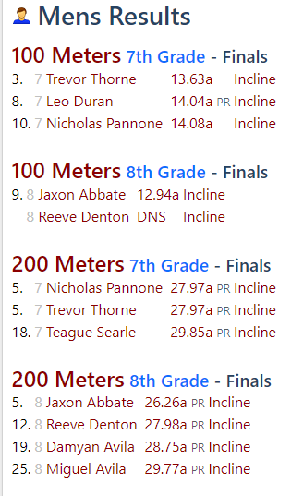

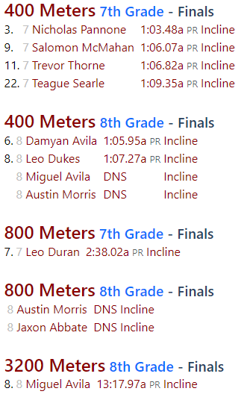
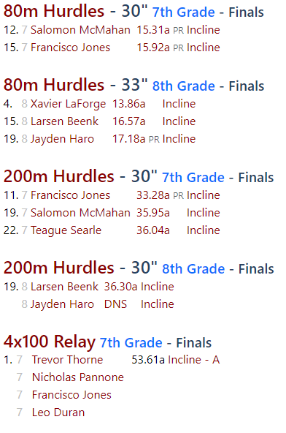
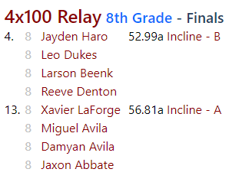

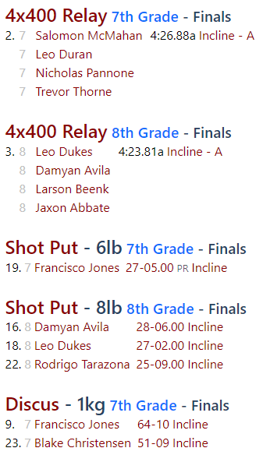
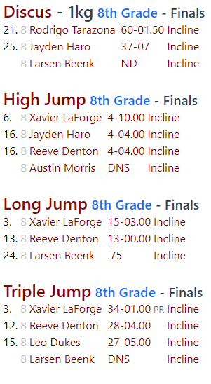
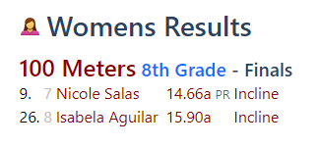

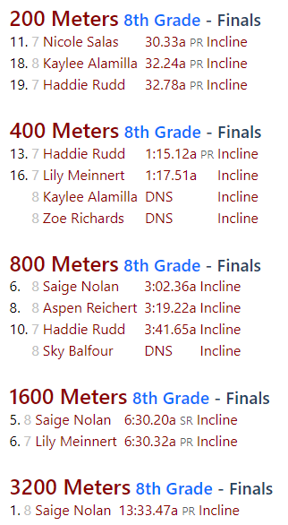
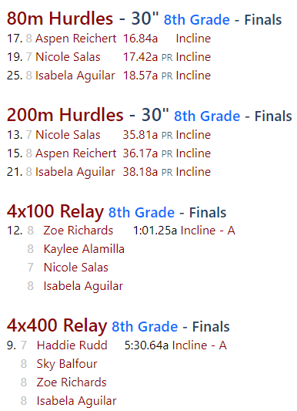
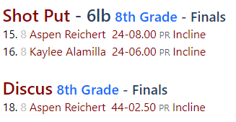
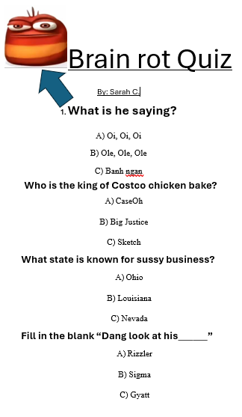
What Are You Doing This Summer?
by Mya Miller
Jayden: I’m going to Wyldlife camp.
Misha: STEM camps.
Aspen: The beach and volleyball.
Sierra: Sleep.
Kaylee: Going to the beach and playing volleyball.
Maria: Going to the water park.
Sky: Eating Maria.
Isabella: Going to the beach and sleeping in.
Zoe G.: Going to the beach and playing volleyball.
Zoe R.: Doing bucket lists with friends.
Ashlyn: Mountain biking.
Justine: Going to France
Alva: Jazz Camp and summer football at IHS.
DJ: Huntin’, fishin’ and havin’ fun.
Emy: Traveling to Seattle and Greece, plus Silver State volleyball.
Blake: Basketball, football, swimming in the lake, and having fun with friends.
Tyler: Go to Northstar to ride downhill.
Damyan: Working and Summer football and basketball.
Kamil: Travel and meeting with family.
Jacob: Going to Las Vegas to see family.
Andres: Sleep and watch TV.
Sarah: Volleyball, soccer, and going to the beach with friends.
Byron: Camp in Sac. and practice builds in no builds.
Miley: Working for $$$
Sofia: Sleep
Nancy: Going to the beach.
Levi: Battlebots for two weeks then hibernation.
Backpack effects on your grades
by Alva and DJ
Emy doesn't care.
Blake Oblock- if u know, u know.
DJ made it stinky.
Kahea socks because he hates lockers.
Jisel- Bad!
Brian- doesn't matter.
Angel- doesn't care.
Theobedsheet wishes he had backpacks.
Mrs. Gentner doesn't agree with the rule.
Steven- bad and stupid for no reason
Reeve- so terrible
Tucker- hates it
Itzel- it’s sooooooo weird!
Sarah- annoying carrying everything.
Levi- Made it way harder to be in school and scared of being stolen from.
Alva-veeeeeeeeeeeeeeeeeeeeeeeee eeeeeeeeeeeeeeeeeeeeeeeeeeeeeeeeeeeeeeeeeeeeeeeeeeeeeeeeeeeeeeeeeeeeeeeeeery annoying.
Experience With the Newspaper
by Alva and DJ
Mr. Vaughan- It is a lot of work planning, editing, designing, formatting, copying, collating, stapling, and distributing the Fat Scoop.
Emy- She “loooooooooves” schoolwork.
Blake does not like writing articles.
DJ- Boring
Sarah- Boring sometimes
Itzel- Fun
Kyler- Chill
Steven- Good
Mrs. Gentner- 8/10
Theo- Good job!
Mr. G- Yeah, a good job for a middle schooler.

Favorite School Jokes for Kids

1. What is a snake’s favorite subject in school?
Hisssssstory

2. Which school supply is king of the classroom?
A ruler

3. What is a witch’s favorite subject in school?
Spelling

4. What do elves learn in school?

The elf-a-bet

5. Why are fish so smart?

Because they live in schools.

6. Why did the kid eat his homework?

Because she said it was a pice of cake.

7. What did one pencil say to the other on the first day of school?

You are looking sharp.

8. How many letters are in the alphabet?

11: T-H-E-A-L-P-H-A-B-E-T

