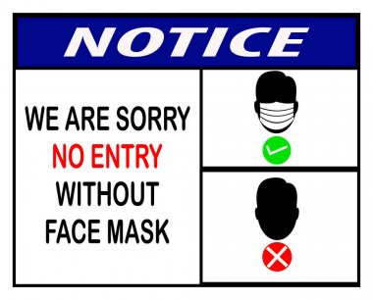** Date:** August 24, 2021

**Back to School Night**

**Time:** 5:30-7:00pm

**Where:** Silver Lake Elementary School

Reno, NV 89506

**Schedule of Events:**

5:30-5:55pm Meet your child’s teacher- Session#1

5:55-6:00pm Transition to classroom

6:00-6:25pm Meet your child’s teacher- Session#2

6:25-6:30pm Transition to classroom

6:30-6:55pm Meet your child’s teacher- Session#3

6:55-7:00pm Thanks for Coming!

We will be having three sessions during the evening for families who have more than one child, or for those who cannot make it to the first session.