**3.1 Notes: Reflections**

**Objectives:**

* **Students will be able to reflect objects over each axis.**
* **Students will be able to reflect objects over horizontal and vertical lines.**
* **Students will be able to identify transformations that are reflections.**

**Exploration:** Use the following link to explore reflections: <https://www.geogebra.org/m/EMJVYA7K>

* Click on the boxes to show the Original, the Reflect, and the Mirror Line.
* Move the points and the mirror line around.
* What do you notice?
* Compare and contrast the original shape and its reflection. What is the same? What is different?

|  |  |  |
| --- | --- | --- |
| **Transformation** | A transformation is when a shape is ___________, resulting in an image. There are four main types of transformations. | 1)  2)  3)  4) |
| **Reflection** | A reflection is a type of transformation where a shape is ___________ over a line. |  |
| **Pre-Image and Image** | The pre-image is the original shape ___________ the transformation.  The image is the shape _____________ the transformation. | Notation:  Pre-Image Image |

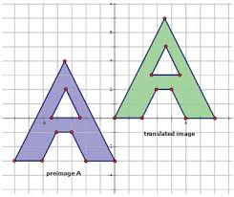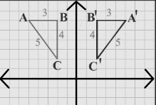**Example 1:** Which options below show a reflection? Select all that apply.

A) B) C)

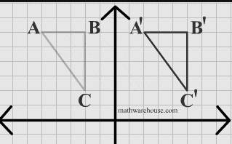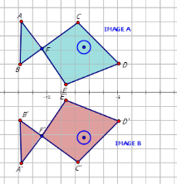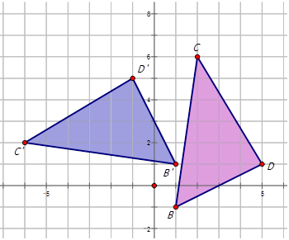D) E) F)

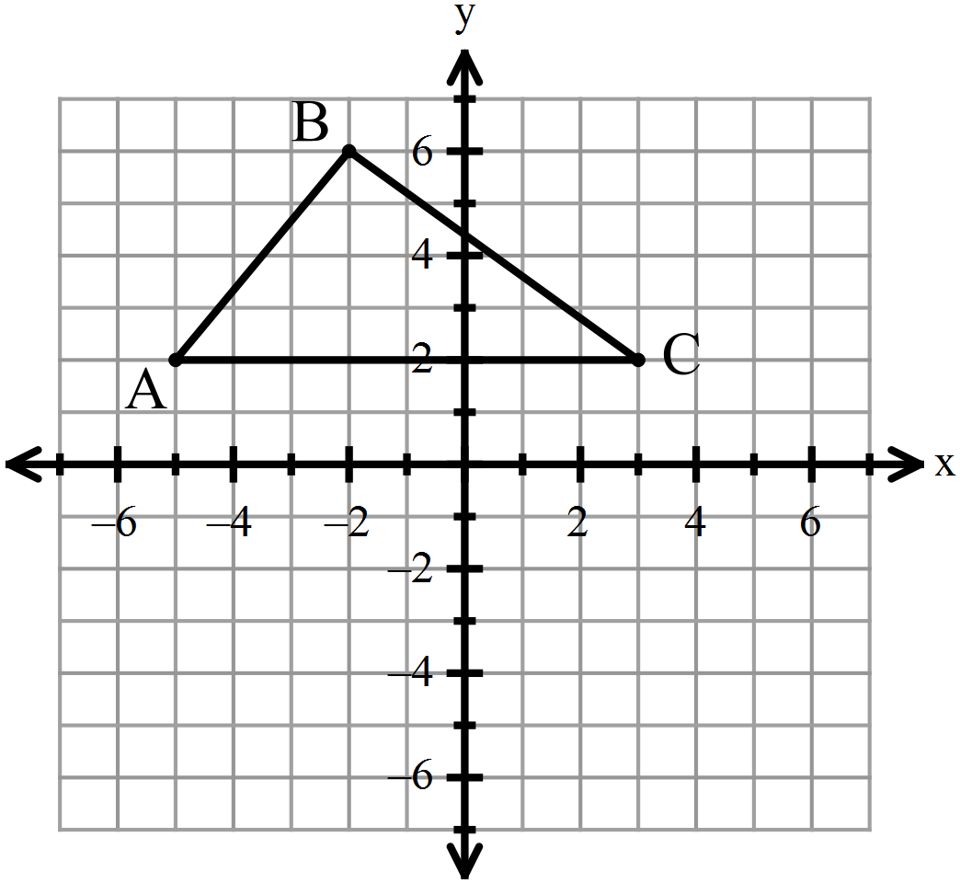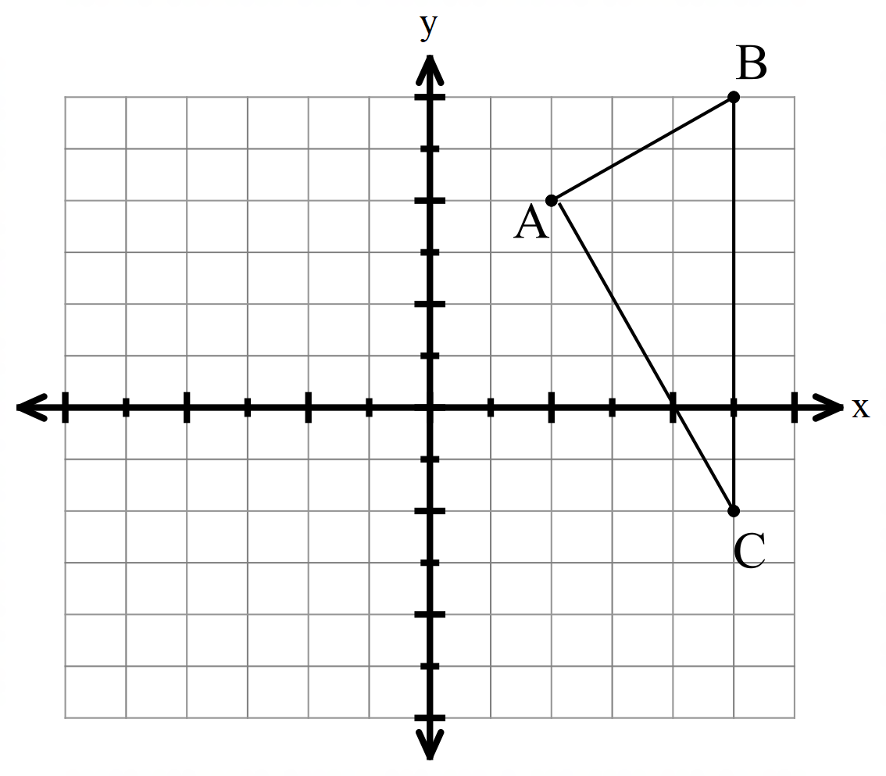**Example 2:** Reflect the given figure in the *x*-axis. **Example 3:** Reflect the given figure in the *y*-axis.

**Look for a pattern!** Compare the coordinates of each pre-image and image.

Make a conjecture about reflecting in the *y*-axis:

**Look for a pattern!** Compare the coordinates of each pre-image and image.

Make a conjecture about reflecting in the *x*-axis:

Compare the images and pre-images for #2 and 3.

Because the image triangles are the same _______________ and same _______________ as the pre-images , we can say that any reflection is a **RIGID TRANSFORMATION.**

**Reminder of graphing horizontal and vertical lines:**

|  |  |  |
| --- | --- | --- |
|  | **Equation** | **Graph** |
| **Horizontal Lines** |  |  |
| **Vertical Lines** |  |  |

*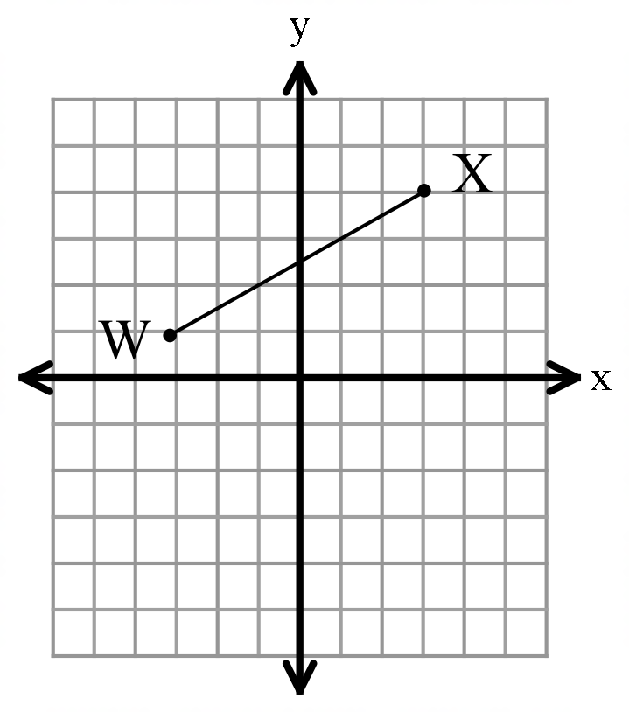***Example 4:** Reflect the shape in **Example 5:**Reflect the shape in the

**Find** the coordinates of each image.

**Find** the coordinates of each image.

**You Try # 6 – 9:**

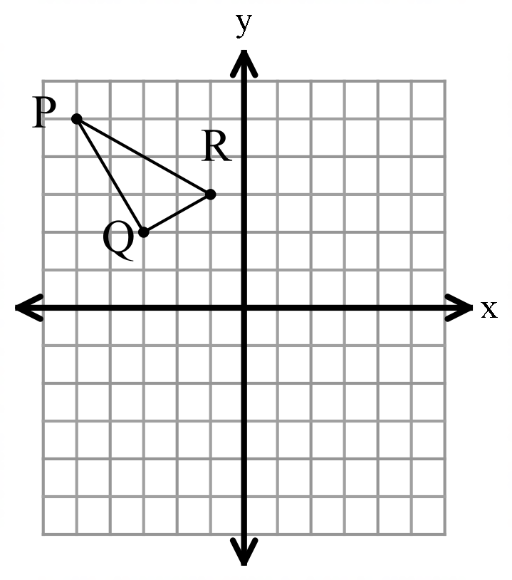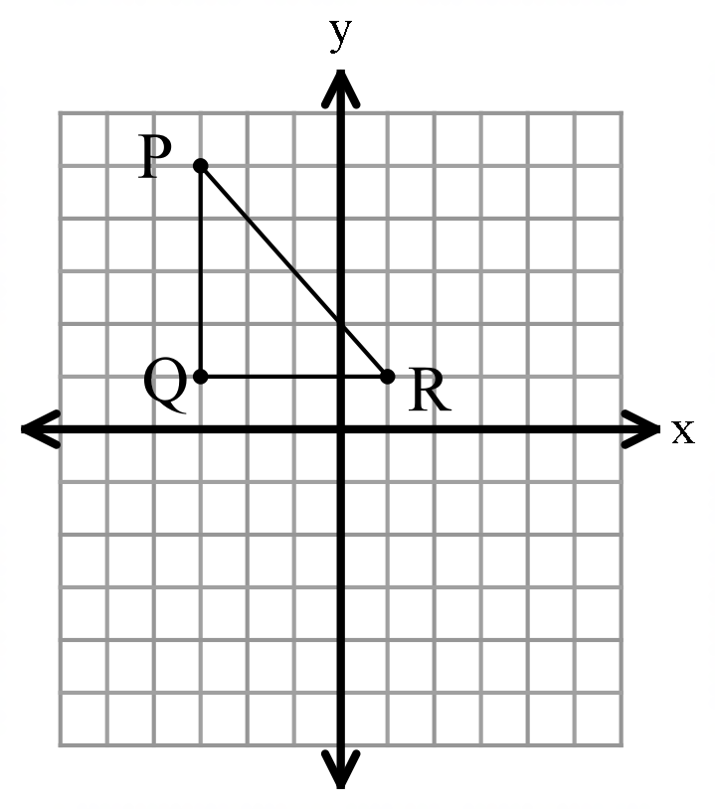**Example 6:** Reflect the shape in the *y*-axis. **Example 7:** Reflect the shape in the *x*-axis.

**Find** the coordinates of each image.

**Find** the coordinates of each image.



*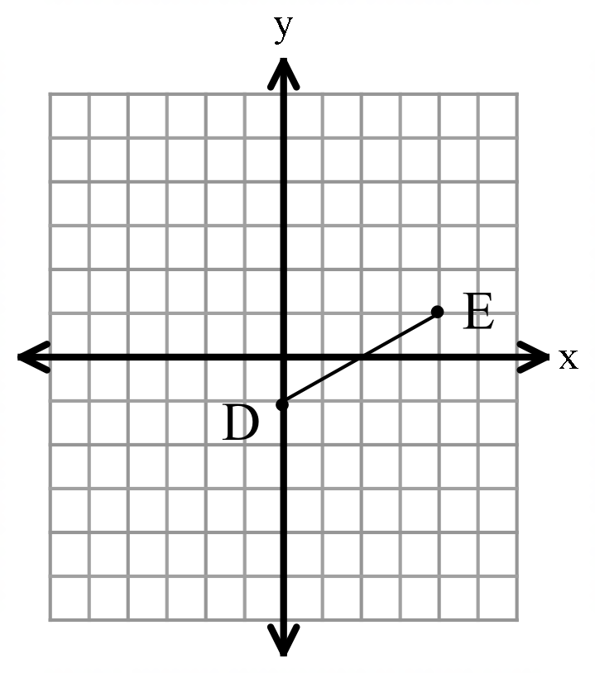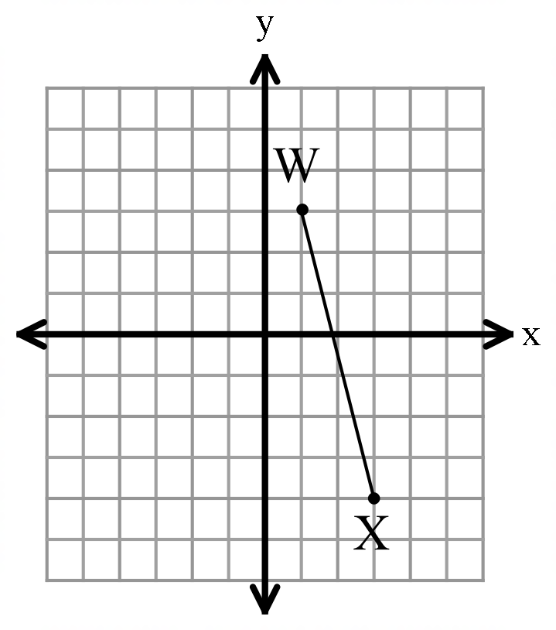***Example 8:** Reflect the shape over *x* = 3. **Example 9:** Reflect the shape over .

**Find** the coordinates of each image.

**Find** the coordinates of each image.

**3.2 Notes: Translations**

**Objectives:**

* **Students will be able to translate objects along a vector.**
* **Students will be able to use both vector and coordinate notation for translations.**
* **Students will be able to identify transformations that are translations.**

**Exploration:** Use the following link to explore translations: <https://www.geogebra.org/m/kyHR7c4c>

* Move the arrow around, and also move around points A, B, and C.
* Move the points and the mirror line around.
* What do you notice?
* Compare and contrast the original shape and its image. What is the same? What is different?

|  |  |  |
| --- | --- | --- |
| **Translation** | A **translation** is a _____________ motion where the coordinates are moved according to a set pattern, called a vector. | Translations ( Read ) | Geometry | CK-12 Foundation |
| **Vector** | A **vector** is a method of communicating how ____- and _____- coordinates change for a translation. | means  means |

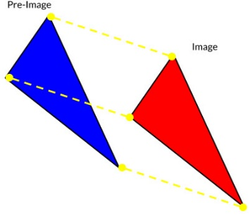

**Example 1:** Which options below show a translation? Select all that apply.

A) B) C)

D) E) F)

**Example 2: Example 3:**

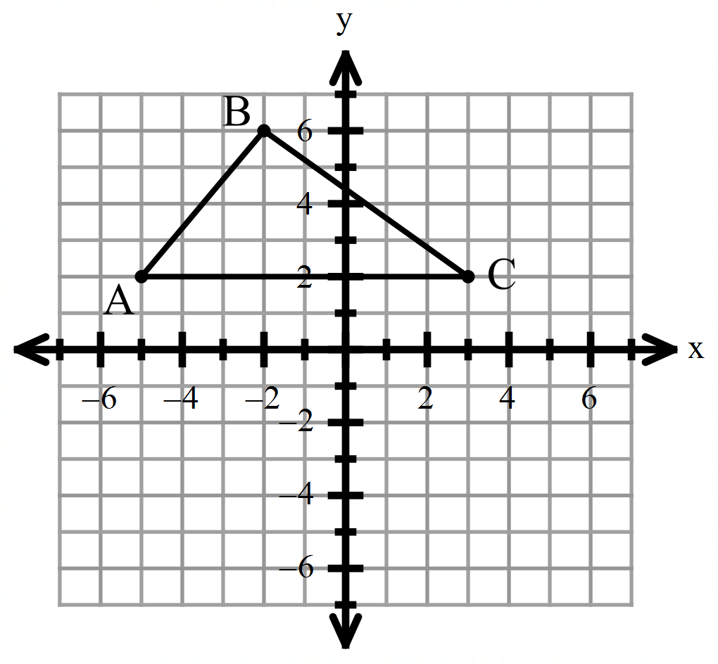Translate the given figure along Translate the given figure along

**Find** the coordinates of each image.

**Find** the coordinates of each image.

**Example 4: Example 5:**

Write the translation vector for Write the translation vector for

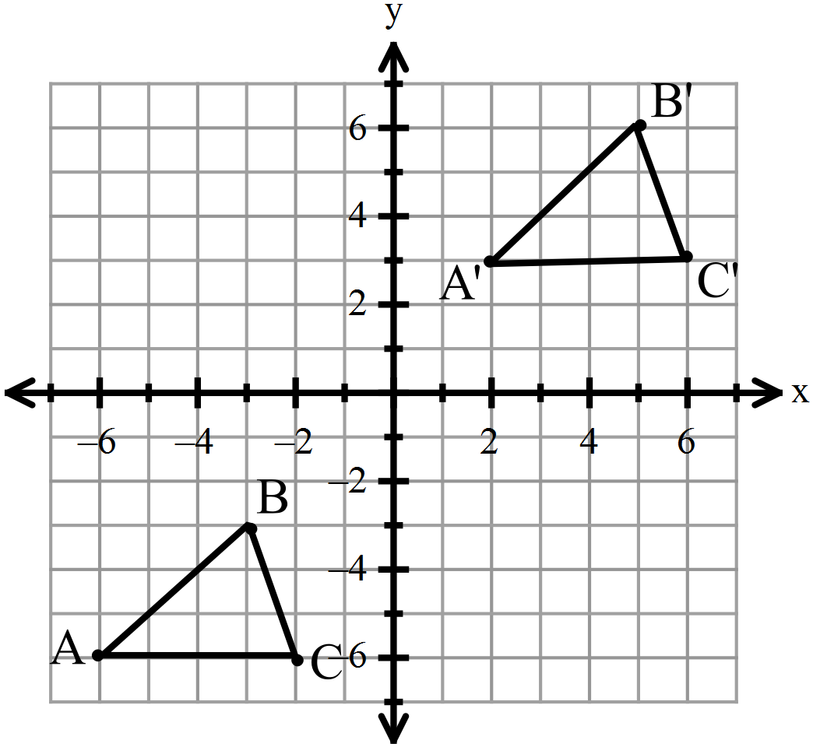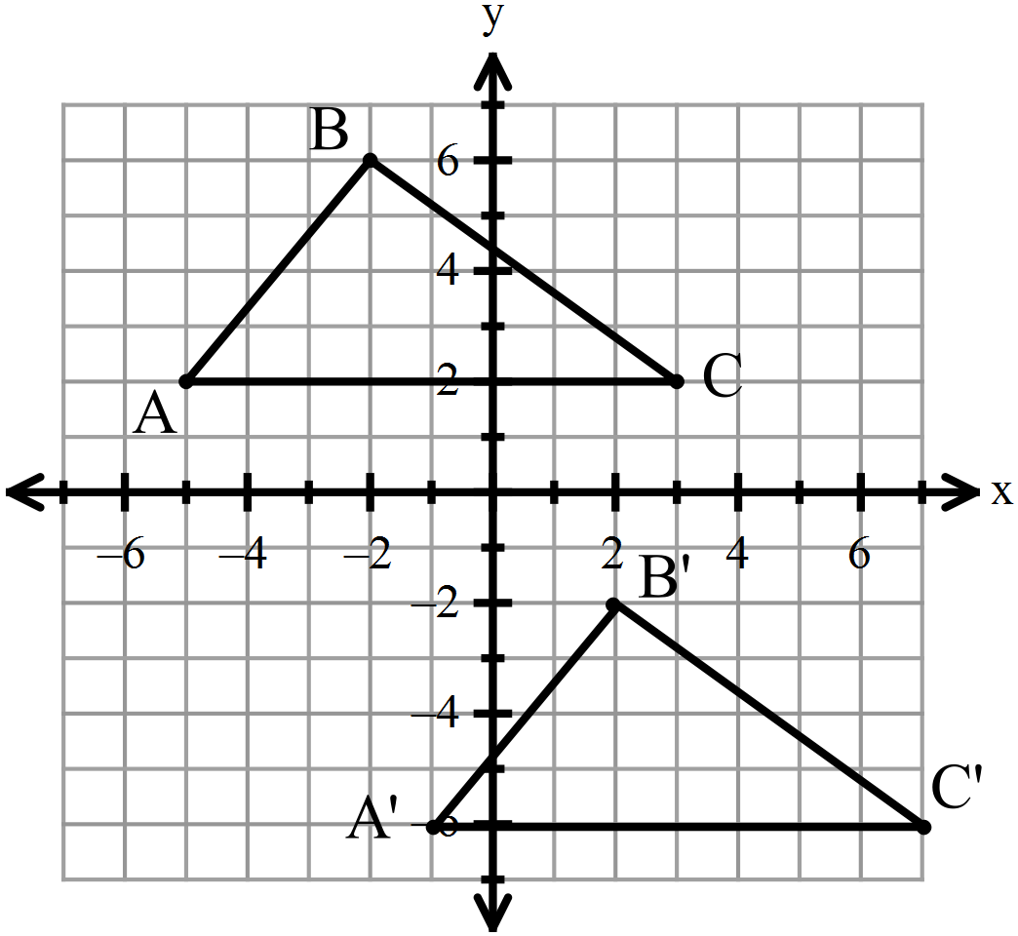

A’

B’

C’

|  |  |  |
| --- | --- | --- |
| **Coordinate Notation** | **Coordinate Notation** is a method of communicating how ____- and _____- coordinates change for a translation. | means  means |

**Example 6:** Describe the movements for the following translation: .

**Example 7**: Translate the given figure along **Example 8**: Write the translation (in

. **coordinate form)** for the movement shown.

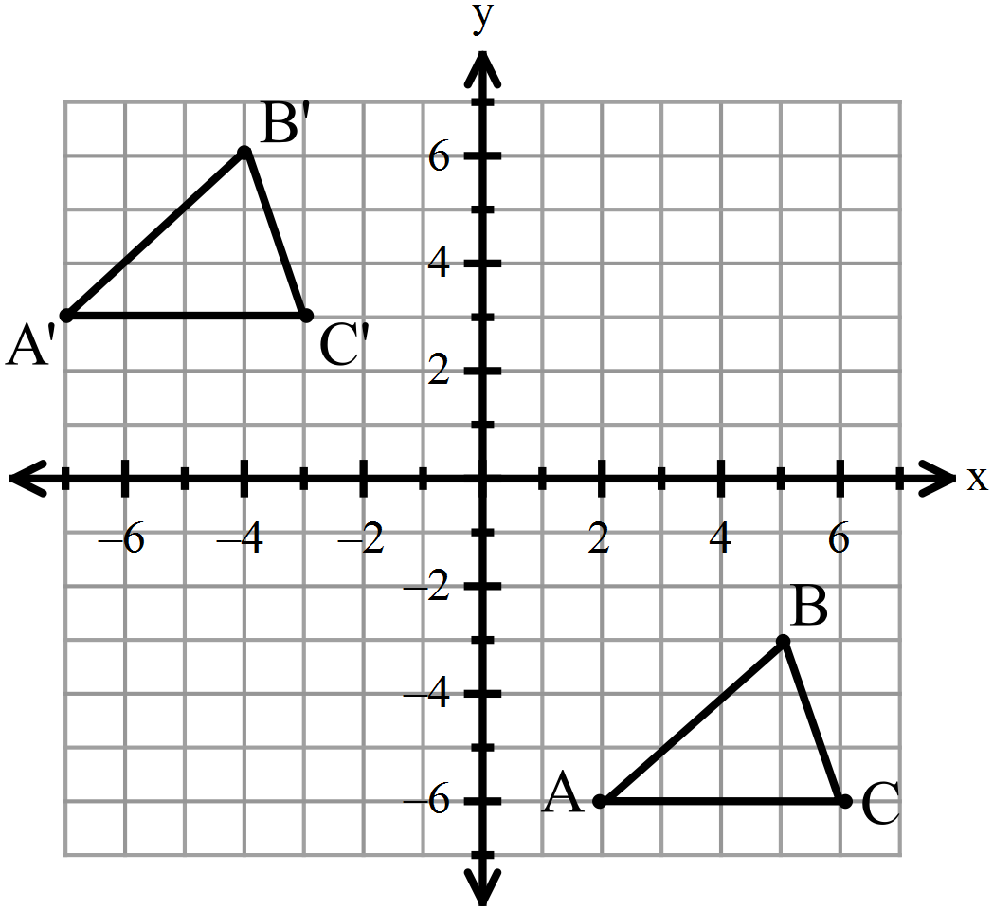

**Find** the coordinates of each image.

**Example 9:** Multiple Choice: Why is a *translation* a rigid transformation?

A) Because the rules are strict and must be followed for translations.

B) Because the image and the pre-image are the same size and shape.

C) Trick question! A translation is not a rigid transformation.

**Challenge Problem!**

**Note:** If more than one transformation is performed on a point , then the image after the first transformation is ; the image after the second transformation is , and so forth.

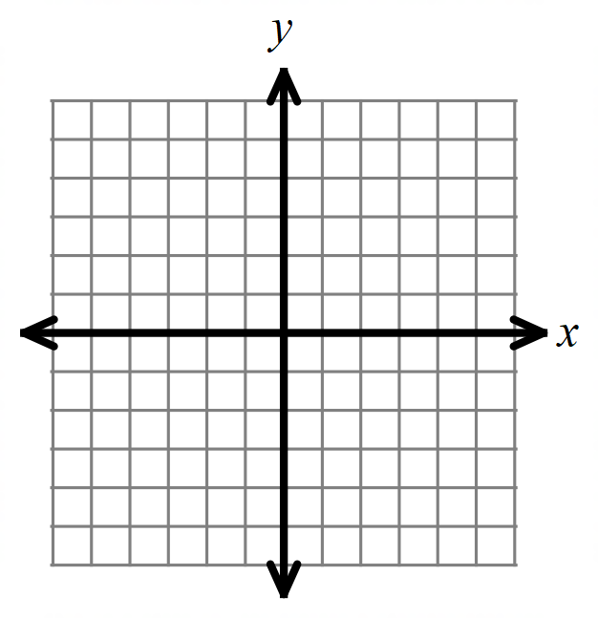Point is reflected in the *x*-axis, and then translated along the vector **. What are the coordinates for after both transformations?**

**3.3 Notes: Rotations**

**Objectives:**

* **Students will be able to rotate shapes around the origin.**
* **Students will be able to identify transformations that are rotations.**

**Exploration:** Use the following link to explore rotations: <https://www.geogebra.org/m/Bp9F8dJ8>

* Move the coordinates of triangle ABC around.
* Compare the coordinates for each pre-image and image.
* What do you notice?
* Compare and contrast the original shape and its image. What is the same? What is different?

|  |  |  |
| --- | --- | --- |
| **Rotation** | A **rotation** is a _______________ motion where each point is turned the same direction and number of degrees. | Representing Transformations as Compositions | Study.com |
| **Clockwise Rotation** | A **clockwise rotation** is when the pre-image is turned in the ___________ direction as the hands of a clock (to the right.) |  |
| **Counter- Clockwise Rotation** | A **counter-clockwise rotation** is when the pre-image is turned in the ________________ direction as the hands of a clock (to the left.) |
| **Angle of Rotation** | The **angle of rotation** is the number of degrees that a shape is turned about the origin. | Common angles of rotation:  90 degrees  180 degrees  270 degrees |

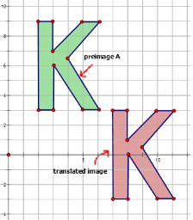**Example 1:** Which transformations below show a rotation? Select all that apply.

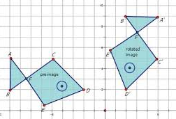 A) B)

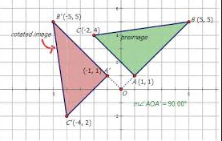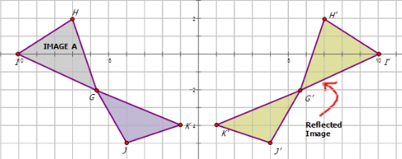 C) D)

**How to find the image of a rotation about the origin:**

**Examples #2 – 7:** For each rotation about the origin, find the image. Note: CCW means “counter-clockwise”

You try #4!

2) 90clockwise 3) 90 clockwise 4) 90 clockwise

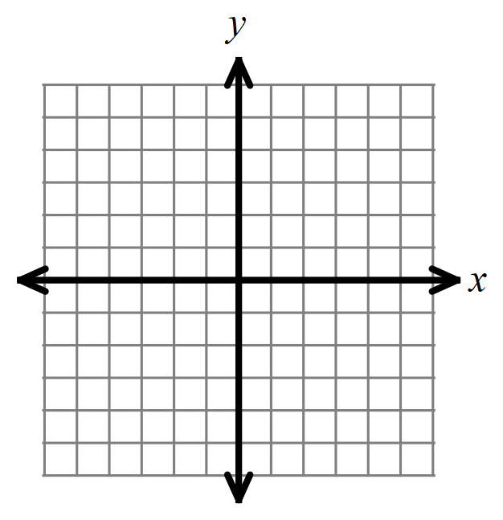

You try #7!

5) 90 CCW 6) 90CCW 7) ; 90CCW

********

**Examples #8 – 13:** For each rotation about the origin, find the image. Note: CCW means “counter-clockwise”

**You try #10!**

8) 180clockwise 9) 180 CCW 10) 180 clockwise

**You try #13!**

11) 270 clockwise 12) 270CCW 13) ; 270CCW

********

**Challenge problem!** Given the point ; first reflect in the *y*-axis; then, translate along the vector , rotate 90 degrees clockwise about the origin. Find the location of

**3.4 Notes: Parallel Lines and Angle Relationships**

**Objectives:**

* **Students will be able to identify angle pair relationships.**
* **Students will be able to solve problems with parallel lines.**

|  |  |  |
| --- | --- | --- |
| **Parallel Lines**  **//** | If two lines are **parallel**, then they are ______________ and do not _______________. |  |
| **Transversal** | A **transversal** is a line that ____________ two or more lines. | Corresponding Angles ( Read ) | Geometry | CK-12 Foundation  There are 4 pairs of corresponding angles in this diagram: |
| **Corresponding Angles** | If two angles are **Corresponding Angles**, then they are in the same _____________ for each point of intersection of a line and the transversal. |

**Exploration:** Use the following link to explore corresponding angles with parallel lines: <https://www.geogebra.org/m/Fr28hJcc>

* Move the slider and the colored lines around.
* Check on boxes to see all the different pairs of corresponding angles.
* What do you notice? Make a conjecture about corresponding angles formed by parallel lines.

|  |  |  |
| --- | --- | --- |
| **Corresponding Angles Theorem** | If _______________ lines, then **Corresponding Angles** are _______________. | Corresponding Angles ( Read ) | Geometry | CK-12 Foundation |

**Examples 1 – 2:** For each example, given that *a* // *b*, find the value of each missing angle.

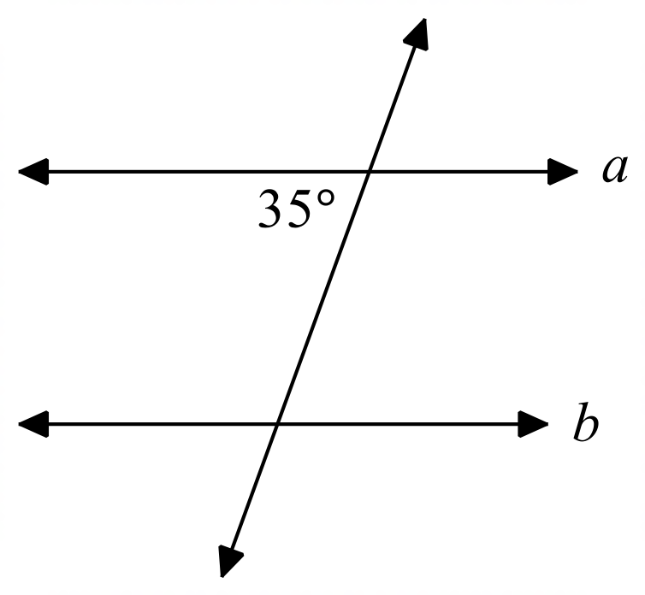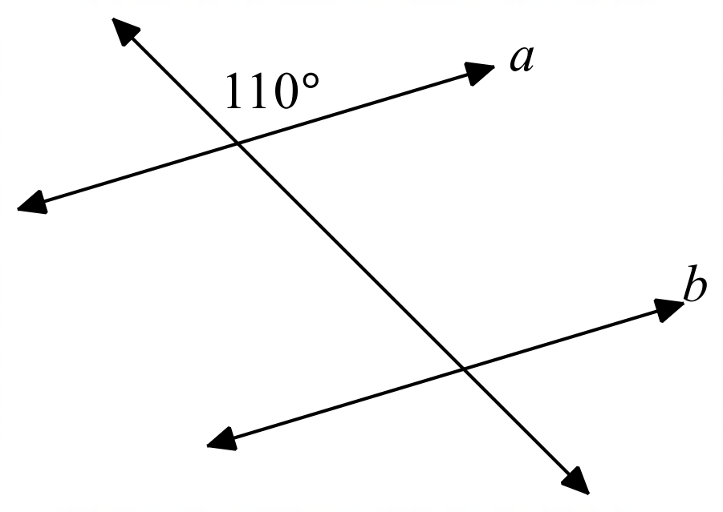 **You try #2!**

1) 2)

***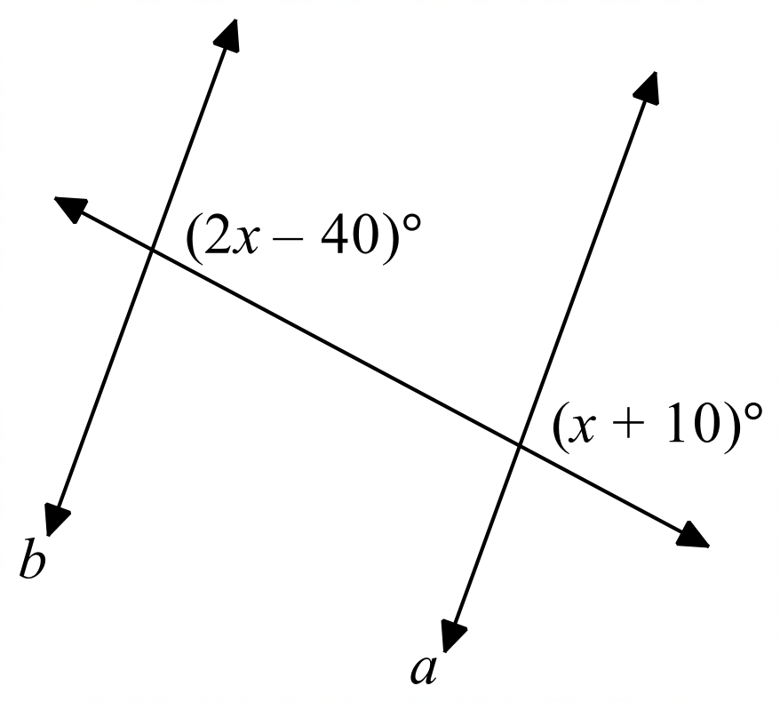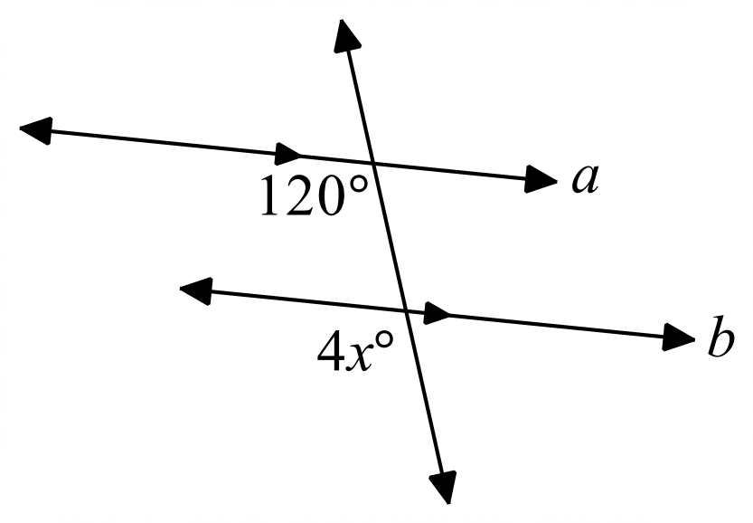*Examples 3 – 6:** Find the value of the variable, given that *a* // *b*.

3) 4)

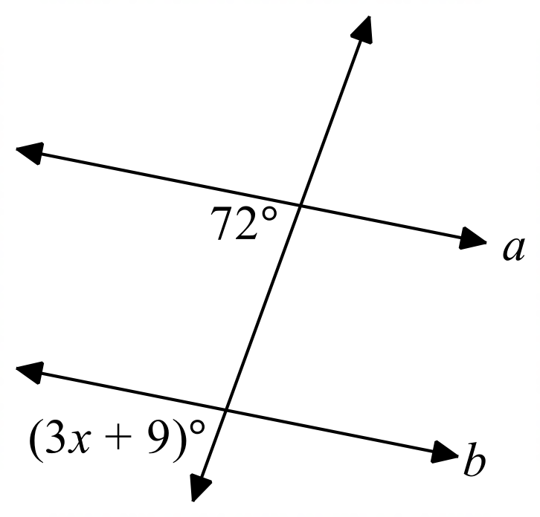 **You try #5 – 6!**

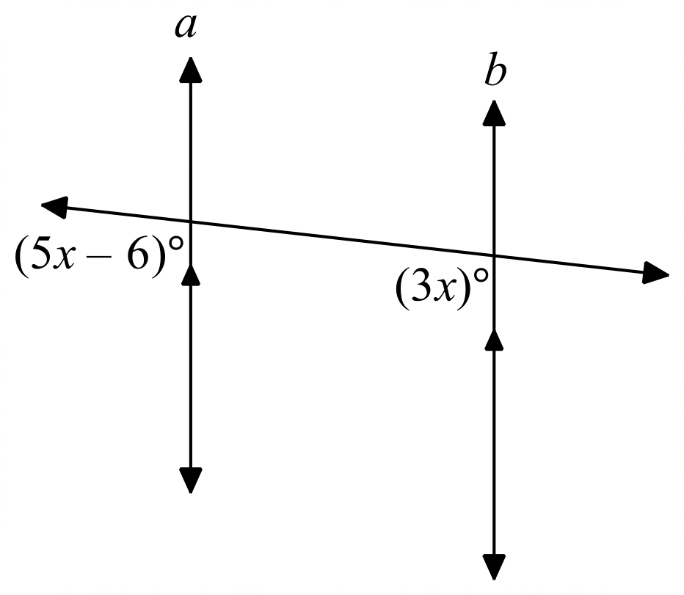 5) 6)

|  |  |  |
| --- | --- | --- |
| **Alternate Interior Angles** | If two angles are Alternate Interior Angles, then they are nonadjacent interior s that lie on ___________ sides of the transversal *t*. | Corresponding Angles ( Read ) | Geometry | CK-12 Foundation |
| **Alternate Interior Angle Theorem** | If _______ lines, then Alternate Interior Angles are _________. |

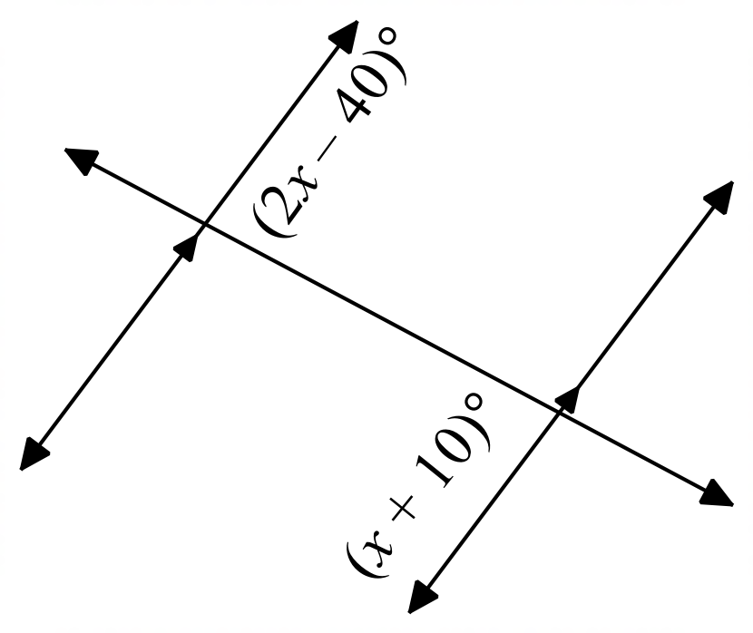**For #7 – 10, find the value of the variable.**

7) 8)

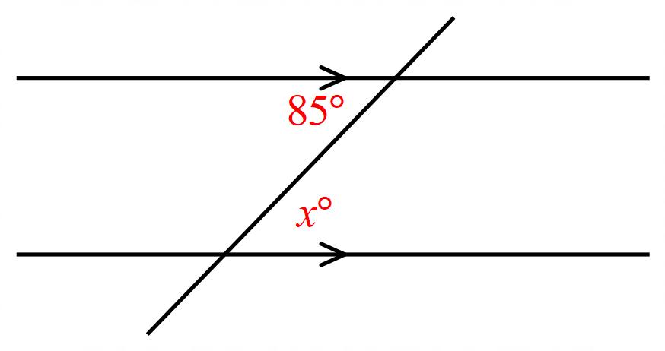

**You try #9 – 10!**

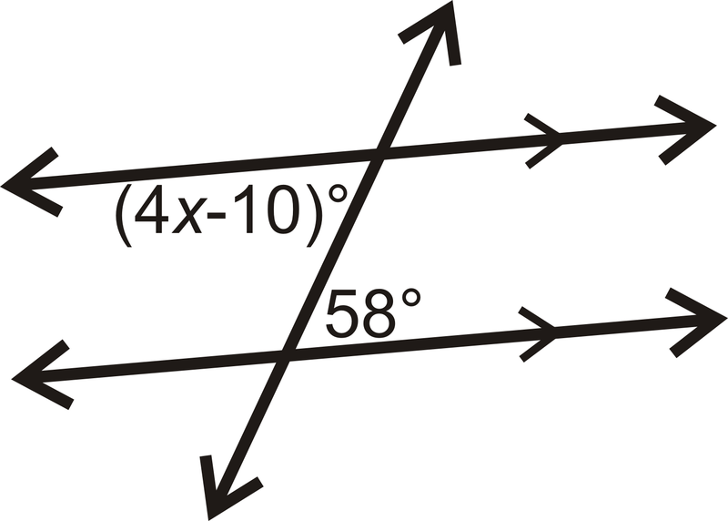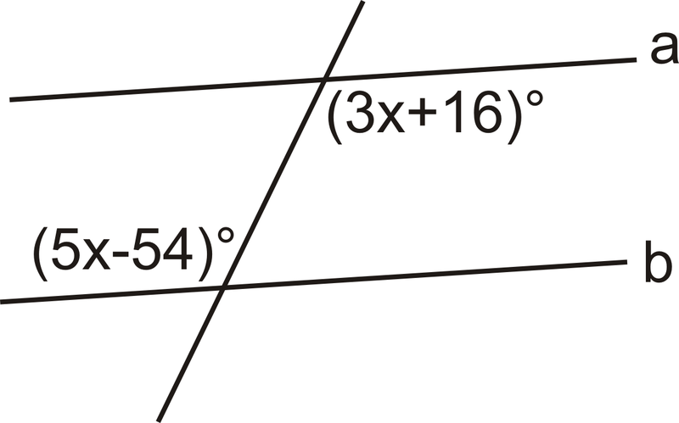9) Given that *a* // *b.*  10)

|  |  |  |
| --- | --- | --- |
| **Consecutive Interior Angles** | If two angles are Consecutive Interior Angles, then they are interior s that lie on the same _________ of the transversal *t*. | Corresponding Angles ( Read ) | Geometry | CK-12 Foundation |
| **Consecutive Interior Angles Theorem** | If _________ lines, then consecutive interior angles are ______________________. |

**Example #11:** Identify each pair of angles as alternate interior, corresponding, or consecutive interior.

|  |  |  |  |  |  |
| --- | --- | --- | --- | --- | --- |
| a. |  | b. |  | c. |  |

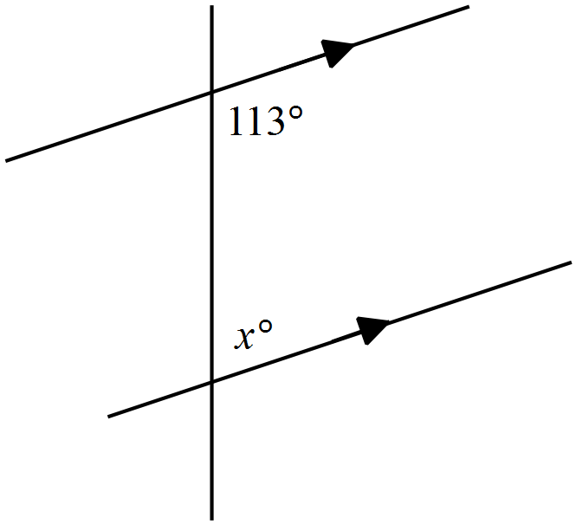**For #12 – 14, find the variable(s) in each diagram.**

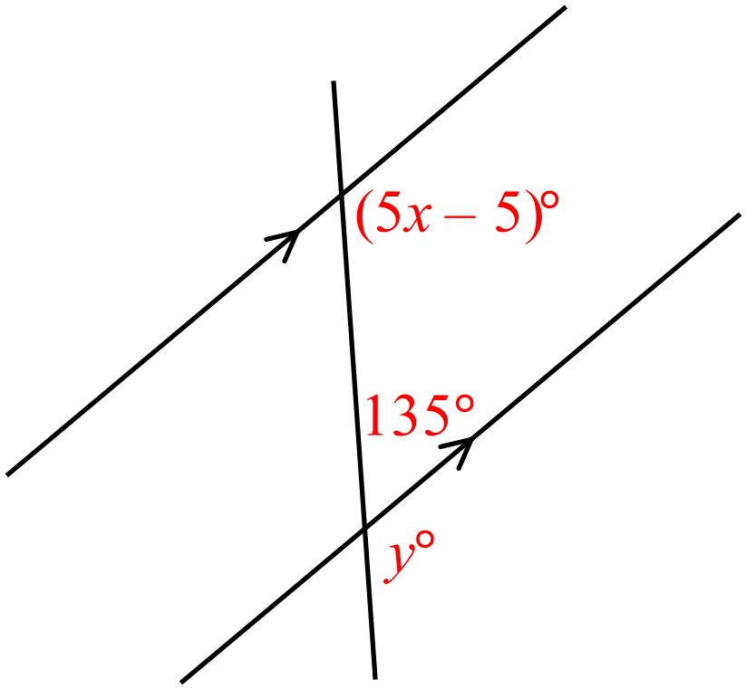

12) 13)

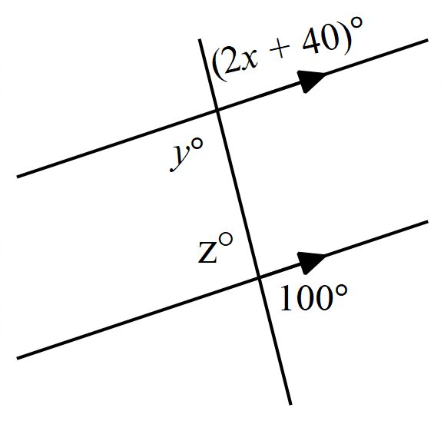

14)

**3.5 Notes: Proofs with Parallel Lines and Transversals**

|  |  |  |
| --- | --- | --- |
| If two**parallel lines**are cut by a transversal, then the following are true: | | |
| **Corresponding Angles Postulate** | If ∥ lines , then Corresponding are ____________ |  |
| **Alternate Interior Angles Theorem** | If ∥ lines, then Alternate Interior are __________ |  |
| **Consecutive Interior Angles Theorem** | If ∥ lines, then Consecutive Interior are _____________________ |  |

|  |  |  |  |  |  |  |  |  |  |  |  |  |  |  |  |  |  |  |  |  |  |  |  |  |  |  |  |  |  |  |  |  |  |  |  |  |  |  |  |  |  |  |  |  |  |  |  |  |  |  |  |  |  |  |  |  |  |  |
| --- | --- | --- | --- | --- | --- | --- | --- | --- | --- | --- | --- | --- | --- | --- | --- | --- | --- | --- | --- | --- | --- | --- | --- | --- | --- | --- | --- | --- | --- | --- | --- | --- | --- | --- | --- | --- | --- | --- | --- | --- | --- | --- | --- | --- | --- | --- | --- | --- | --- | --- | --- | --- | --- | --- | --- | --- | --- | --- |
| |  |  |  | | --- | --- | --- | | **Example #1:** Choose the correct reason for Step 2.  Given:  Prove: | |  | | **Statement** | **Reason** | | | | 1. | 1. Given | | | | 2. | 2. | | |     A) If two lines are parallel, then corresponding angles are congruent.  B) If two lines are parallel, then alternate interior angles are congruent.  C) If two lines are parallel, then alternate exterior angles are congruent.  D) If two lines are parallel, then consecutive interior angles are supplementary.  **Example #2:** Choose the correct reason for Step 2.   |  |  |  | | --- | --- | --- | | Given:  Prove: | |  | | **Statement** | **Reason** | | | | 1. | 1. Given | | | | 2. | 2. | | |     A) If two lines are parallel, then corresponding angles are congruent.  B) If two lines are parallel, then alternate interior angles are congruent.  C) If two lines are parallel, then alternate exterior angles are congruent.  D) If two lines are parallel, then consecutive interior angles are supplementary.   |  |  |  | | --- | --- | --- | | **Converse of Corresponding ∠s Postulate** | If corresponding angles are ______________, then // lines |  | | **Converse of Alternate Interior ∠s Theorem** | If alternate interior angles are______________, then // lines |  | | **Converse of Consecutive Interior ∠s Theorem** | If consecutive interior angles are______________, then // lines |  |   **Example #3**: Provide the reason for Step 2.   |  |  | | --- | --- | | Given: |  | | Prove: | | **Statement** | **Reason** | | 1. | 1. | | 2. | 2. |   **Example #4**: Provide the reason for Step 2.   |  |  | | --- | --- | | Given: |  | | Prove: | | **Statement** | **Reason** | | 1. | 1. | | 2. | 2. | |  |

**3.6 Writing Equations of Lines**

**Objectives:**

* **Students will be able to analyze the slope of a line.**
* **Students will be able to write a line equation in form that are parallel and perpendicular.**

|  |  |  |
| --- | --- | --- |
| **Slope formula** |  |  |

**slope**

Name all the ways that you know to define the slope between the points.

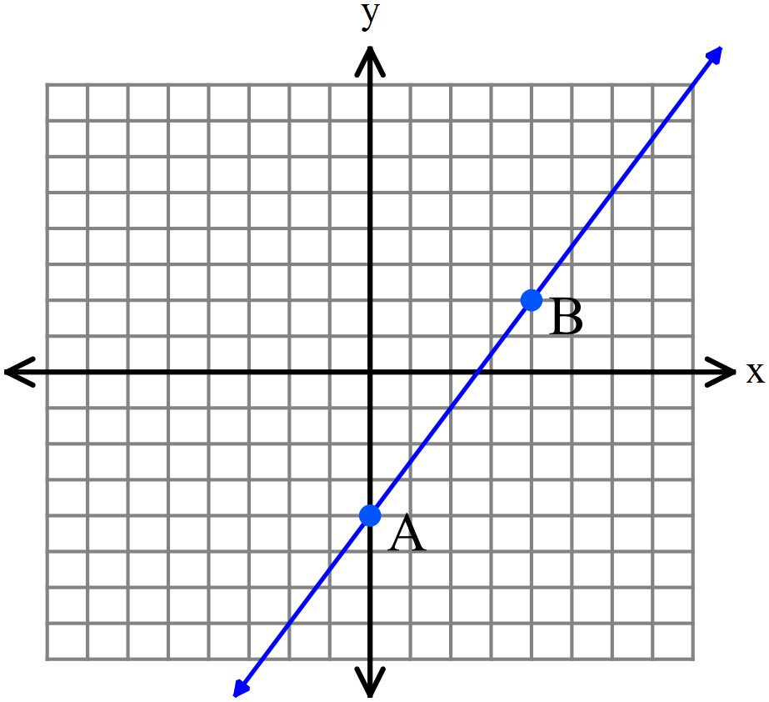

Oof, this is steep!



|  |  |  |
| --- | --- | --- |
| **Slope-Intercept Form of a line** |  | is the ________ of the line.  is the ______-_________________ of the line. |
| **(h,k) form of a linear equation** |  | is the ________ of the line.  is an _____________ _________ of a point on the line. |
| **Slope of parallel lines** | Parallel lines have the ________ slope. |  |
| **Slope of perpendicular lines** | Perpendicular lines have  ­___________ __________ slopes. |  |

**slope of parallel lines**

What does it mean to have two **parallel** lines?

**Example #1:** The equations of four lines are given. Identify which lines are parallel. Choose all that apply.

|  |  |  |
| --- | --- | --- |
| **Example #2:** Write the equation of each line that is described. Write your final answer in () form. | | |
| a. | Slope of 3 and passes through the point . | |  |
| b. | Parallel to the line and passes through the point . | |  |
| **Challenge:** | | Write the equation of the line that passes through and is parallel to the graph of the line that passes through the points and ? |  |

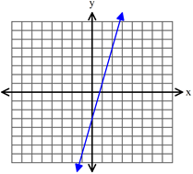**Example #3:** Which of the following equations describes a line parallel to the line graphed? Choose all that apply.

**Slope of perpendicular lines**

What does it mean for lines to be ***perpendicular***?

|  |  |  |  |  |
| --- | --- | --- | --- | --- |
| **Example #4**: Which of the following pair of equations describes perpendicular lines? | | | | |
| |  |  |  |  |  | | --- | --- | --- | --- | --- | | **I.** |  | **III.** |  | | | **II.** |  | **IV.** |  | | |  | |
|
|
| **Example #5:** Write the equation of each line in form. | | | | |
| a. | Perpendicular to the line and passes through the point . | | | |
| b. | Perpendicular to the line and passes through the point | | | |
| **Example #6**: What is the equation of the line perpendicular to line that passes though point ?  A) B)  C) D) | | |  | |