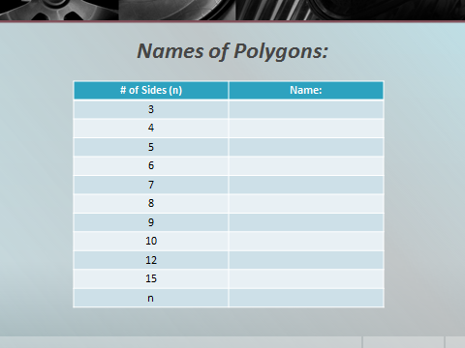**6.1 Notes: Polygons and Angles**

**Polygon**

**Regular polygon**

**Convex polygon Concave polygon**

**The sum of the interior angle measures** of an n-sided convex polygon is:

**Example 1:** Find the sum of the measures of the interior angles in a decagon.

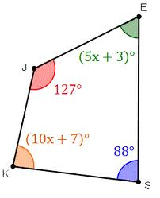

**Example 2:** Find the measure of each angle in the polygon shown.

The measure of one interior angle in a REGULAR polygon is:

**The sum of the exterior angle measures** of a convex polygon, one at each vertex :

The measure of **one exterior angle in a REGULAR polygon is:**

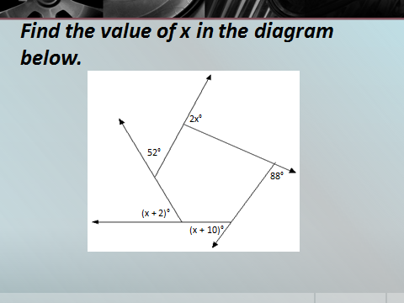Example 3: Find *x* in the diagram shown.

Example 4: Find the measure of each exterior angle of a regular dodecagon.

Example 5: Find the number of sides of a regular polygon with each interior angle having a measure of 108°

**6.2 Notes: Properties of Parallelograms**

**Definition of a Parallelogram:**

If a quad is a parallelogram, then both pairs of opposite sides are parallel.

**Properties of Parallelograms**

|  |  |  |
| --- | --- | --- |
|  | Property | Diagram |
| 1 | If a quad is a parallelogram, then opposite sides are congruent. |  |
| 2 | If a quad is a parallelogram, then opposite angles are congruent. |  |
| 3 | If a quad is a parallelogram, then consecutive angles are supplementary. |  |
| 4 | If a quad is a parallelogram, then diagonals bisect each other. |  |

**Work in groups to prove the two properties your teacher assigns to you. Hint: use the definition of a parallelogram to start each proof.**

**Theorem: If one angle of a parallelogram is a right angle, then all four angles are right angles.**

Why is this so? Explain your answer in words.

**Theorem: The diagonals of a parallelogram divide the parallelogram into congruent triangles.** Show why this theorem is true.

Example 1: Find each variable if the quad shown is a parallelogram. Exact answers only.

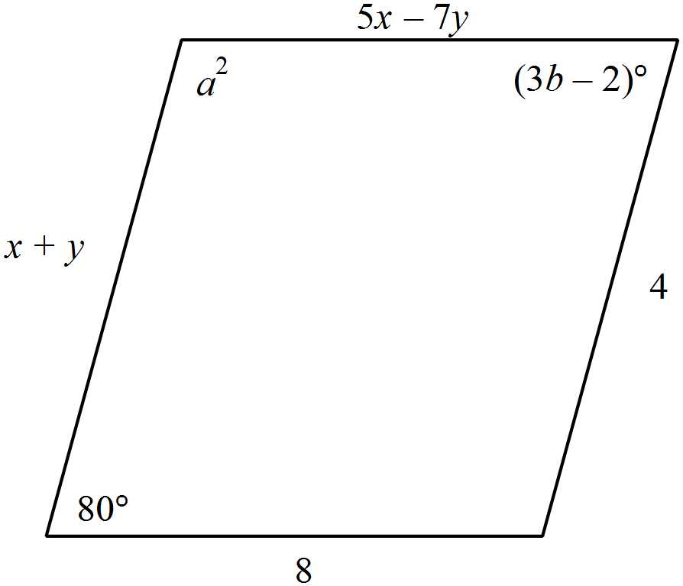

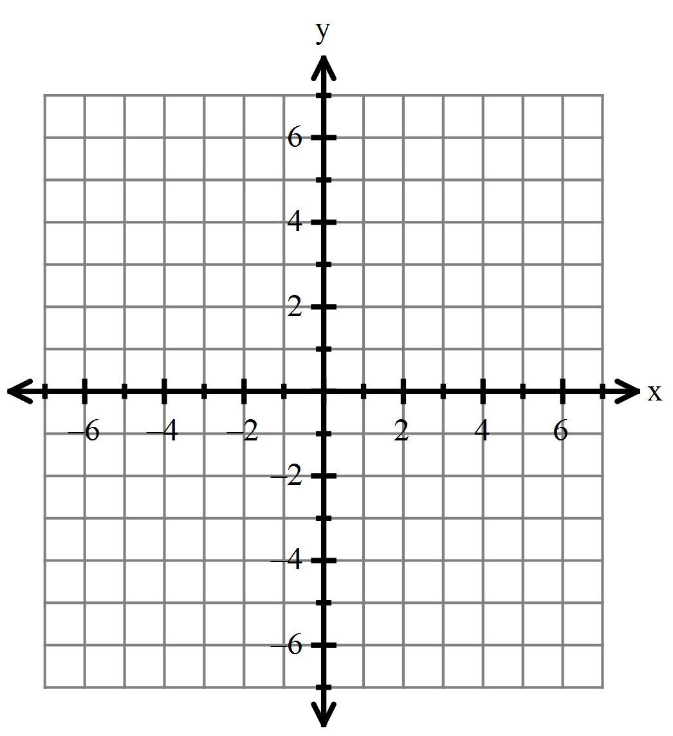

Example 2: Determine the coordinates of the missing vertex of

parallelogram ABCD with vertices A(-4, 3), B(5, 6), C(4, -2).

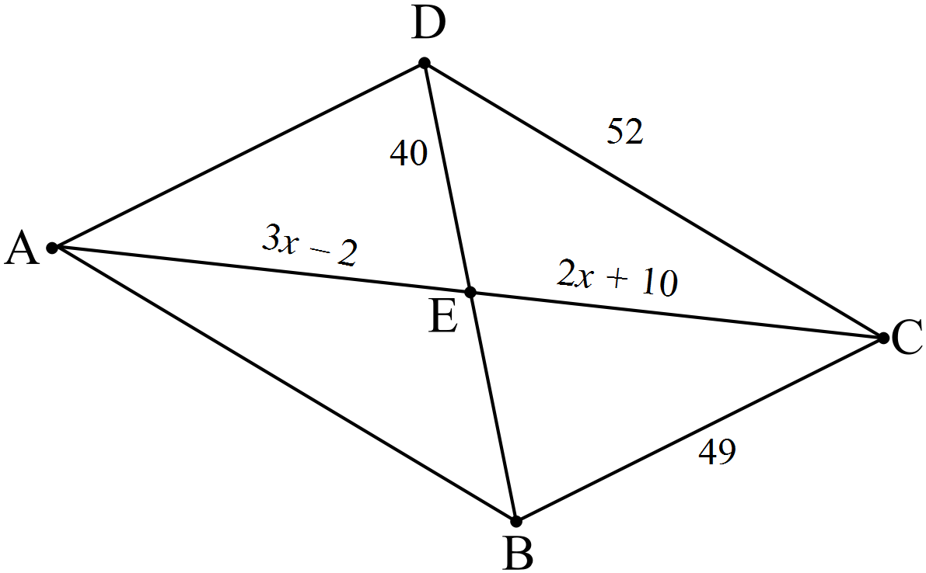Example 3: Find the perimeter of if ABCD is a parallelogram.

**6.3 Notes: Tests for Parallelograms**

**To prove that a quadrilateral is a parallelogram, use one of the following theorems.**

1. If a quad has *both* pairs of opposite sides _________________, then it is a parallelogram.
2. If a quad has *both* pairs of opposite sides __________________, then it is a parallelogram.
3. If a quad has *both* pairs of opposite angles _________________, then it is a parallelogram.
4. If a quad has *all* pairs of consecutive angles _________________, then it is a parallelogram.
5. If a quad has diagonals that _______________ _____________ _________________, then it is a parallelogram.
6. If a quad has one pair of sides that is *______________ and ________________,*  then it is a parallelogram.

**Proof of the 6th theorem above:**

Prove: ABCD is a parallelogram

A

B

C

D

A

B

C

D

1

2

Prove: ABCD is a parallelogram

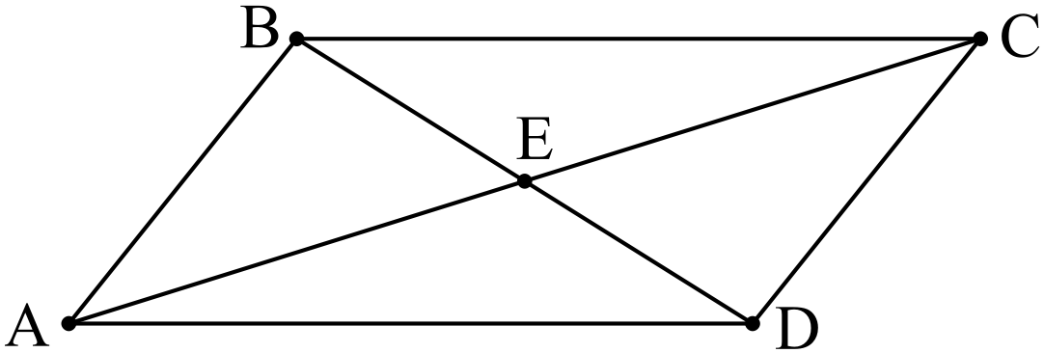

Prove: ABCD is a parallelogram

Example 3) Graph the quadrilateral with the given vertices. Determine whether the figure is a parallelogram. Justify your answer with the indicated formula.

J(-4, -4), K (-3, 1), L (4, 3), M (3, -3); Distance Formula

[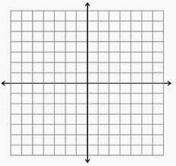](http://www.google.com/imgres?num=10&hl=en&tbo=d&biw=1280&bih=878&tbm=isch&tbnid=Khql0lrrMy_nDM:&imgrefurl=http://mathbits.com/MathBits/StudentResources/GraphPaper/GraphPaper.htm&docid=6RPEjJentpQNrM&imgurl=http://mathbits.com/MathBits/StudentResources/GraphPaper/14by14%20axes.jpg&w=302&h=285&ei=hcjVUNGfDbC-2AWv04HICw&zoom=1&iact=hc&vpx=108&vpy=155&dur=924&hovh=218&hovw=231&tx=143&ty=130&sig=110928772939558472342&page=1&tbnh=151&tbnw=160&start=0&ndsp=45&ved=1t:429,r:1,s:0,i:160)

Example 4, if time: Repeat #3, but use the slope formula to justify your conclusion.

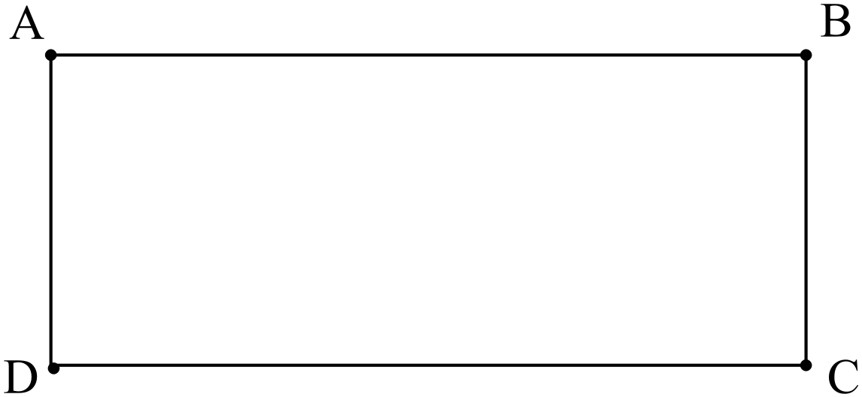**6.4 Notes: Rectangles**

**Properties of Rectangles:**

**All properties of a parallelogram AND**

* Parallelogram with four right angles
* Diagonals are congruent

**Theorems:**

* If a parallelogram has one right angle, then it is a rectangle.
* If a parallelogram has congruent diagonals, then it is a rectangle.

**Ex 1:** Given rectangle ABCD with If AC = 15, then find the perimeter of the rectangle. Exact answers, only.

A

B

C

D

**Ex 2:** A cabinet has a rectangular opening for a television. The opening has length to height at a ratio of 4:3, with a perimeter of 140 inches. Television sizes are given by the length of the diagonal of the screen, in whole inches. What is the largest size television that can fit in the cabinet, assuming that the television has a border of ½ inch around the screen? Assume that the depth of the television will fit inside the cabinet.

**Ex 5:** Given rectangle ABCD with AC = , and BD = . If the diagonals meet at point M, then find the length of CM.

**Ex 4:** Given quadrilateral DEFG with D(3, 4), E(-2, 2), F(2, -8), and G(7, -6), prove or disprove that DEFG is a rectangle.

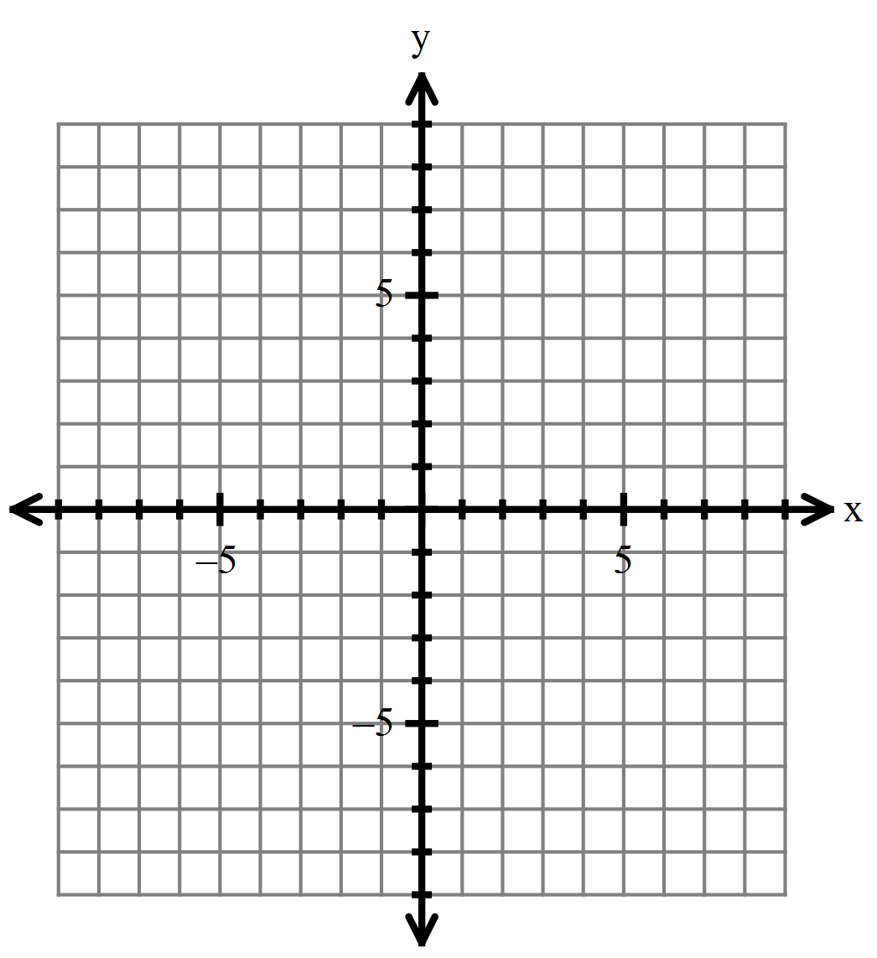

**6.5 Notes: Squares and Rhombi**

**Definition of a rhombus:** A rhombus is a parallelogram with all four sides congruent.

**Properties of a rhombus: All properties of a parallelogram, AND**

* Diagonals are perpendicular bisectors of each other.
* Diagonals bisect the angles.

Example 5: Find the perimeter of a rhombus with diagonals of 12 and 16 cm.

Example 6: Find the length of the longest diagonal in a rhombus with a perimeter of 40 and one angle of 110 degrees.

**Definition of a square:** A square is a parallelogram with four congruent sides and 4 right angles.

* + **In other words,** it is a __________________ that is also a ___________________.

**Properties of a square**

* All properties of a parallelogram
* All properties of a rectangle
* All properties of a rhombus
* The diagonals create 45-45-90 triangles

**Quadrilaterals**

Example 7: One diagonal of a square measures 14 cm. Find the area of the square.

Example 8: A rectangle has a perimeter of 20 and has whole number sides. Find the dimensions of the rectangle that will provide the smallest area.

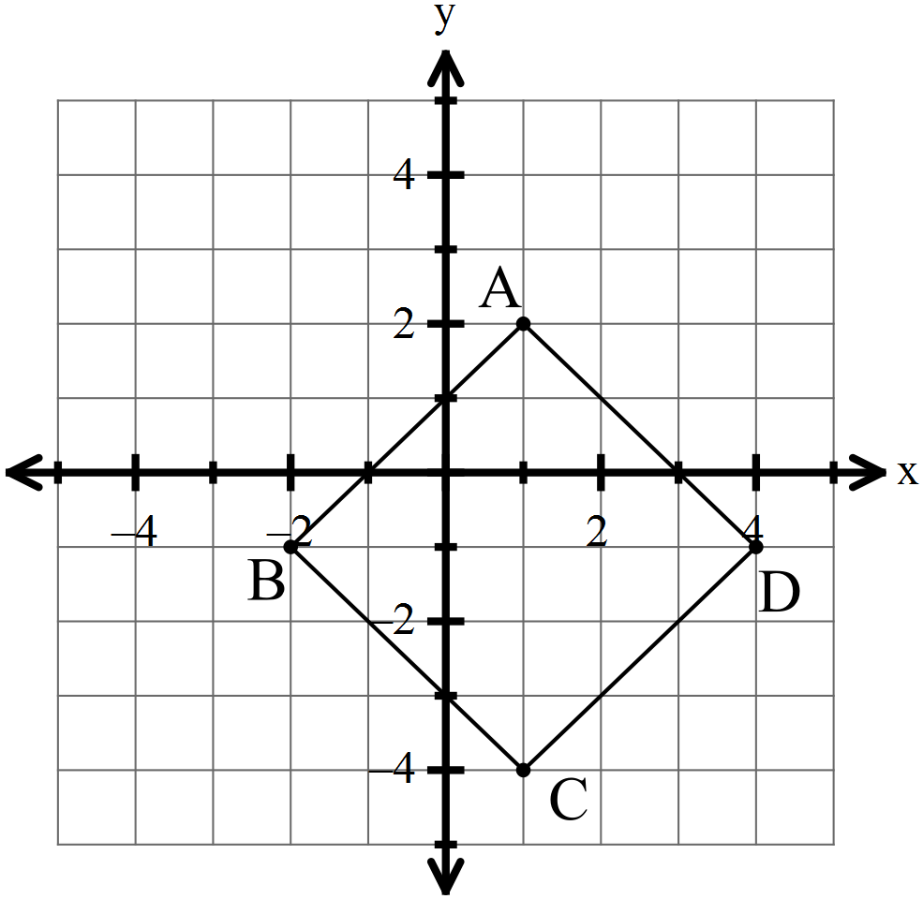Example 9: Given the set of vertices, determine whether ABCD is a

Parallelogram, rhombus, rectangle, or a square. List all that apply.

Show work to justify your conclusion. A (1, 2), B (-2, -1), C (1, -4), D (4, -1)

If time… Draw a quadrilateral ABCD. Draw your quadrilateral so that no two sides are congruent, no two angles are congruent, and no two sides are parallel.

1. Let P, Q, R, and S be the midpoints of sides AB, BC, CD, and DA, respectively. Use a ruler to locate these points as precisely as you can, and join them to form a new quadrilateral PQRS. What do you notice about the quadrilateral PQRS?
2. Suppose your quadrilateral ABCD lies in the coordinate plane. Let   B ,

C , and D . Use coordinates to prove the observation you made in part (1).

**6.6 Notes: Trapezoids and Kites**

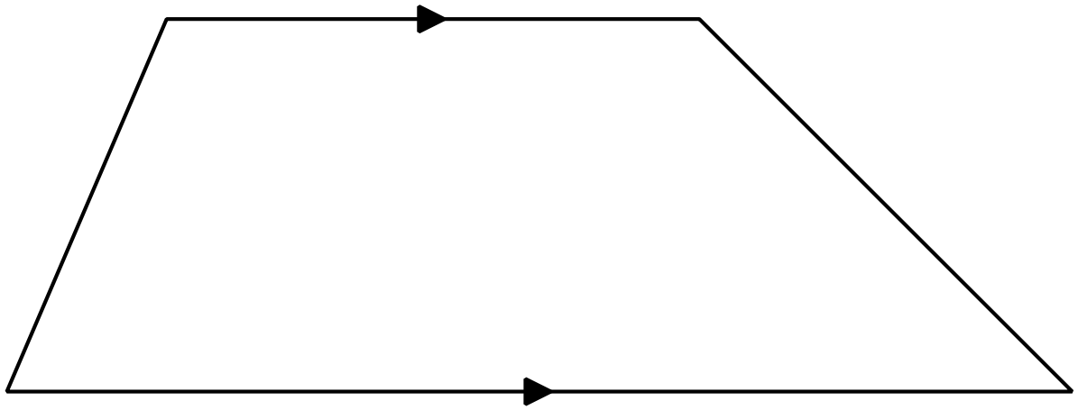**Definition of a Trapezoid:** If a quadrilateral is a trapezoid, then it has exactly one pair of opposite sides parallel.

Note: the parallel sides are called the ______________.

The non-parallel sides are called the ______________.

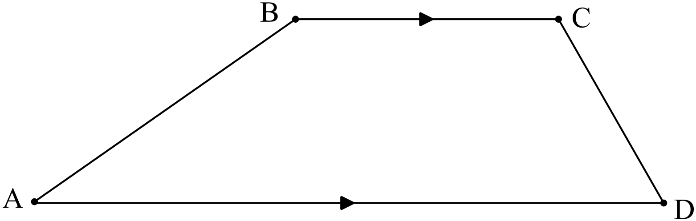Consider the trapezoid ABCD below with bases BC and AD. Can you determine any relationships between angles? Justify your reasoning.

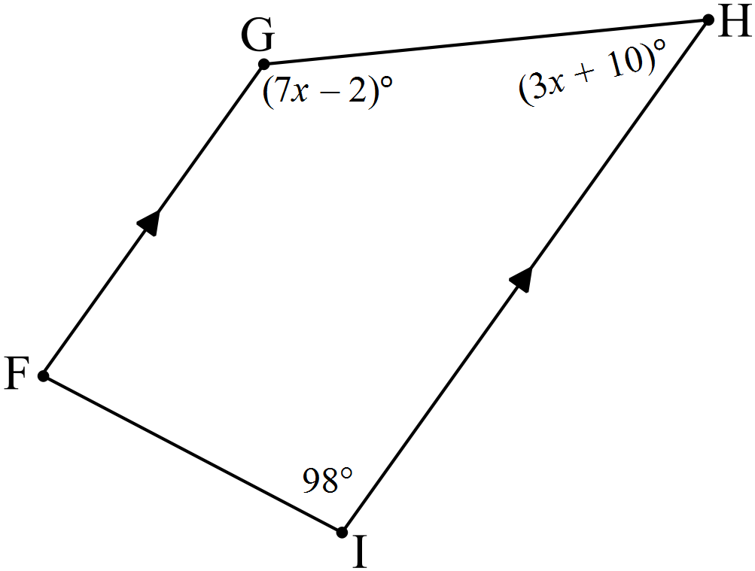Example 1: Find the measure of each missing angle in the given trapezoid.

**Definition of Isosceles Trapezoid:** If a trapezoid is isosceles, then it has congruent legs.

**Properties of an Isosceles Trapezoid:**

* Lower base angles are ________________.
* Upper base angles are ________________.
* Any lower base angle is _______________ to any upper base angles.
* Diagonals are _______________.



Example 2: Find the measure of in isosceles trapezoid EFGH if EF and HG are bases, , and .

Example 3: Quadrilateral ABCD has vertices A(-4, -1), B (-2, 3), C (3, 3), and D (5, -1). Show that ABCD is an isosceles trapezoid.

**Midsegment of a Trapezoid:** If a segment is a midsegment of a trapezoid, then it connects the midpoints of the legs. The following formula is true for any midsegment M of a trapezoid, where and are the bases of the trapezoid.

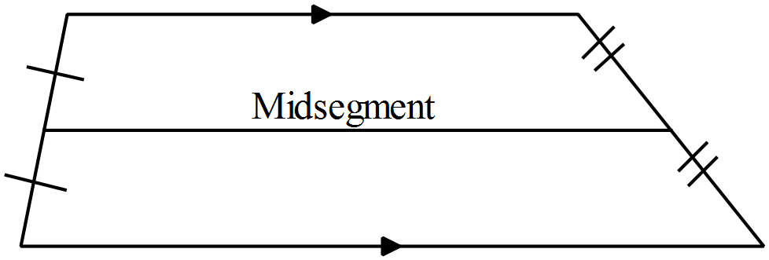

Example 4: The upper base of a trapezoid is 14cm, and the lower base is 27 cm. Find the length of the midsegment.

Example 5: The upper base of a trapezoid is 29 cm, and the midsegment is 20 cm. Find the length of the lower base.

**Definition of a Kite:** If a quadrilateral is a kite, then it has two pairs of consecutive sides congruent.

Draw a kite: Is a kite always a parallelogram?

Is a rhombus a kite? Is a square a kite?

**Properties of kites:** (Notice that these are “half properties” of rhombi.)

* One diagonal is the ____________________ _________________ of the other diagonal.

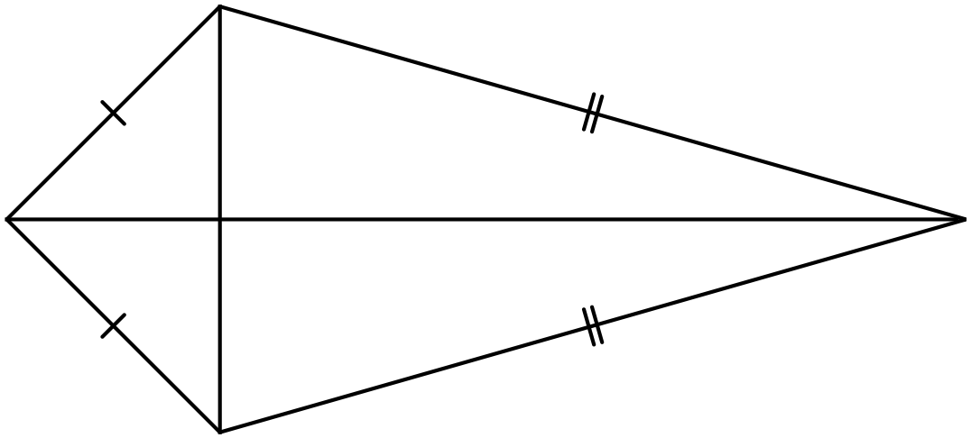

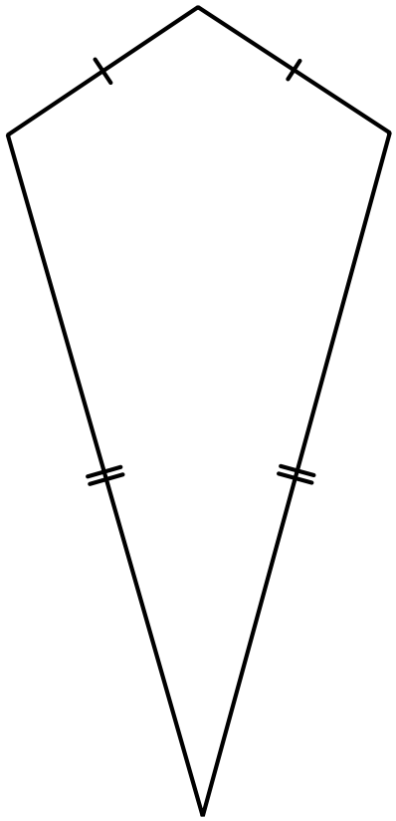

* One pair of opposite angles is ______________________.
* One diagonal ______________________ one pair of opposite angles.



Example 6: IF ABCD is a kite with AC = 8, , and , then find each measure. Exact answers.

a) AB

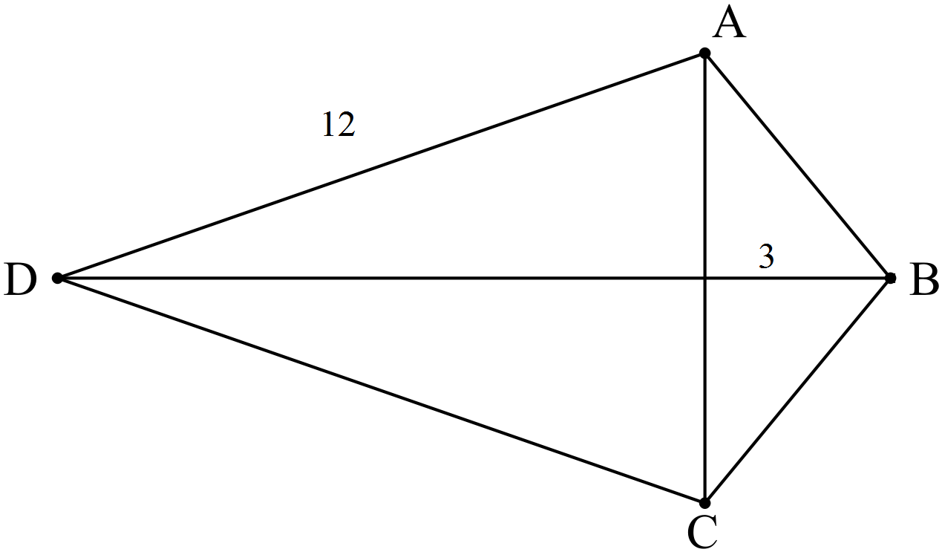

b) DB