**Chapter 3 Notes Packet: Transformations**

|  |  |  |
| --- | --- | --- |
| **Date** | **Day** | **Assignment** |
| **10/10/23**  **10/11/23** | **Tuesday (A)**  **Wednesday (B)** | Notes: 3.1 Reflections  **HW: 3.1 Worksheet** |
| **10/12/23**  **10/13/23** | **Thursday (A)**  **Friday (B)** | Notes: 3.2 Translations  **HW: 3.2 Worksheet** |
| **10/16/23**  **10/17/23** | **Monday (A)**  **Tuesday (B)** | Notes: 3.3 Rotations  **HW: 3.3 Worksheet** |
| **10/18/23**  **10/19/23** | **Wednesday (A)**  **Thursday (B)** | Notes: 3.4 Parallel Line and Angle Relationships  **HW: 3.4 Worksheet** |
| **10/20/23**  **10/23/23** | **Friday (A)**  **Monday (B)** | Notes: 3.5 Proofs with Parallel Lines and Transversals  **HW: 3.5 Worksheet** |
| **10/24/23**  **10/25/23** | **Tuesday (A)**  **Wednesday (B)** | Chapter 3 Review  **HW: Chapter 3 Review Worksheet** |
| **10/26/23**  **10/30/23** | **Thursday (A)**  **Monday (B)** | Chapter 3 Test  **HW: No Homework** |
| **10/31/23**  **11/1/23** | **Tuesday (A)**  **Wednesday (B)** | Notes: 3.6 Writing Equations of Lines  **HW: 3.6 Worksheet** |
| **11/2/23**  **11/3/23** | **Thursday (A)**  **Friday (B)** | Ch 3 Project: Equations of Lines  **HW: No Homework** |

HW Hints:

* Check out our class YouTube channel: [**https://www.youtube.com/channel/UCh9fLvgw9metmQuIb6vQ5Zw**](https://www.youtube.com/channel/UCh9fLvgw9metmQuIb6vQ5Zw)
* Show all work and draw the diagrams for each problem.
* Students who complete every assignment this semester will get a 2% bonus.
* For extra practice, visit [www.khanacademy.org](https://washoeschools.sharepoint.com/sites/damontehs/STAFFSHARED/Math/Geometry/Ch%201%20Angles/www.khanacademy.org)
* Check out [www.mathguy.us](https://washoeschools.sharepoint.com/sites/damontehs/STAFFSHARED/Math/Geometry/Ch%201%20Angles/www.mathguy.us) for extra help.

**3.1 Worksheet Name________________________**

**For #1 – 6, reflect each shape over the specified line by drawing the image.**

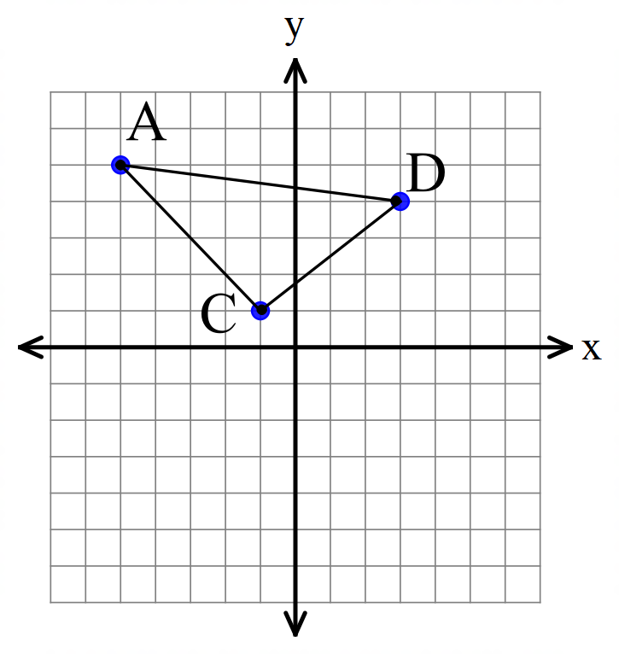1) over the *x*-axis 2) over the *y*-axis 3) over

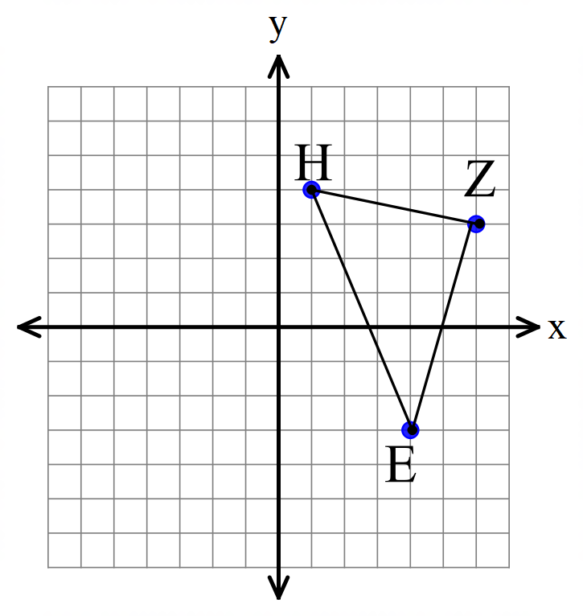

4) Find the coordinates from #1. 5) Find the coordinates from #2. 6) Find the coordinates from #3.

7) over the line 8) over the *x*-axis 9) over the *y*-axis

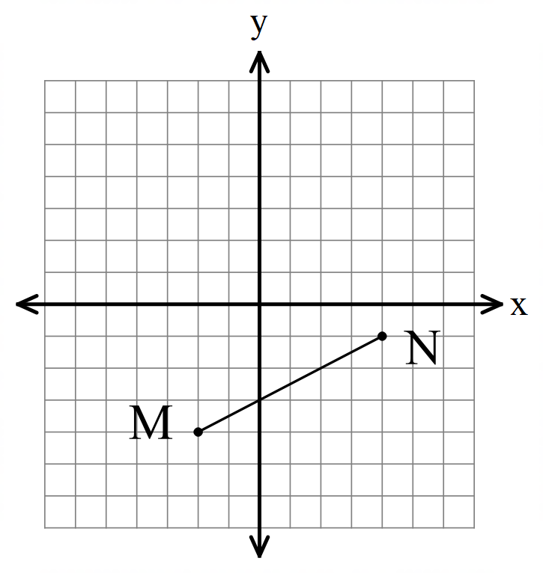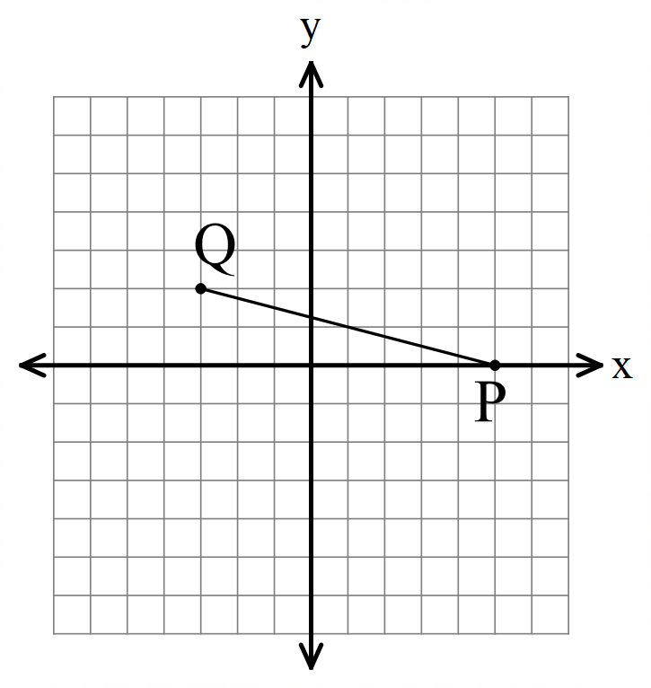

10) Find the coordinates from #7. 11) Find the coordinates from #8. 12) Find the coordinates from #9.

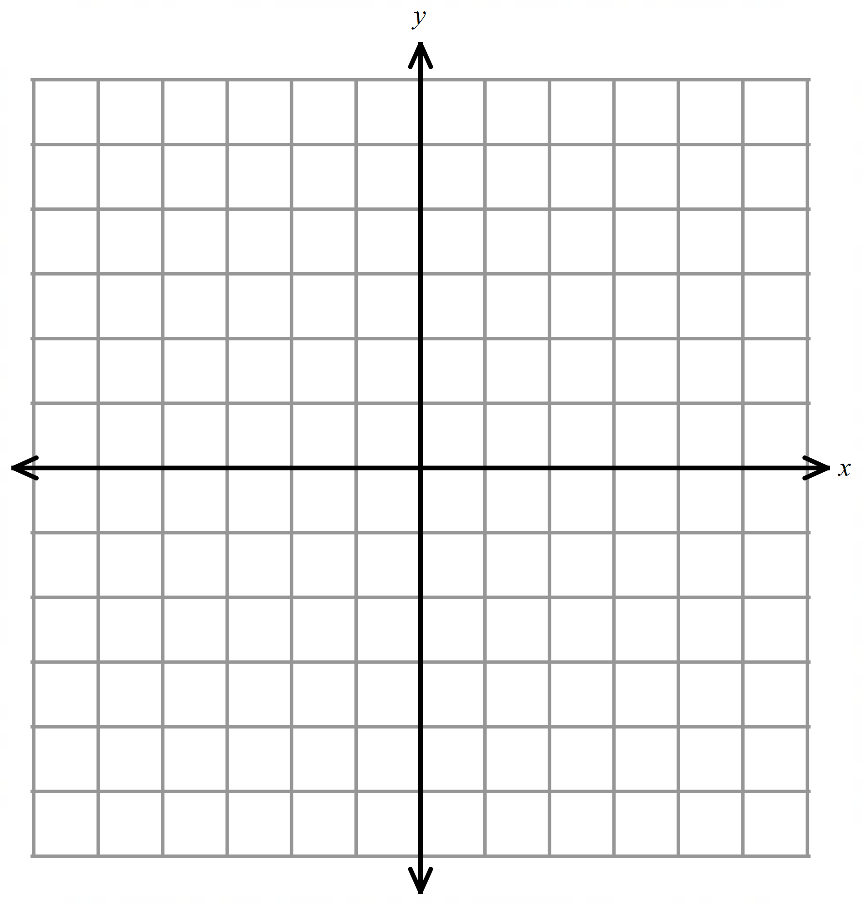

**For #13 – 15. Multiple Choice. Find each image.**

13) ; reflect in the *y*-axis.

A) (5, 2)

B) (2, 5)

C) (-5, 2)

D (-2, -5)

**3.1 HW cont’d on next page.**

**3.1 HW, con’d**

14) ; reflect in

A) (4, 2)

B) (2, 4)

C) (-2, -2)

D) (4, 4)



15; reflect in

1. (3, -5)
2. (3, 4)
3. (-1, -3)
4. (-7, 1)

**For #16 – 18, solve each equation by factoring:**

16) 17) 18)

19) Which set of images below shows a reflection? Choose all that apply.

A) B) C)

**3.2 Worksheet Name________________________**

**For #1 – 6, translate each image according to the given vector. DRAW the image and write the ordered pair for each vertex in the image.**

1) 2) 3)



****4) 5) 6.



**For #7 – 10, translate each point by the given vector and find the image. Multiple Choice.**

7) ; 8) ;

A) (0, 8) A) (5, 0)

B) (-4, 2) B) (1, -10)

C) (-4, 8) C) (5, -10)

D) (0, 2) D) (1, 0)

**3.2 HW continued on the next page…**

**3.2 HW continued…**

9) ; 10) ;

A) (-10, -3) A) (-2, 10)

B) (2, -3) B) (2, 5)

C) (-2, -1) C) (2, 10)

D) (2, -1) D) (-2, 5)

11) Which set of images below shows a translation? Choose all that apply.

A) B) C)

12) The point is reflected in the *x*-axis. What is the coordinate of the final image?



13) The point (-2, 3) is translated by the vector . After that, the new point is reflected in the *y* axis. What is the coordinate of the final image ?

14) Solve by using the quadratic formula:

.

15) Find the length of segment AB if A(5, 2) and B(0, 4). Round to the nearest tenth.

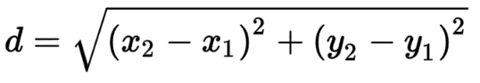

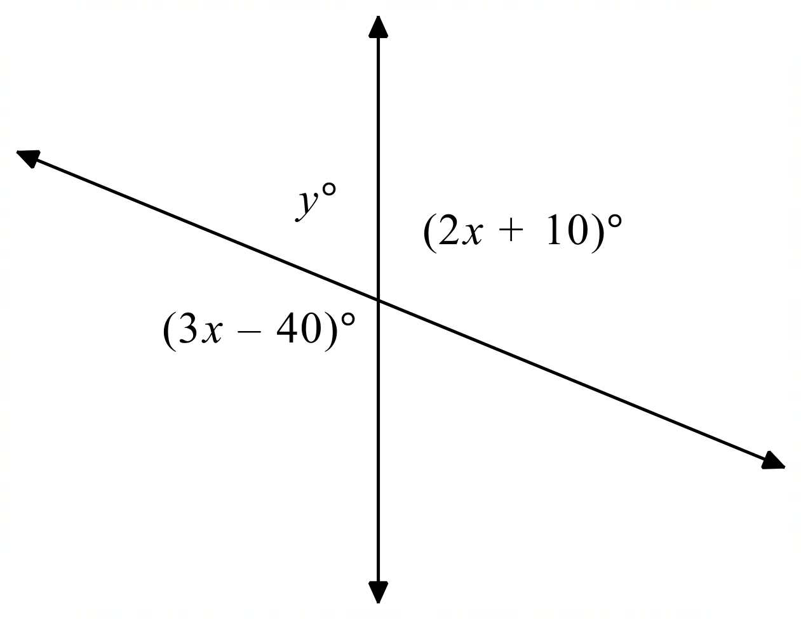

**For #16 – 17: use the diagram shown.**

16) Find *x*. 17) Find *y*.

**3.3 Worksheet Name________________________**

**For #1 –9,** rotate each point around the origin, as described below. What are the coordinates of the image?

**Note: CW = clockwise; CCW = counter-clockwise.**

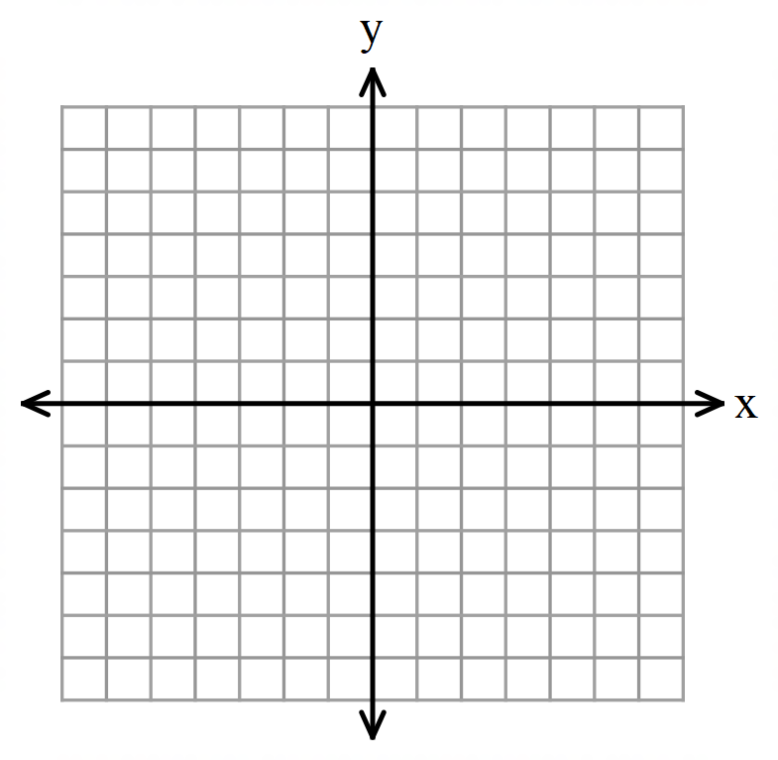 1) ; CW 2) ; CCW 3) ; CCW



4; CW 5) ; CW 6) ; CCW



7) ; CCW 8) ; CW 9) ; CCW



**3.3 HW continued on next page…**

**3.3 HW, continued:**

10) Given that and , then which description below is the correct transformation?

A) rotation CCW

B) reflection in the *x*-axis

C) translation

D) rotation CW

11) Given that and , then which description below is the correct transformation? **Select all that apply.**

A) rotation CCW

B) reflection in the *x*-axis

C) translation

D) rotation CW

12) Which of the following show a rotation? Select all that apply.

A) B) C)

13) Consider the point Rotate point A 90 degrees clockwise about the origin to get , and then reflect in the *y*-axis. What are the coordinates of the final image



14) Consider the point Rotate point B 90 degrees **counterclockwise** about the origin to get , and then translate along the vector . What are the coordinates of the final image



15) Solve:

16) Factor:

**3.4 Worksheet Name________________________**

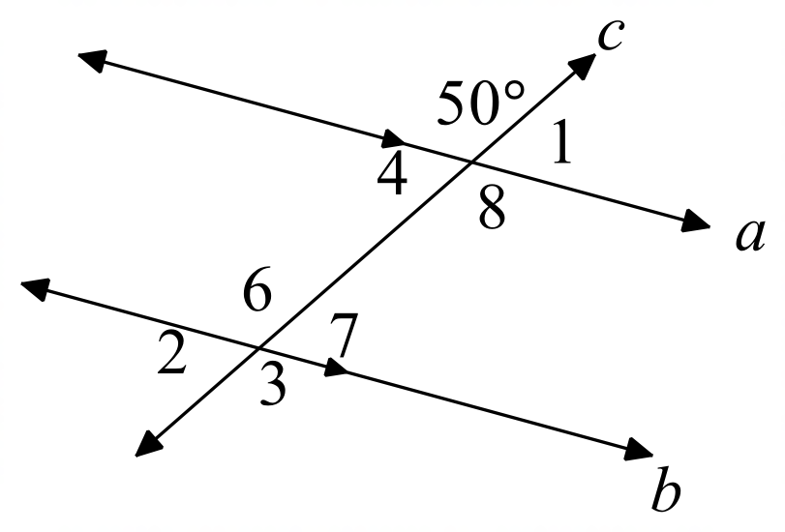**For #1 – 10, use the diagram shown, where** *a // b*.

1) Find . 2) Find . 3) Find .

4) Find . 5) Find . 6) Find .

7) Find .

8) Which angle forms alternate interior angles with

9) Which angle forms corresponding angles with

10) Which angle forms consecutive interior angles with

**For #11 – 16, solve for the variable(s). Assume the lines shown are parallel.**

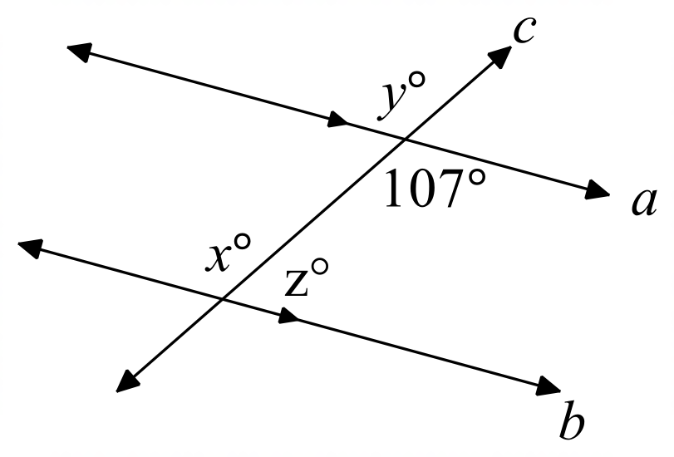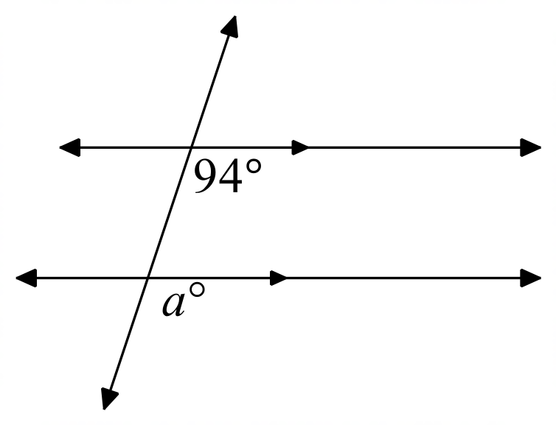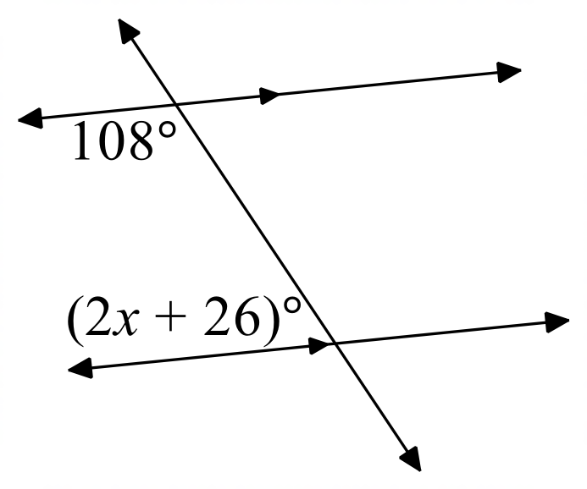11) 12) 13)

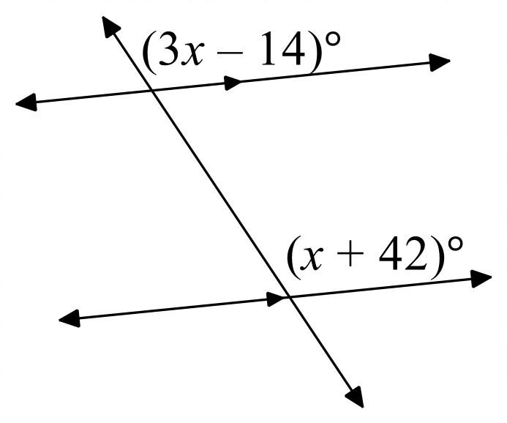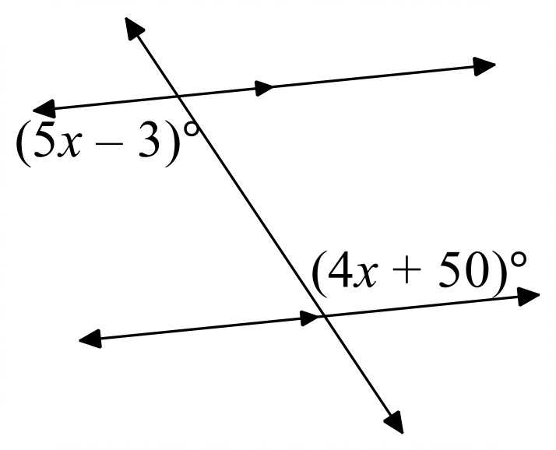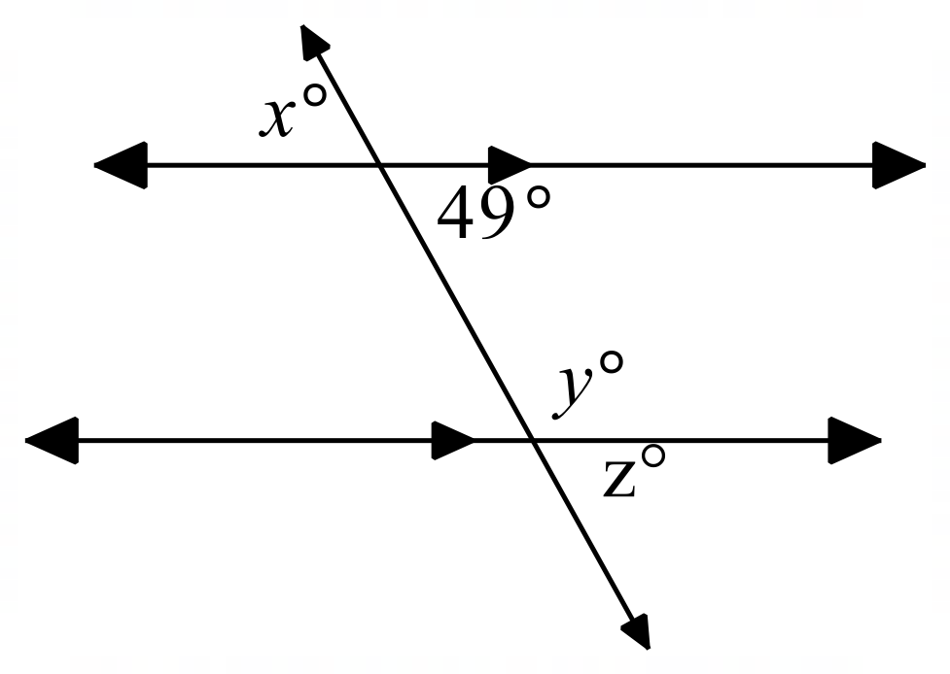

14) 15) 16)

**3.4 Worksheet continued on the next page.**

**3.4 Worksheet, continued…**

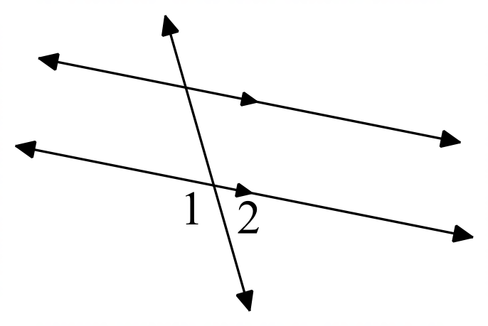**For #17 – 21, name the relationship between**  and in each diagram as vertical, linear pair, alternate interior, corresponding, or consecutive interior.

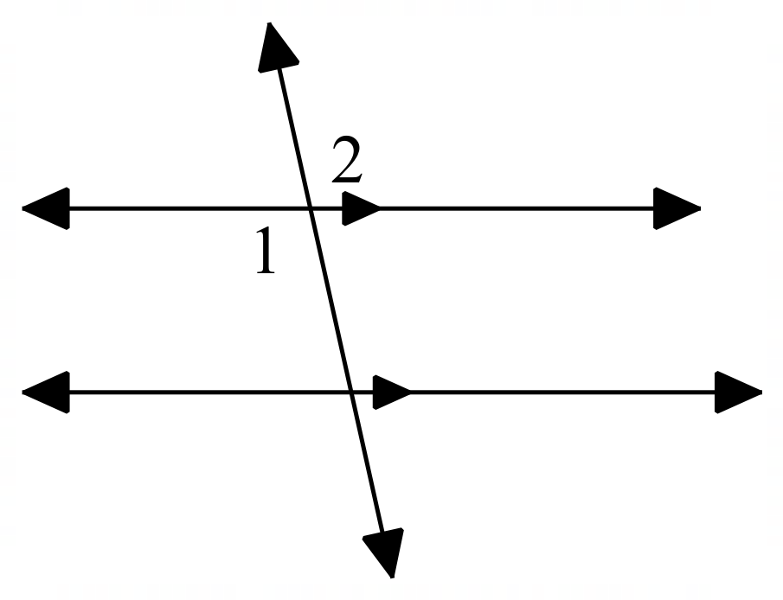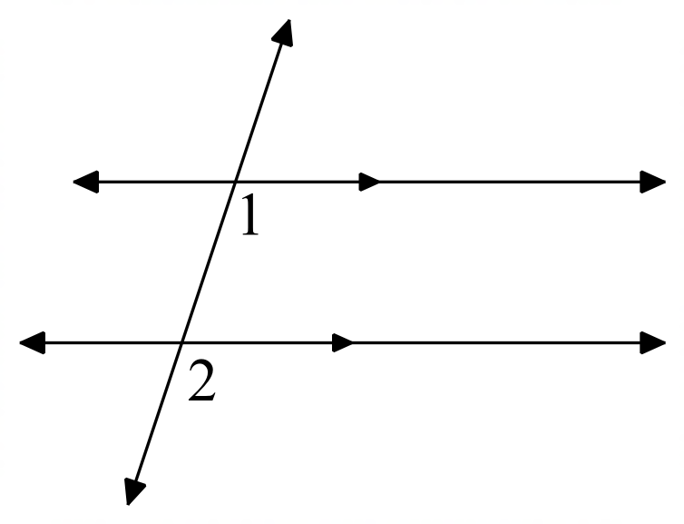17) 18) 19)

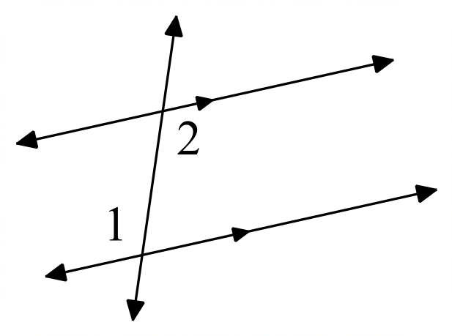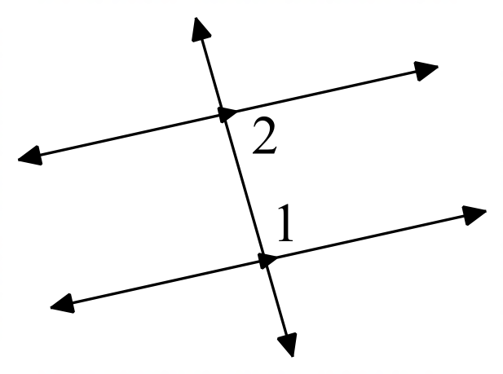

20) 21)

**3.5 Worksheet Name________________________**

**Fill in the blank spaces for each proof. A list of possible reasons is below. Answers can be used more than once.**

Given

If parallel lines, then alternate interior angles are congruent

If parallel lines, then corresponding angles are congruent

If parallel lines, then consecutive interior angles are supplementary

If alternate interior angles are congruent, then lines are parallel

If corresponding angles are congruent, then lines are parallel

If consecutive interior angles are supplementary, then lines are parallel.

|  |  |  |
| --- | --- | --- |
| **For #1 – 3:** Given:    Prove: | |  |
| **Statement** | **Reason** | | |
| 1. #1 | 1. #2 | | |
| 2. | 2. #3 | | |

|  |  |  |
| --- | --- | --- |
| **For #4 – 6:** Given:    Prove: | |  |
| **Statement** | **Reason** | | |
| 1. #4 | 1. #5 | | |
| 2. | 2. #6 | | |

|  |  |  |
| --- | --- | --- |
| **For # 7 – 9:** Given:    Prove: | |  |
| **Statement** | **Reason** | | |
| 1. #7 | 1. #8 | | |
| 2. | 2. #9 | | |

|  |  |  |
| --- | --- | --- |
| **For #10 – 12:** Given:    Prove: | |  |
| **Statement** | **Reason** | | |
| 1. #10 | 1. #11 | | |
| 2. | 2. #12 | | |

|  |  |  |
| --- | --- | --- |
| **For #13 – 15:** Given:    Prove: | |  |
| **Statement** | **Reason** | | |
| 1. #13 | 1. #14 | | |
| 2. | 2. #15 | | |

**3.5 Worksheet continued on next page…**

**3.5 Worksheet, continued…**

**For #16 – 19, find the value of the variable(s) given that each diagram shows parallel lines.**

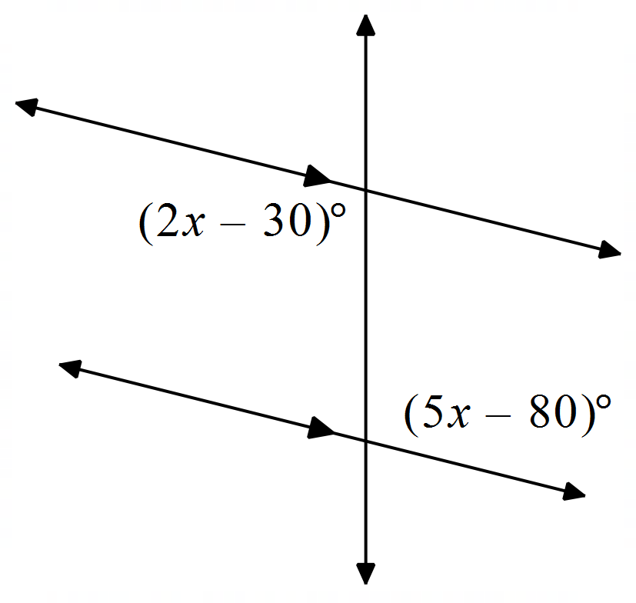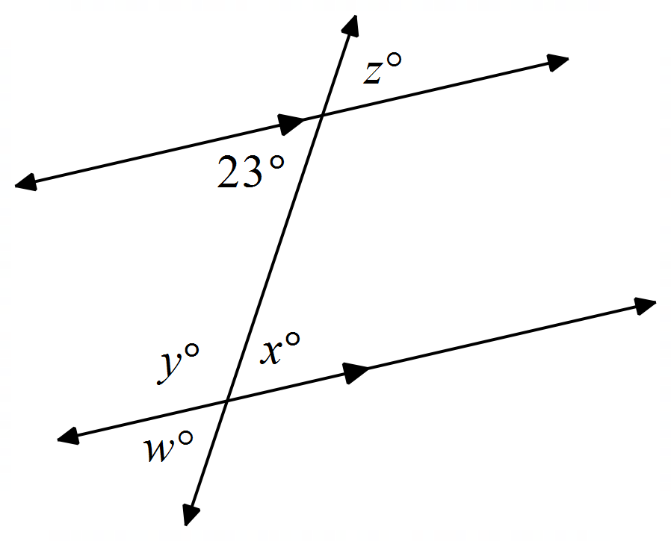

16) 17)

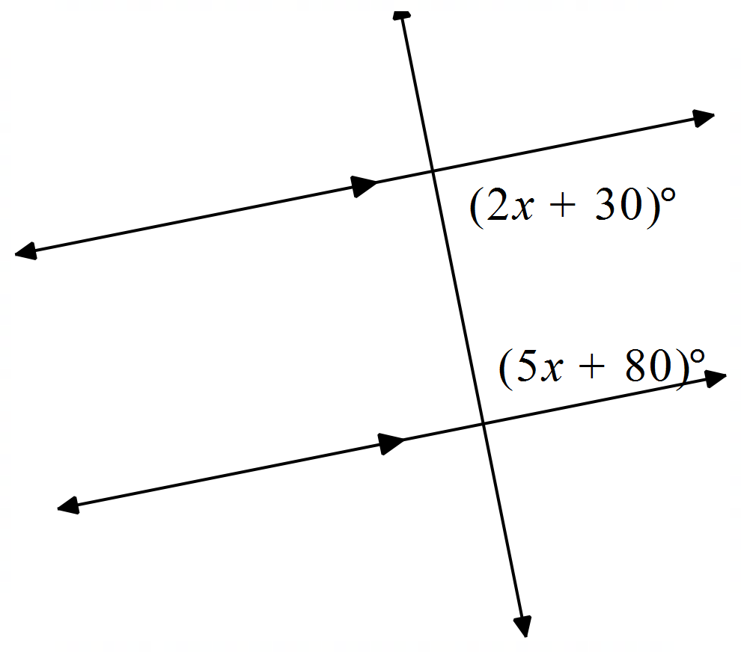

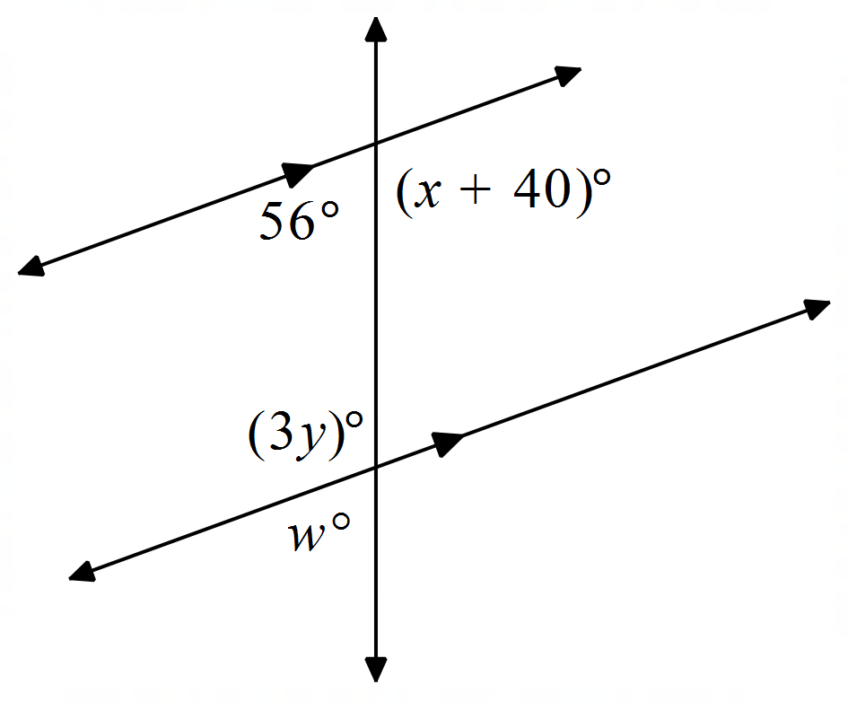18) 19)

**For #20 – 23, find the coordinates of the image of point P after the given transformation.**

20) reflection in the *x*-axis 21) rotation 90 degrees counterclockwise

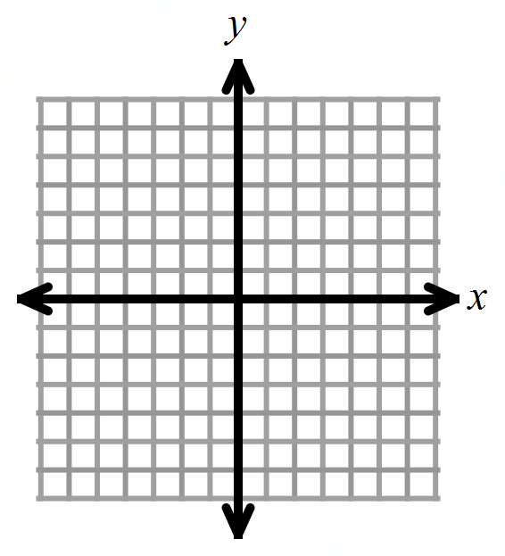

22) translation along the vector 22) rotation 180 degrees clockwise



**Ch 3 Review Worksheet Name________________________**

**For #1 – 6, reflect the point over the specified line. Name the coordinates of**

1) over the *x*-axis 2) over the *y*-axis 3) over

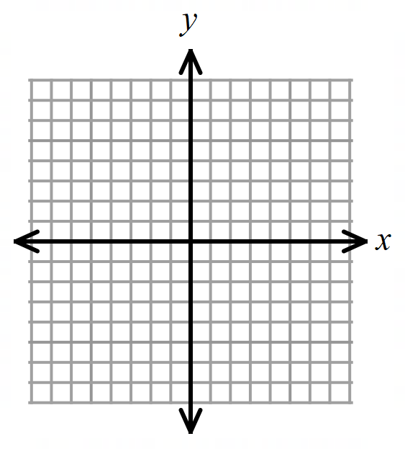

4) over the line 5) over 6) over



**For #7 – 9, translate each figure along the identified vector. List the coordinates for the image.**

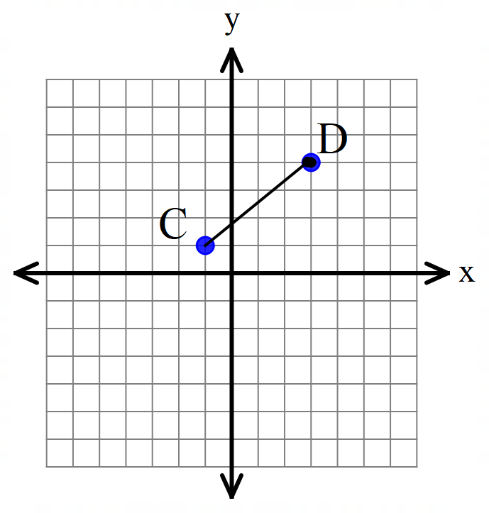7) 8) 9)

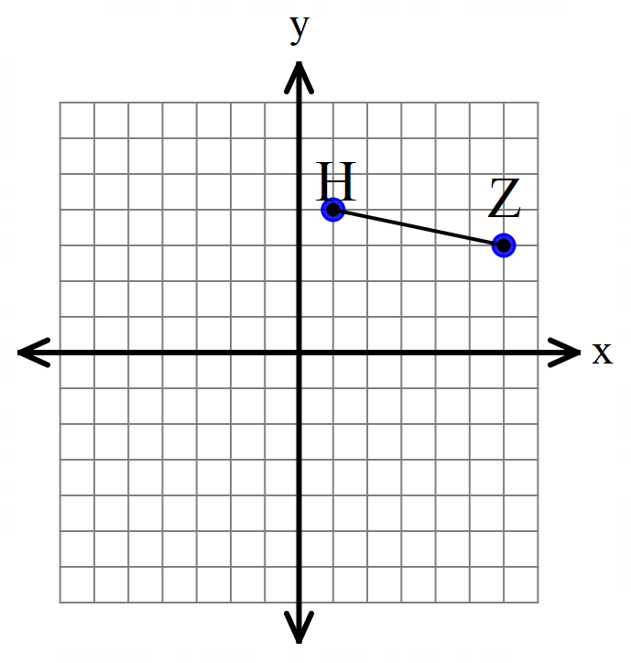

**Ch 3 Review Worksheet, continued…**

**For #10 – 15,** rotate each point around the origin, as described below. What are the coordinates of the image?

**Note: CW = clockwise; CCW = counter-clockwise.**

10) ; CW 11) ; CCW 12) ; CCW



13; CW 14) ; CW 15) ; CCW



**For #16 – 25, use the diagram shown, where** *a // b*.

16) Find . 17) Find . 18) Find .

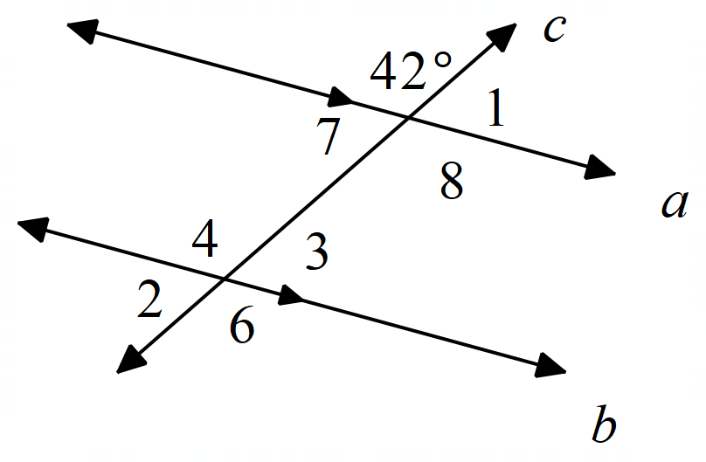

19) Find . 20) Find . 21) Find . 22) Find .

23) Which angle forms alternate interior angles with

24) Which angle forms corresponding angles with

25) Which angle forms consecutive interior angles with

**For #26 – 29, solve for the variable(s). Assume the lines shown are parallel.**

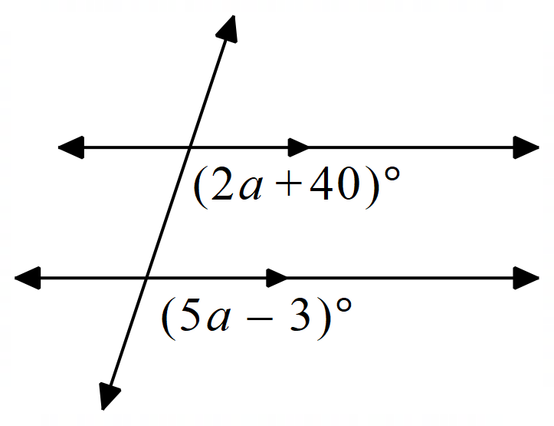26) 27) 28)

**Ch 3 Review Worksheet, continued…**

**Complete the proofs below.**

|  |  |  |
| --- | --- | --- |
| **For # 30 – 33:** Given:    Prove: | |  |
| **Statement** | **Reason** | | |
| 1. #30 | 1. #31 | | |
| 2. | 2. #32 | | |

|  |  |  |
| --- | --- | --- |
| **For #34 – 36:** Given:    Prove: | |  |
| **Statement** | **Reason** | | |
| 1. #34 | 1. #35 | | |
| 2. | 2. #36 | | |

**3.6 Worksheet Name________________________**

**For #1-3: Determine whether or not the two lines are parallel. Show your work!**

|  |  |  |
| --- | --- | --- |
| 1.) | 2.) | 3.)  : Passes through the points .  : Passes through the points . |

**For #4-6: Determine whether or not the lines are perpendicular. Show your work!**

|  |  |  |
| --- | --- | --- |
| 4.) | 5.) | 6.)  Passes through the points .  Passes through the points . |

**For #7 – 14, write each equation in form:**

|  |  |
| --- | --- |
| 7) Write the equation of a line that has a slope of and passes through . | 8) Write the equation of the line that is parallel to and passes through . |
| 9) Write the equation of the line that is perpendicular to and passes through . | 10) Write the equation of the line that is parallel to and passes through . |
| 11) Write the equation of the line perpendicular to that passes through . | 12) Write the equation of the line that passes through and is parallel to |
| 13) Write the equation of the line that passes through is perpendicular to | **Challenge problem:** 14) Write the equation of the line that is passes through and is perpendicular to the line through and . |

|  |  |  |
| --- | --- | --- |
| 15) Which of the following equations describes a line parallel to the line graphed at right? Choose all that apply.  A.  B.  C.  D. |  | |
| 16) Which of the following pairs of equations describes perpendicular lines?   |  |  |  |  | | --- | --- | --- | --- | | **I.** |  | **III.** |  | | **II.** |  | **IV.** |  | | |  |  | | --- | --- | | a. | I and II | | b. | II and III | | c. | II and IV | | d. | III and IV | | |
| 17) Which of the following lines is perpendicular to the line ?  A. Line 1  B. Line 2  C. Neither  D. Both | Line 2  Line 1 |