The Bryantville Times

By: Ace Boelow

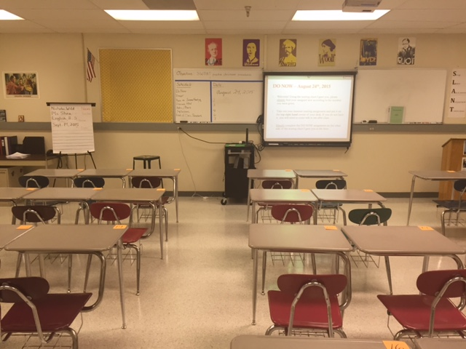

The Brantville classrooms are a working environment, but it’s always a good time in the classrooms. The teachers do a great job at teaching every student, and helping them individually.

In the social studies classroom this month students have been learning about the holocoust. It has been a great learning experience in the classroom. Since it is such a touching subject teachers have to be very careful on how they teach it and what they say. Our teacher has been amazing at this. This topic will most likely travel to next month as well. The classes are starting to go into the more difficult part to teach and learn. That is what has been happening this month in the social studies classroom.

The math classrooms are always filled with numbers and sometimes even letters. This month it's been just that. The classes have been learning how to solve systems and linear equations. It's been very difficult to learn, and maybe even to teach. The students have learned many different ways to do these equations. At the end of this month the district test is finished for math, and started a new packet. This packet includes transformation, and tons of other stuff.

In the english arts classroom the students have been learning how to write essays. This is preparing the kids for the upcoming argument essay. The class includes reading and note taking, but that doesn't mean we are not aloud to have fun. There is a fun envolvement in this class. This class is a great learning environment.

That is what is happening in the bryantville classrooms. As you can see this is a great learning environment that every one loves.

Bryantville also has tons of sports! The most recent sport activity has been volleyball. The tryouts were very exciting for everyone involved. There have been 5 games so far and there will be more to come! Out of all the games there have only been 1 win for team B and 0 for team A.

That's it for the Bryantville times news letter. There will be one monthly every 1st or 2nd of every month.