1) Multiple Select. Which relations below are functions? **Select all that apply.**

A)

B)

C)

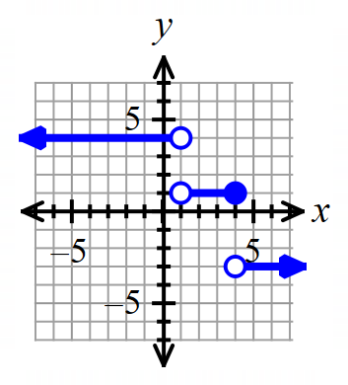 D)

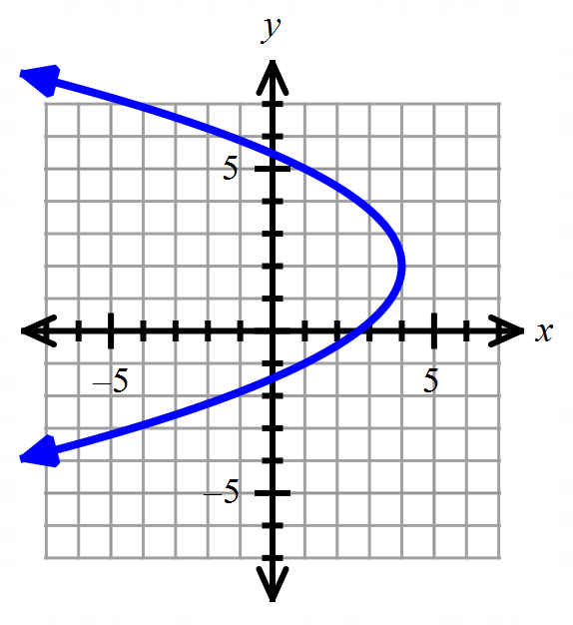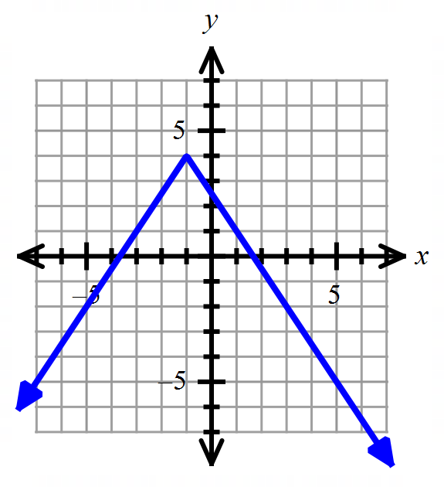 E) F) G)

**For #2 – 3, evaluate each expression as indicated, and simplify.**

2) 3)

**For #4 – 5, find the following information for each function.**

a) interval(s) increasing, in interval notation. b) interval(s) decreasing, in interval notation.

c) Domain and Range, in interval notation. d) coordinates of any relative extrema.

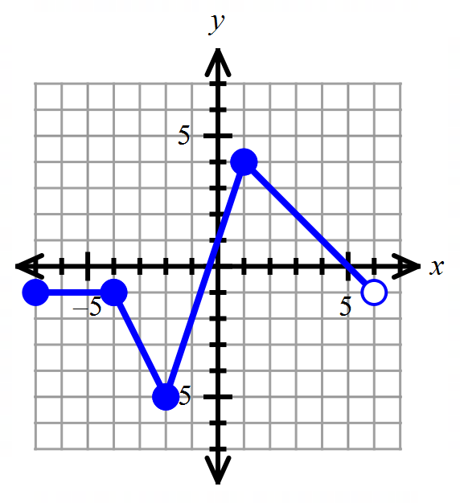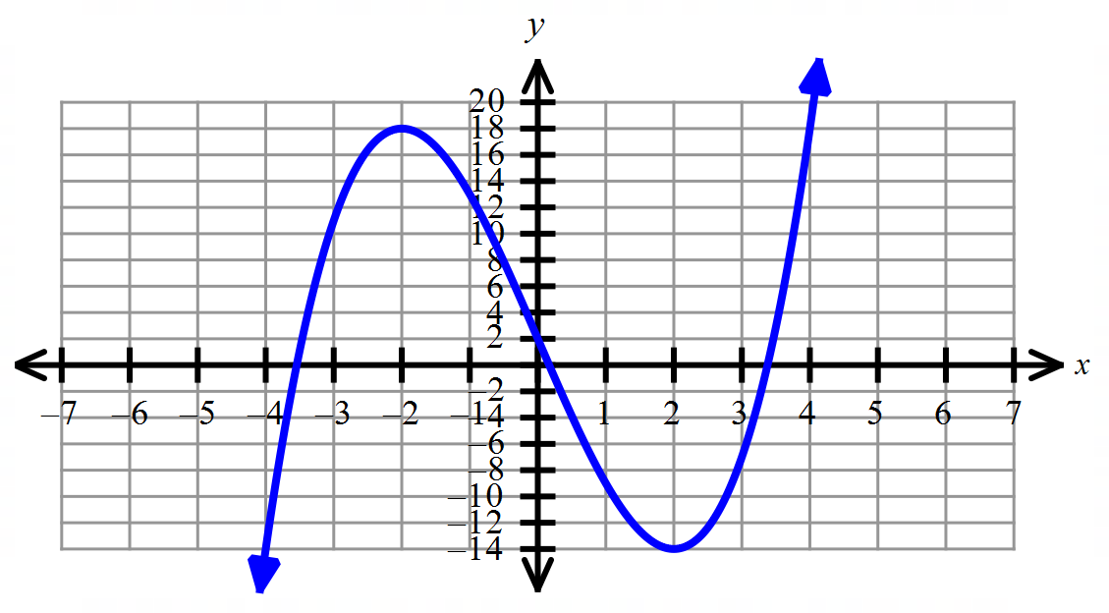

4) 5)

**For #6 – 7, determine whether each function is even, odd, or neither.**

6) 7)

**For #8 – 9, evaluate each piecewise function at the indicated value.**

8) Find if 9) Find if

**For #10 – 11: Graph each piecewise function.**

10) 11)

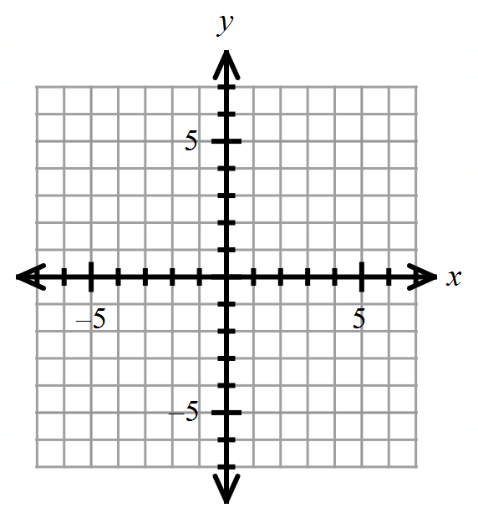

12) Given that , find given that . Simplify your answer fully.

**For #13 – 14, write the equation of each line in point-slope form, slope-int form,  *and* in form.**

13) Passes through with an *x*-intercept at *x* = -1.

14) Passes through

**For #15 – 19, given that and , find the requested value or expression.**

15) Find . 16) Find

17) Find 18) Find In other words, find

19) Find . In other words, find

**For #20 – 21, Multiple Choice. Select the best answer.**

20) Find the functions and so that given that

A) B)

C) D)

21) Which two functions below are inverses of each other?

A) B) C) D) None

22) Find the inverse of the one-to-one function:

23) Does the graph represent a function that has an inverse function? Explain your reasoning.

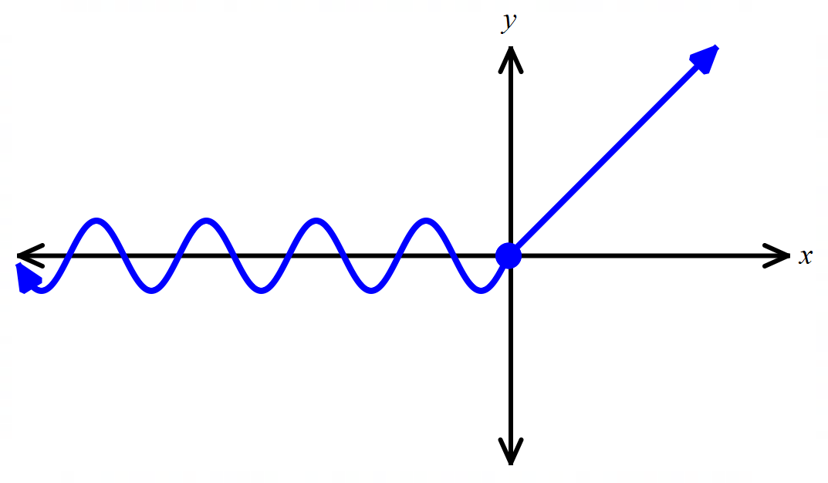

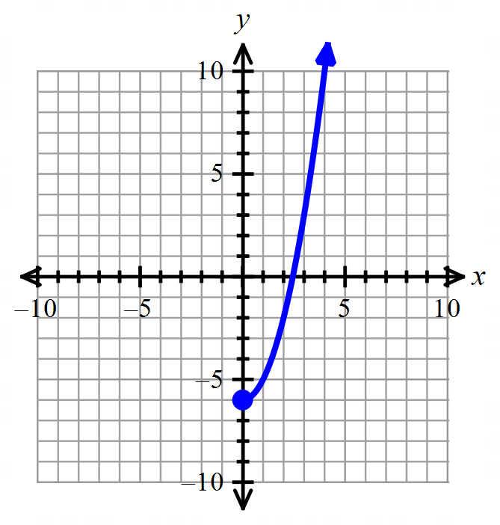

24) Graph given as shown.

Also, find the domain and range of in interval notation.

25) Given and , find In other words, find

26) Given the graph of as shown below. 27) Graph below.

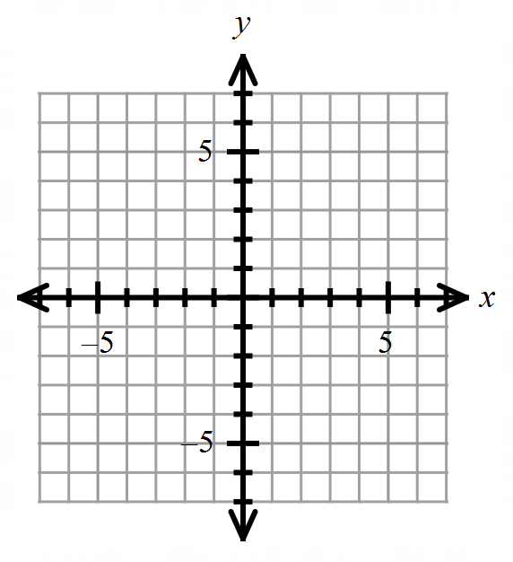Graph on the same coordinate system if

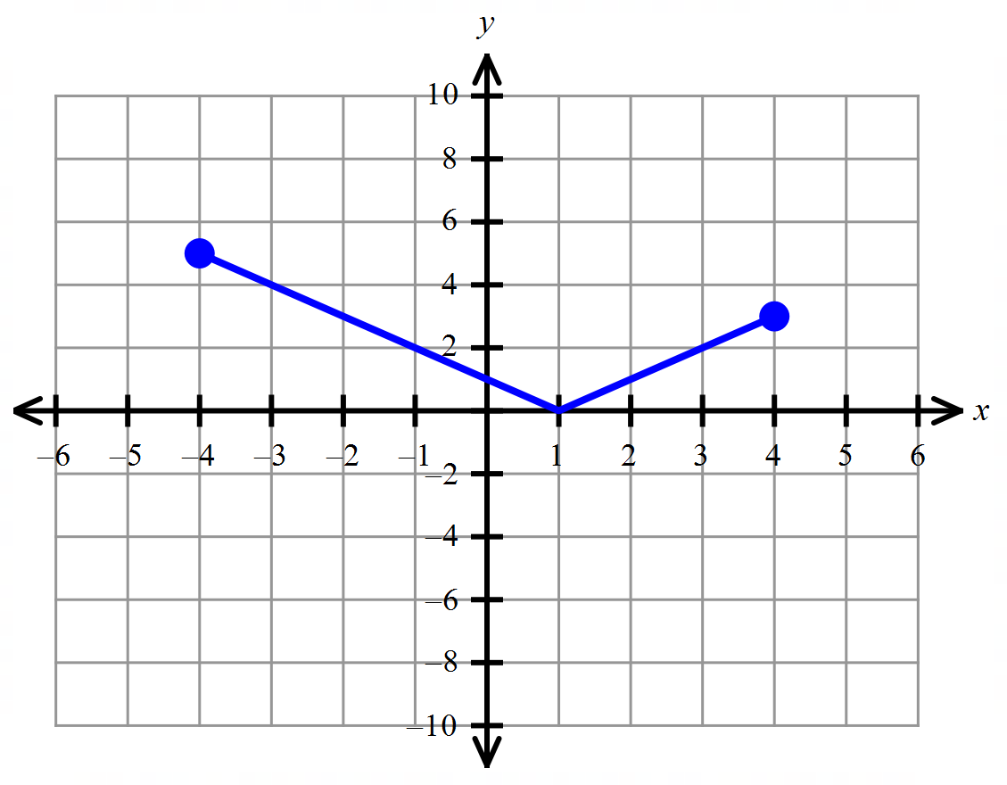

**Answers:**

1) B, D, E, G 2) 3)

4) a. , b. , c. D: , R: , d. R. Max: , R. Min:

5) a. , b. , c. D: , R: , d. R. Max: , R. Min:

6) Even 7) Neither 8) 9)

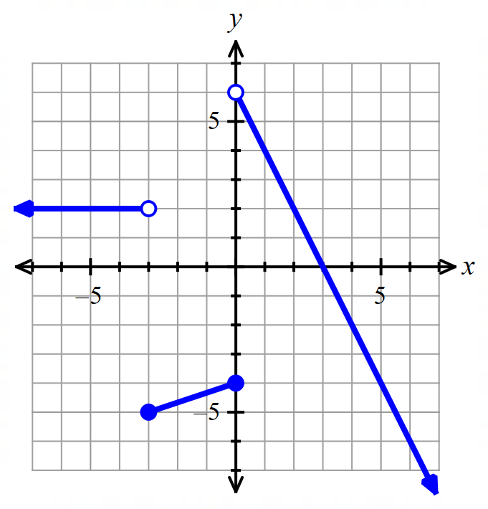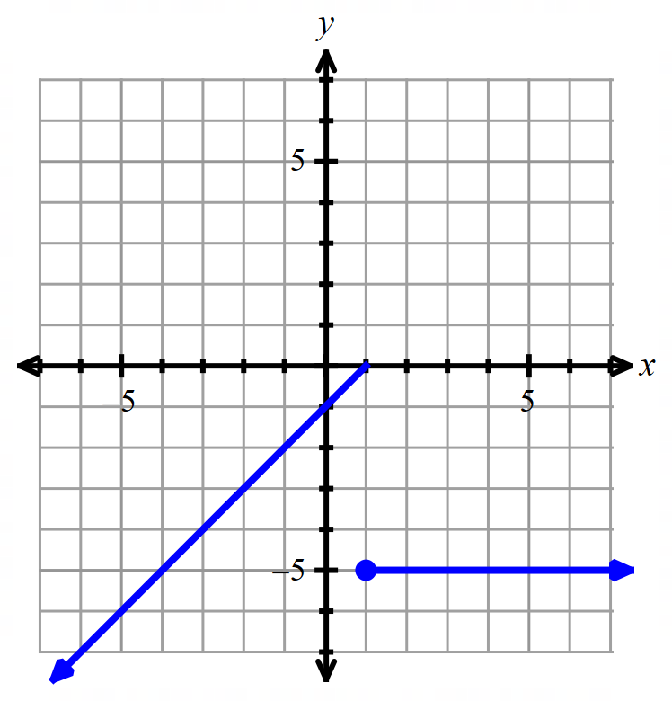

10) 11) 12)

|  |  |  |  |
| --- | --- | --- | --- |
| 13) | (h, k) Form | Point-Slope Form | Slope-Intercept Form |
|  |  |  |  |
| OR |  |  |  |
| 14) |  |  |  |
| OR |  |  |  |

15) 16) 17) or 18)

19) 20) D 21) B 22) 23) No, doesn’t pass the horizontal line test.

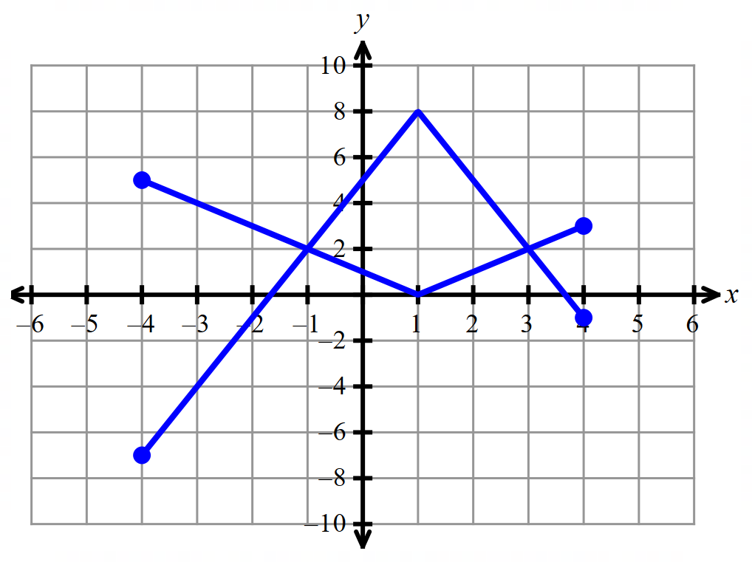

24) D: , R: 25) 26)

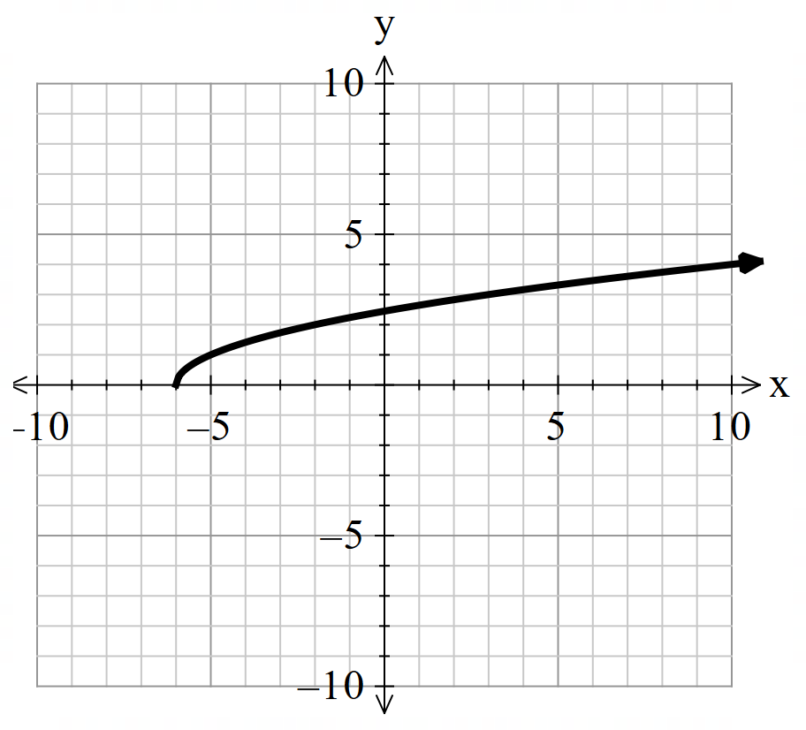

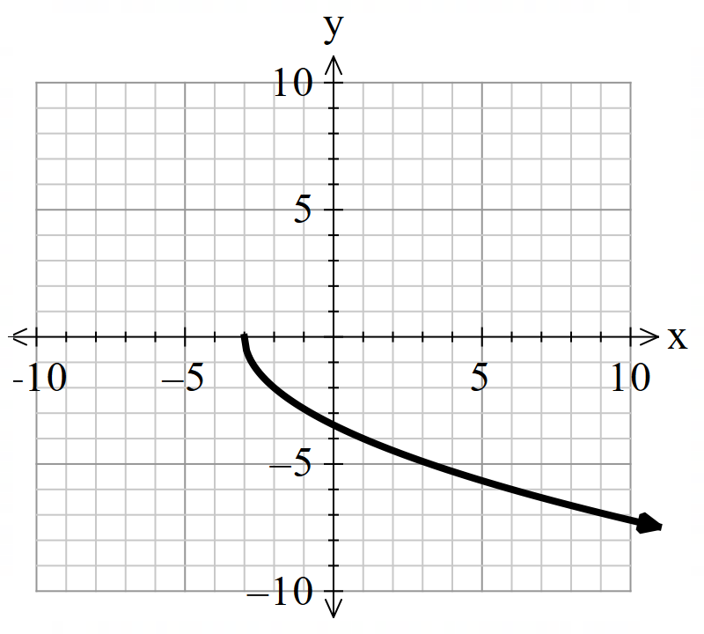 27)