Formal Geometry Assignments 2022

Ch 3: Relationships in Triangles and Transformations

|  |  |  |
| --- | --- | --- |
| **Day** | **Date** | **Assignment** (Due the next class meeting) |
| Wednesday  Thursday | 9/21/22  9/22/22 | **Ch 2 Test**  3.1 p.226-229 # 18 – 26 even, 36 – 38, 50, 52, 58  **3.1 Extra Problems**  ***Read pages 240 – 241 and 249 – 251 in your textbook.*** |
| Tuesday  Wednesday | 9/27/22  9/28/22 | 3.2 p.235-238 #14 – 18 even, 21, 23, 24, 30, 37, 38, 40  3.3 p.243-246 #14 – 18, 20, 24, 26, 27, 39, 40, 41, 44 |
| **Fall Break 10/2/22 – 10/7/22** | | |
| Monday  Tuesday | 10/10/22  10/11/21 | 2.8 To be announced |

***\*All Book Assignment answers can be found on the website:***

[**www.washoeschools.net/drhsmath**](http://www.washoeschools.net/drhsmath)

**\*Each problem will be worth 1 point unless otherwise specified.**

**\*All assignments must be complete the day that they are due to receive full credit, this means:**

*Every problem must be attempted with the picture drawn and work shown.

* None of the proofs can be left blank

**\*Corrections are expected to be done to earn back points missed for each assignment.**

**\*Need Help? Try** [www.khanacademy.org](http://www.khanacademy.org)

* **Students with no late or missing assignments for the entire semester w**ill be rewarded with a pizza party
* Students with 100% assignment completion at the end of the semester will receive a 2% grade increase.

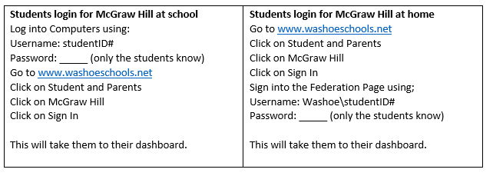

**3.1 Extra Problems**

|  |
| --- |
|  |
| 2) 2. |
| 3) A, B and C are collinear with B between A and C. Find the length of BC if |
| 4) |
| 5) Given:          Find: |

Answers:

**1) B 2) B 3) 80 4) D 5)** 66°